AWS Devops

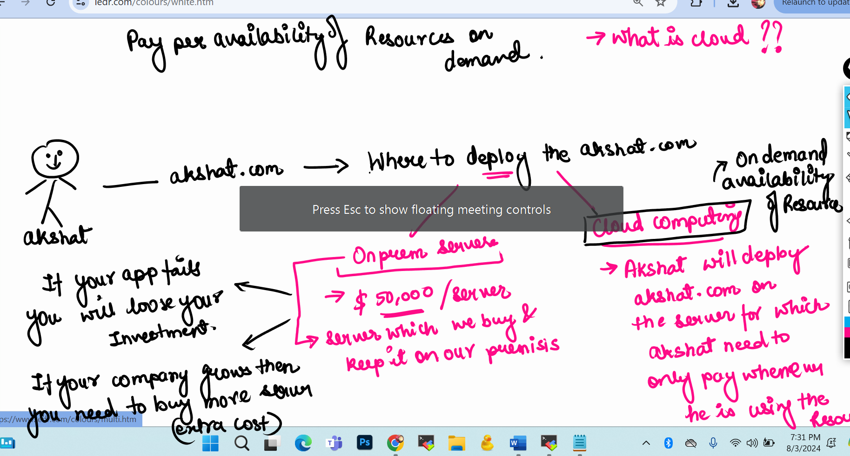

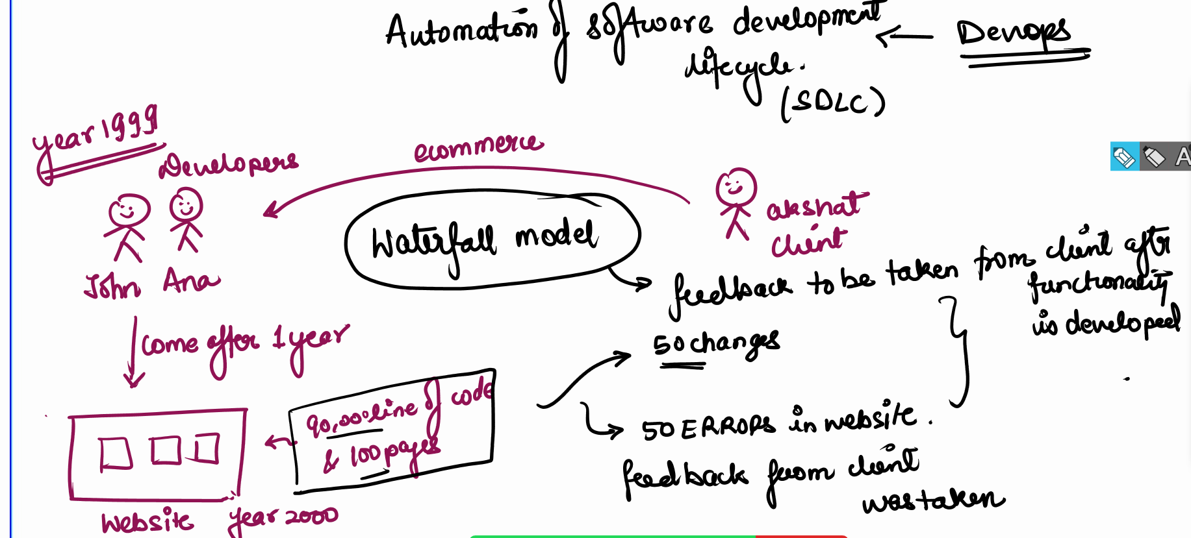

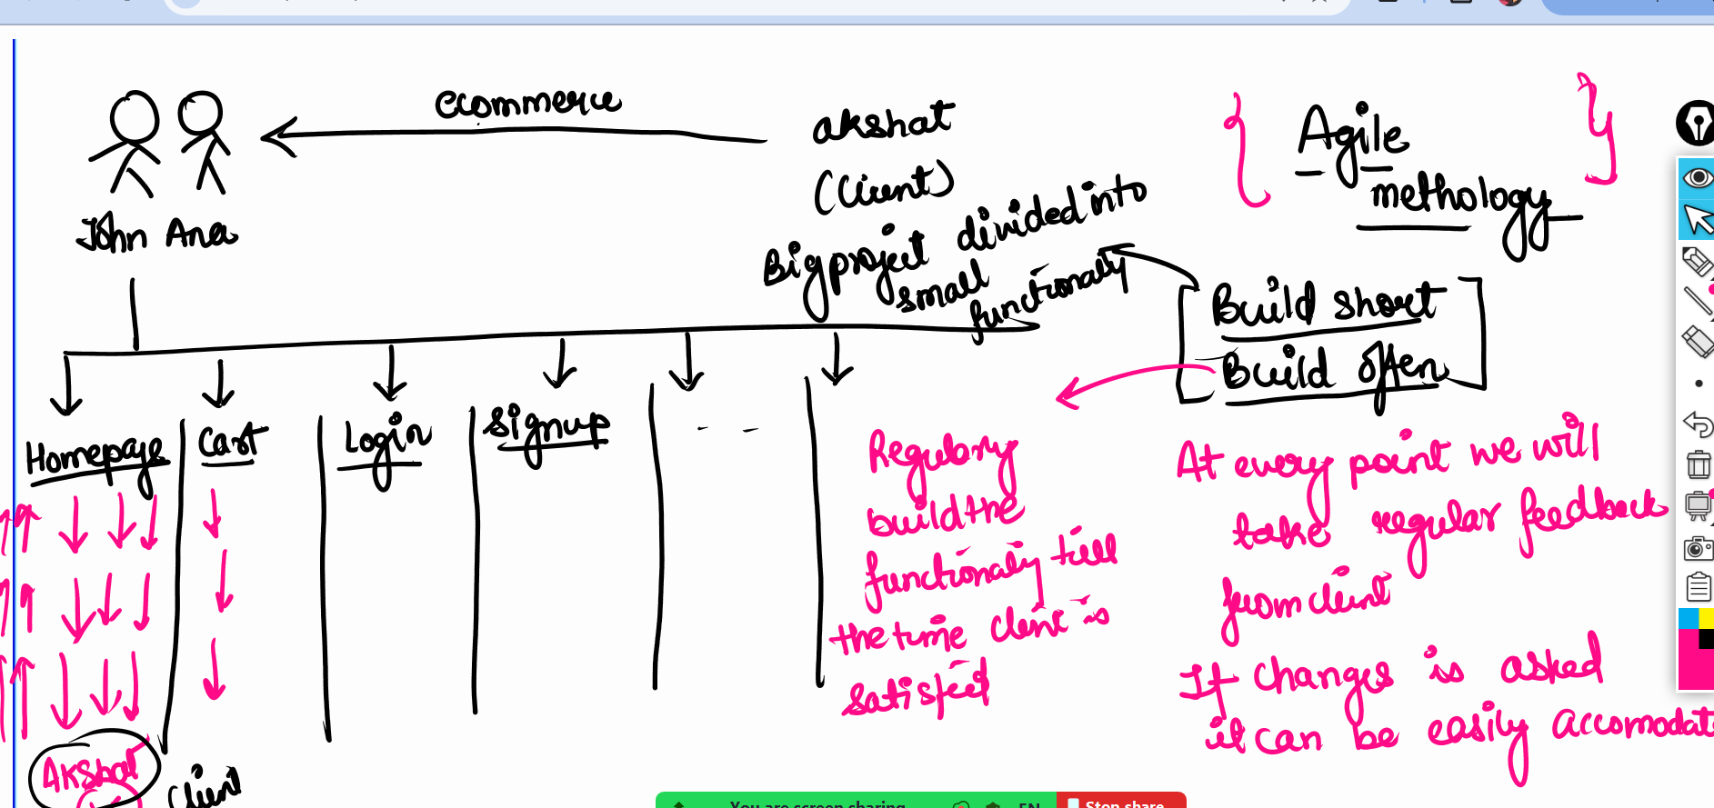

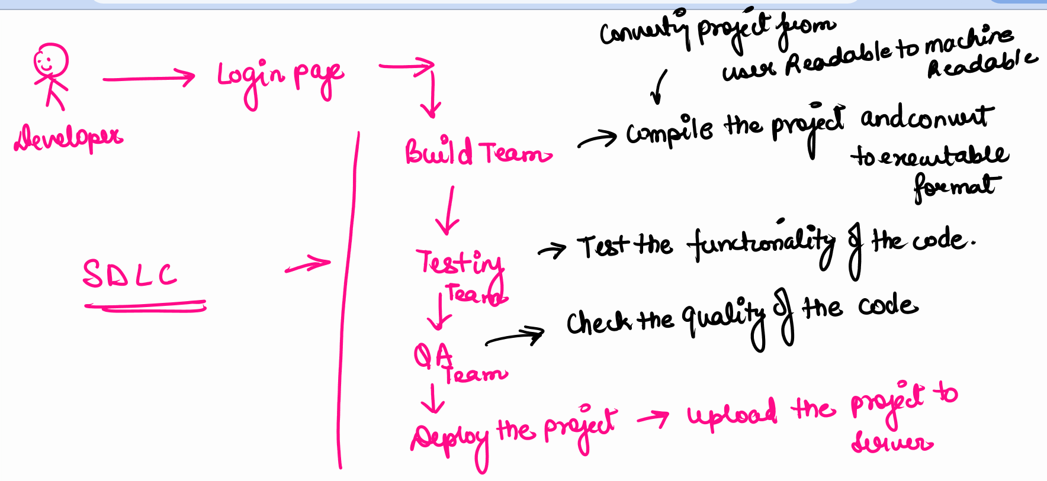

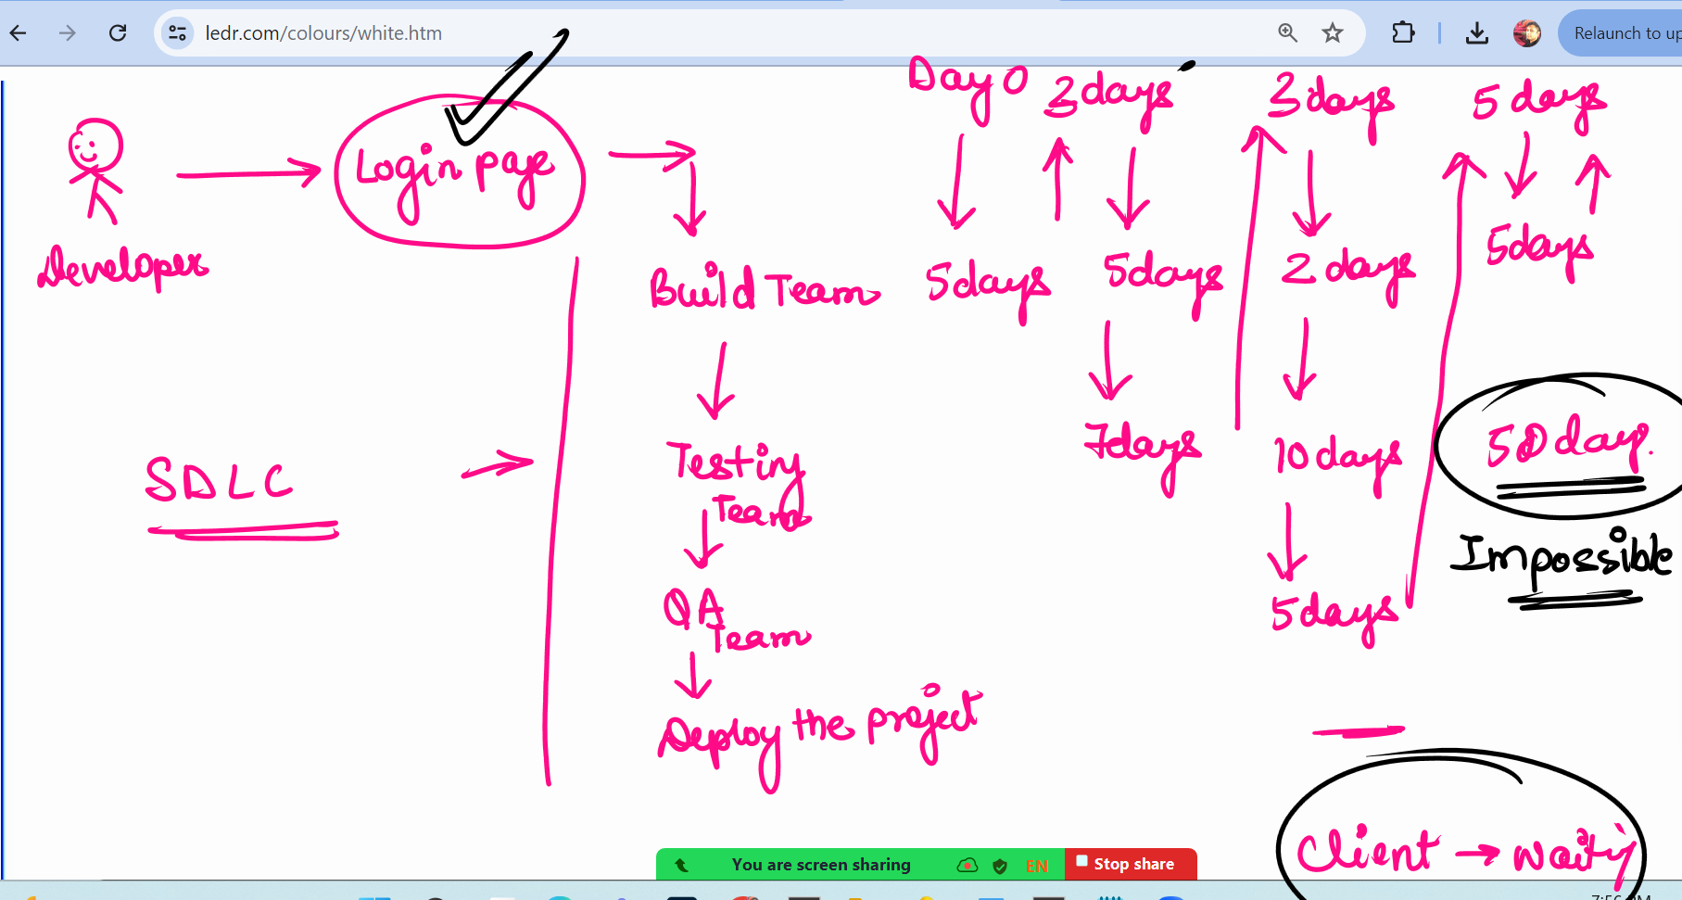

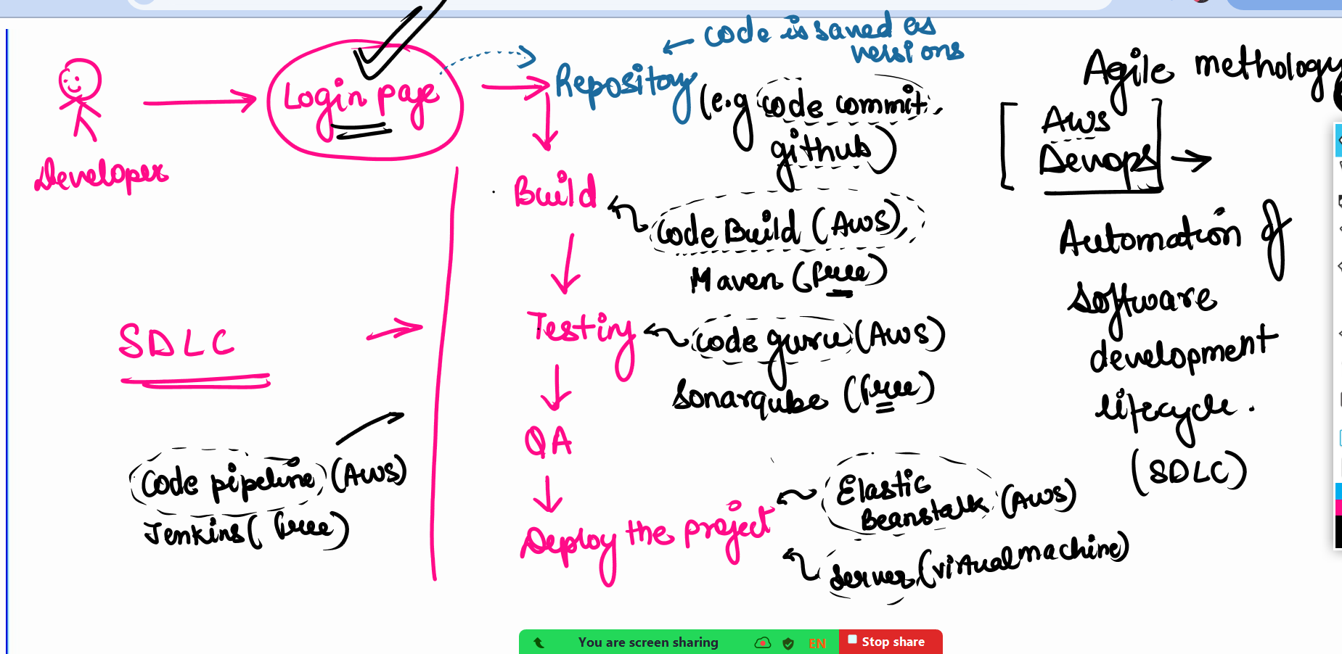

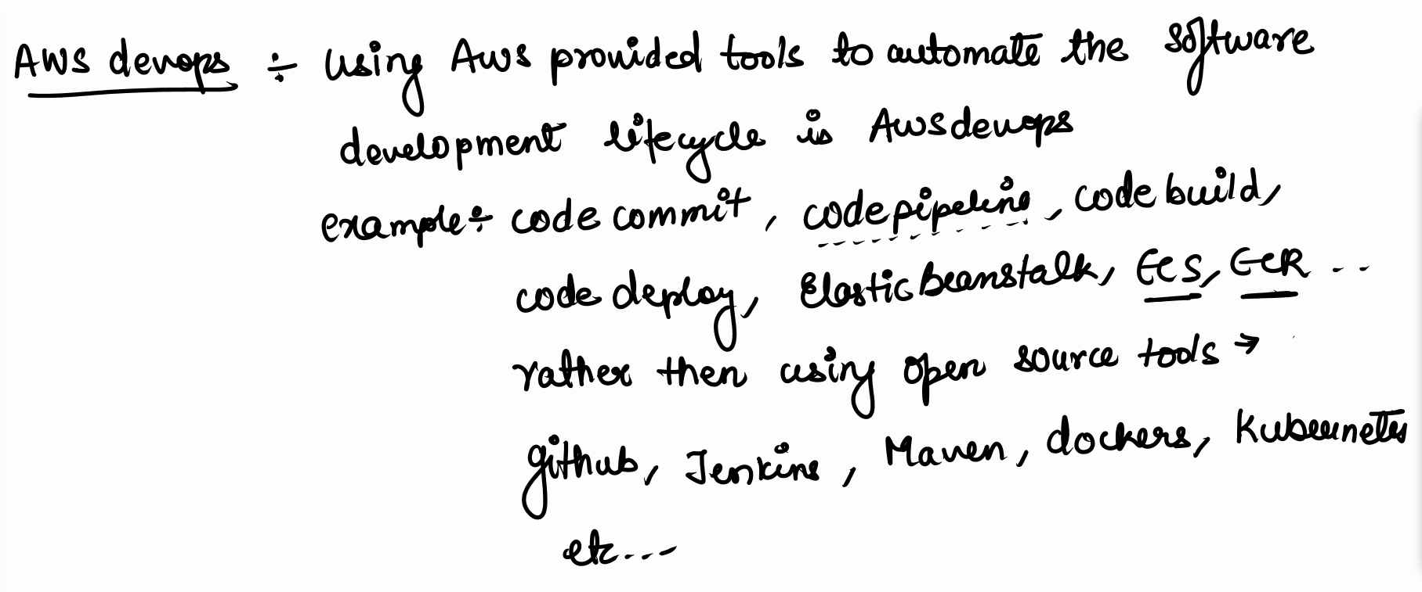

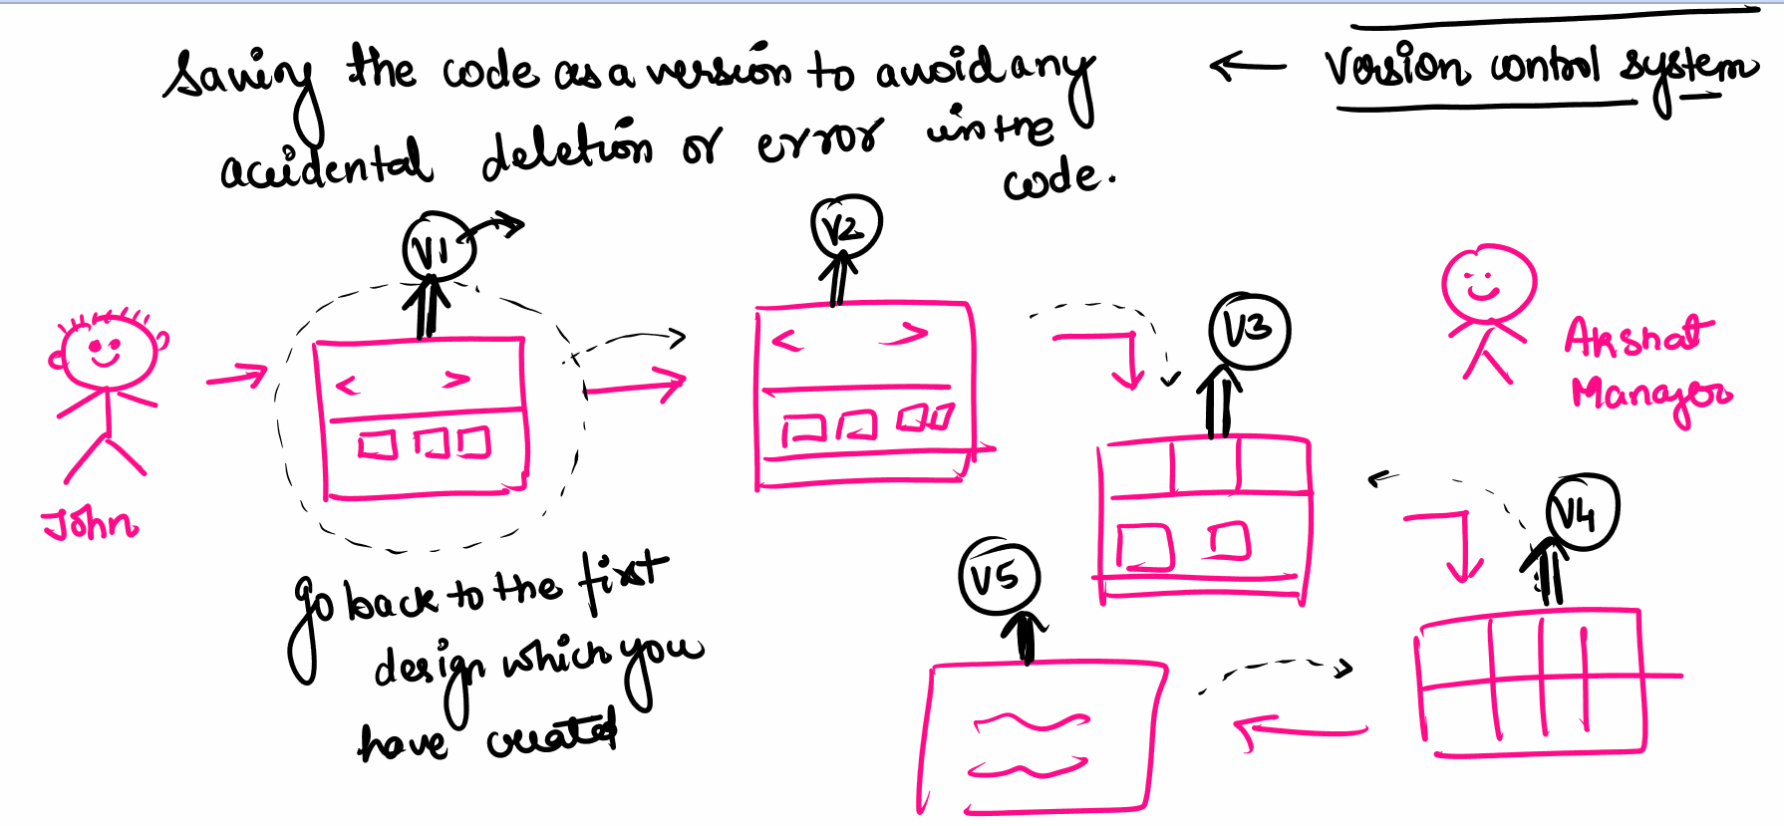

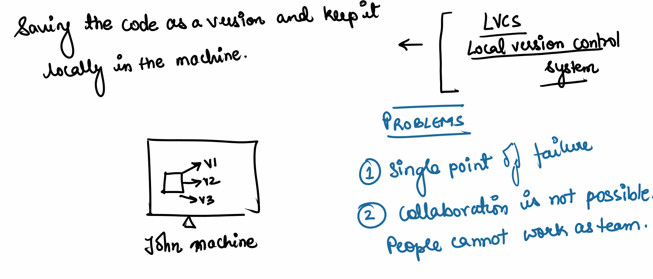

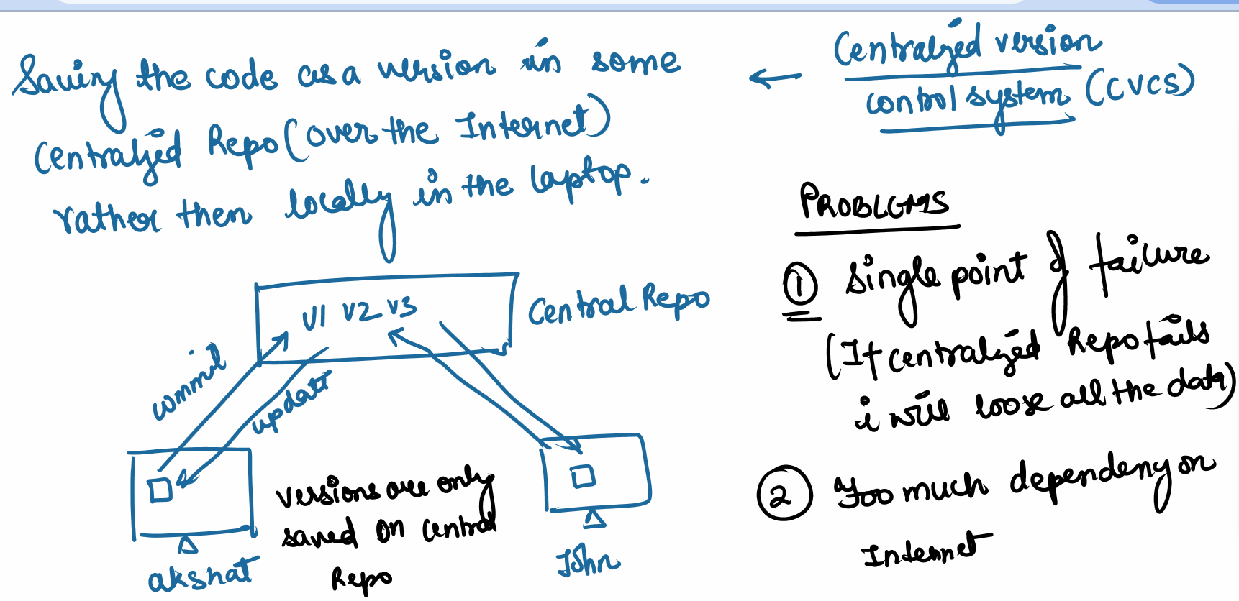

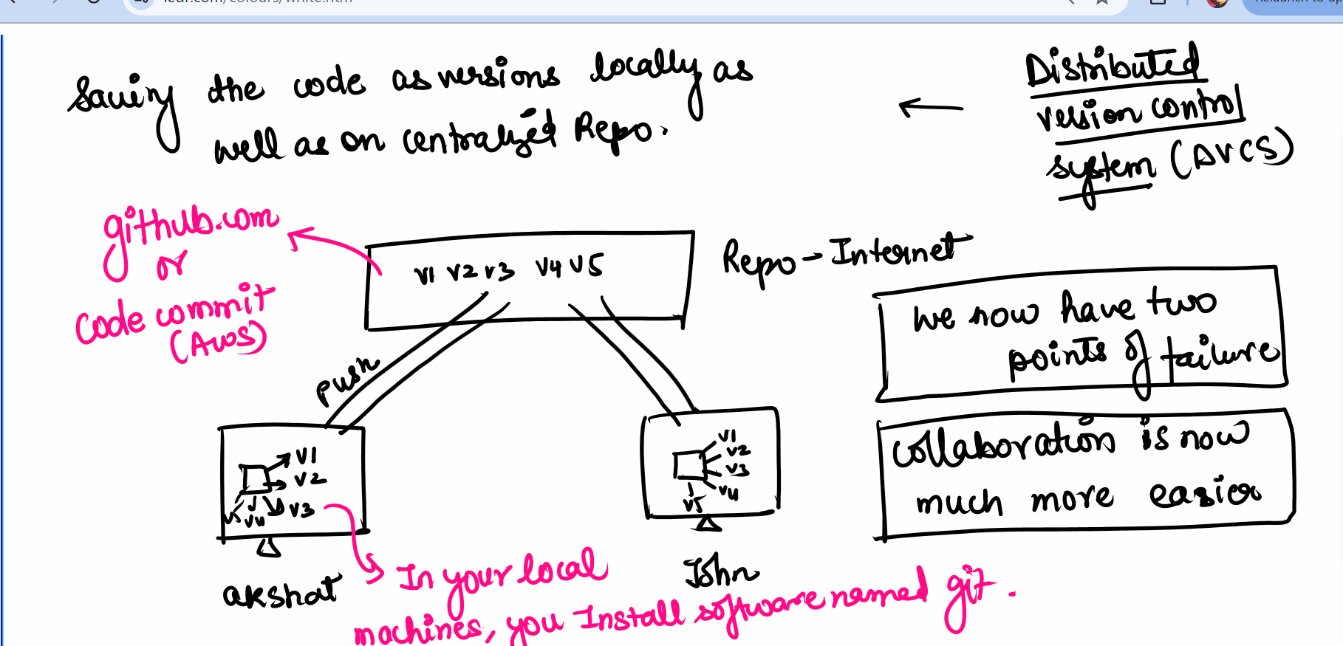

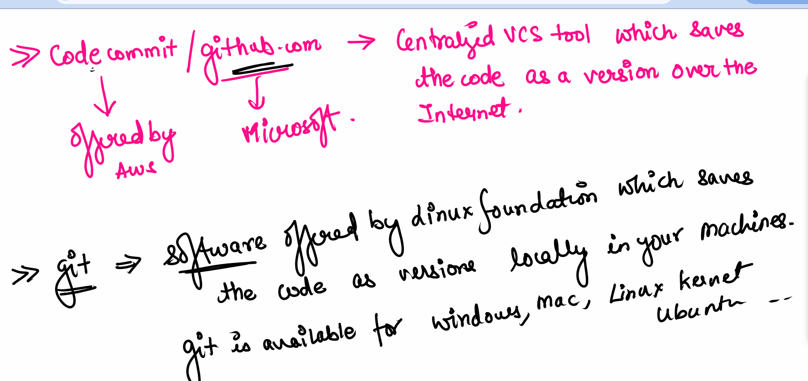

####
Goal: We will see how to install git and create the versions locally in the machine

Windows : https://git-scm.com/download/win
Download 64 bit git
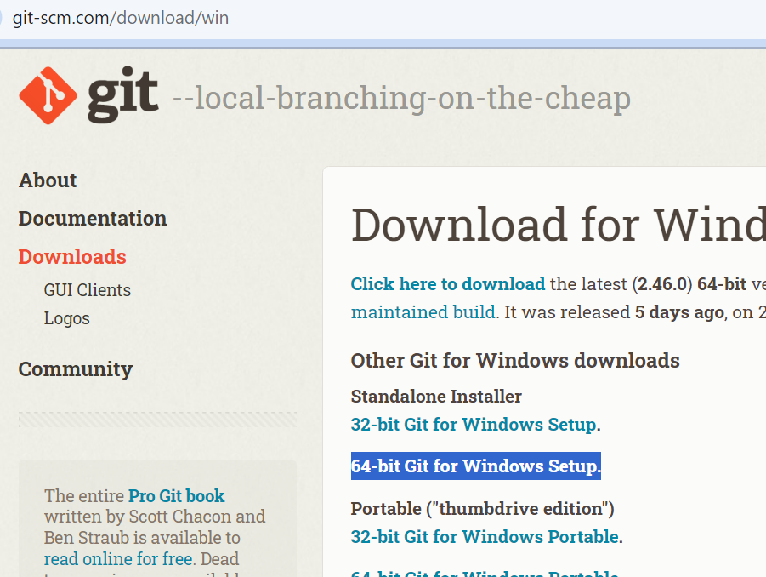

Open the exe file ..and install the software in your laptop

### for MAC OS

https://git-scm.com/download/mac

Open the mac terminal
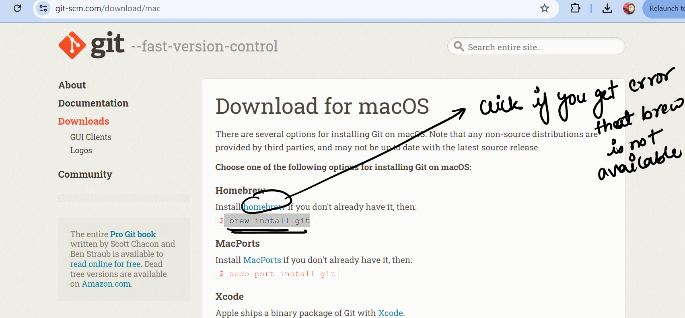

For ubuntu users:

sudo su
apt update
apt install git -y
git --version

##################

Now in windows , we will create a folder …inside folder we will right click and open gitbash

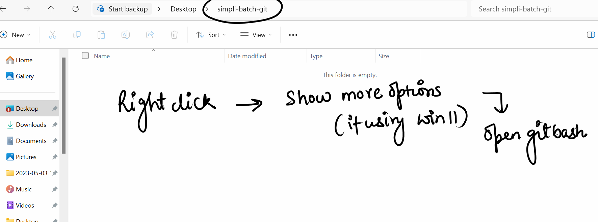

(if you are mac user you need to open the mac terminal inside the folder)

We will now create a new text file inside the folder

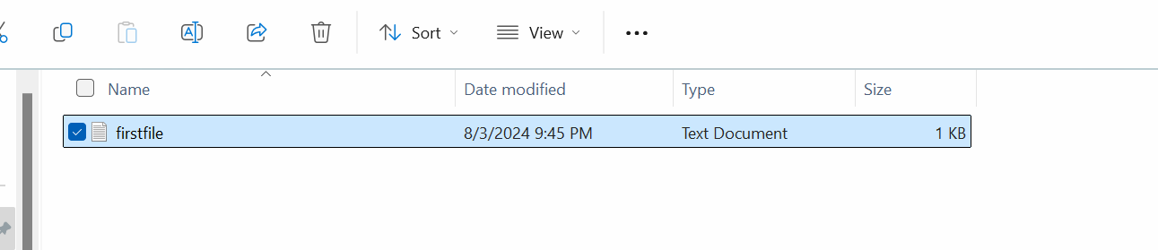

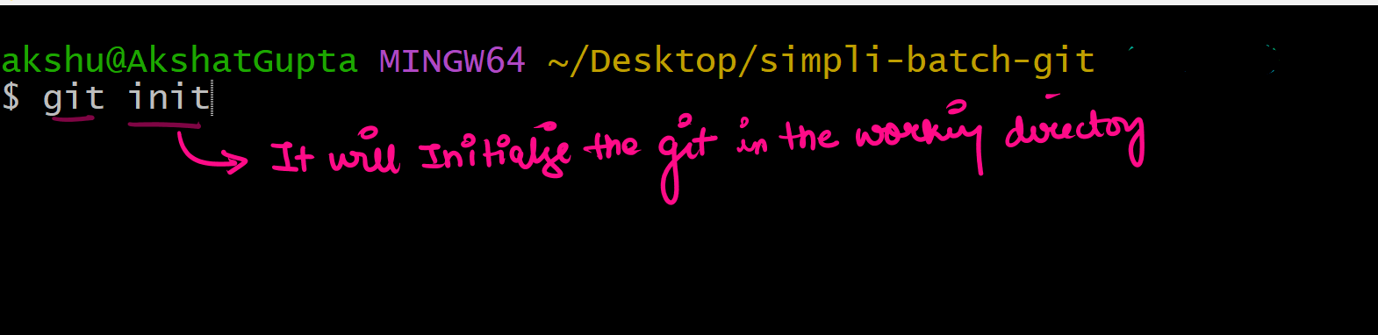

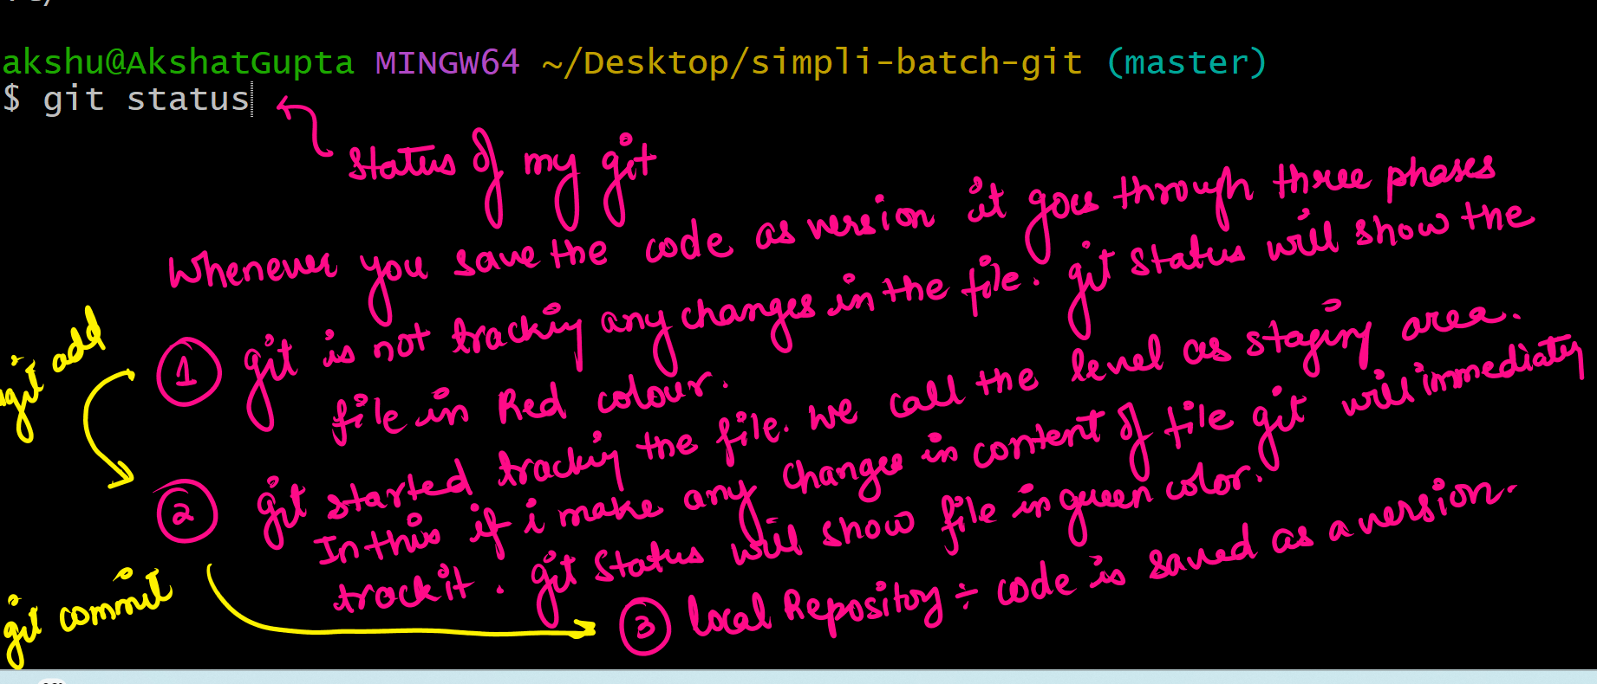

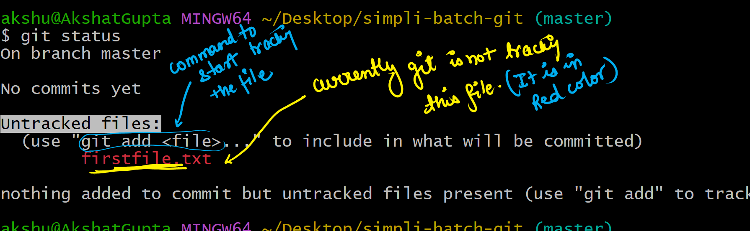

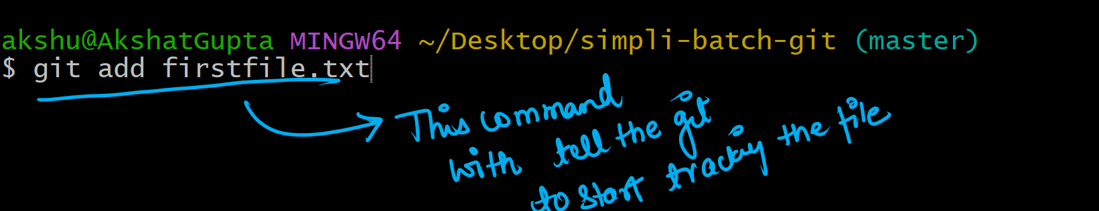

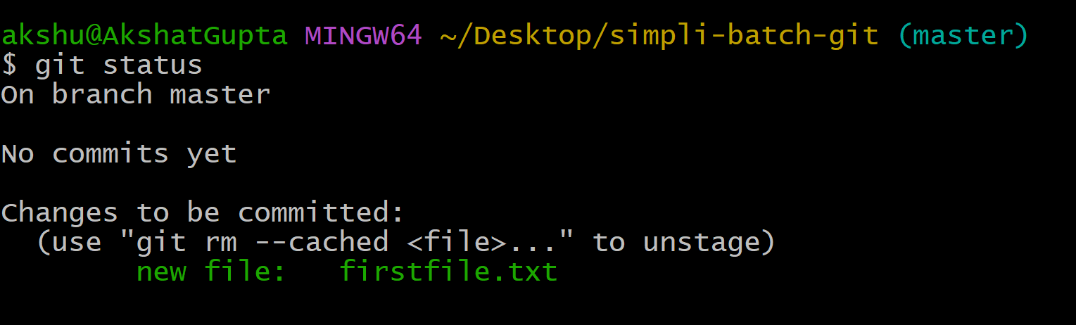

#### DO TILL THIS POINT #############

Now we need to perform one time process where we need to configure in git and tell the git which user would be pushing the code on codecommit /github

We will configure the git and tell the git the username and the email address of the person working in this laptop

git config --global user.name "akshat"

git config --global user.email "akshu20791@gmail.com"

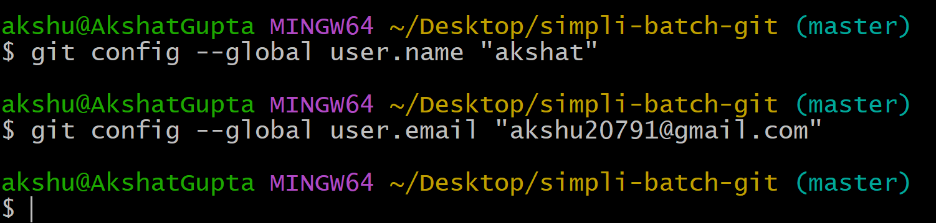

To check if we have configured the name and email properly

git config --list

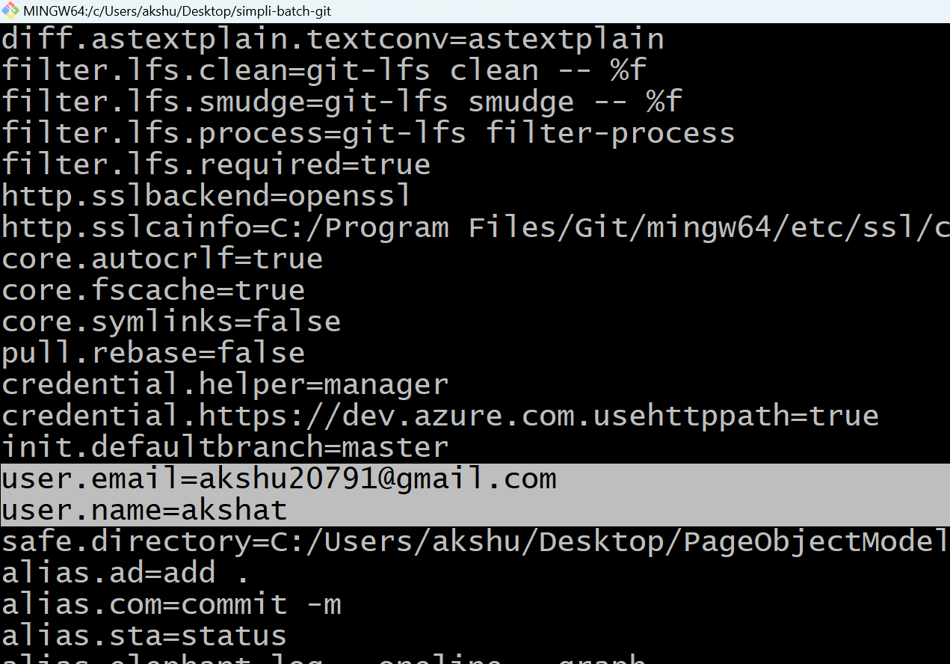

Keep pressing enter till the time you reach end and press q

## we are now going to save the code as version

git commit -m”my first version ”

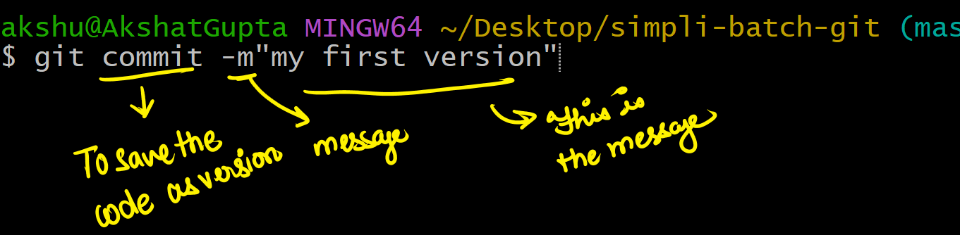

#####

## to see the versions which is created
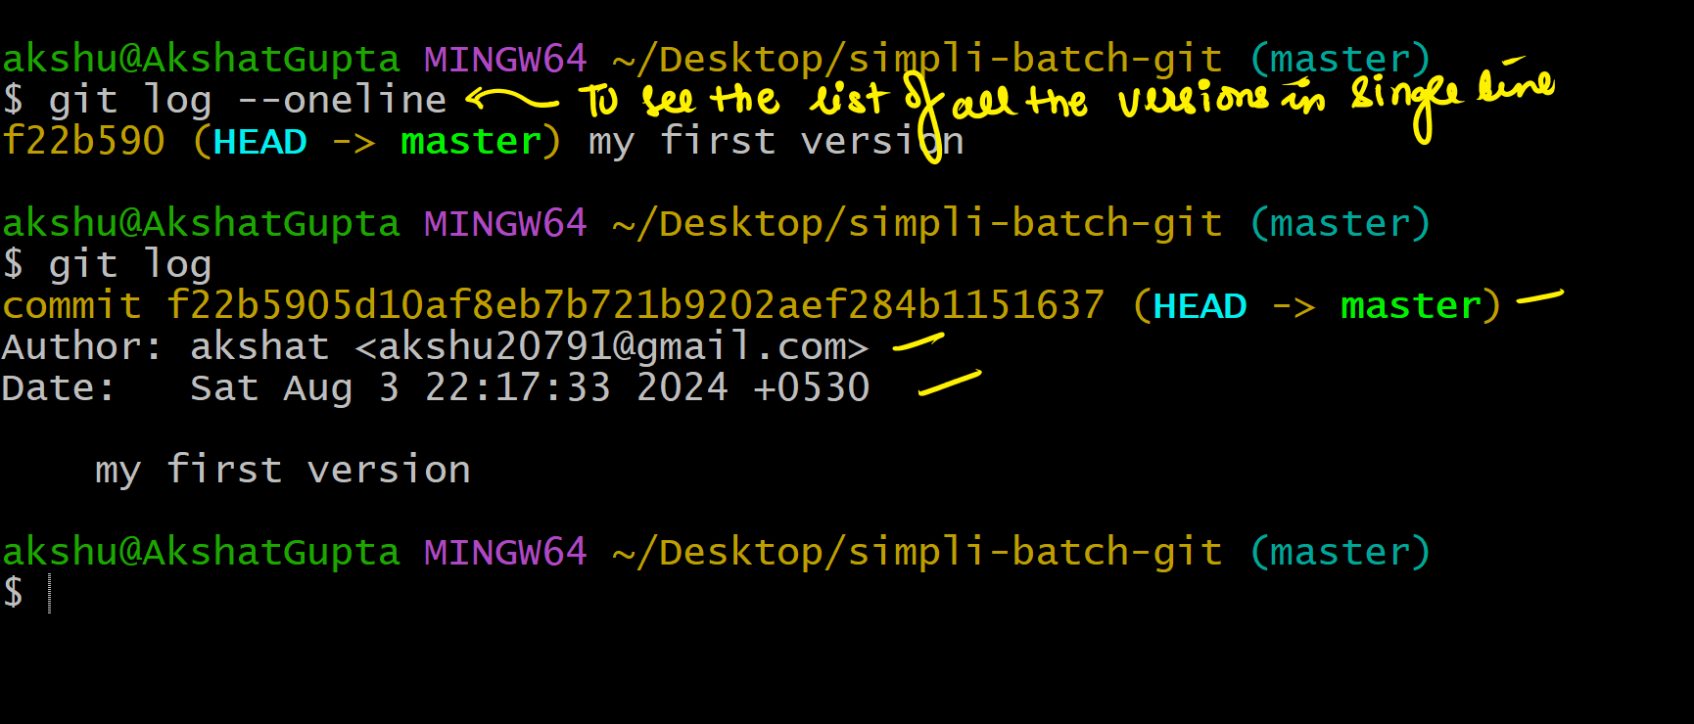

git log --oneline

git log

##############

###

Ques: Lets suppose you have three files file1 , file2 ,file3 with three different content. I want to only save content of file1 and file2 as version …how can i do it ?

Answer:

We will create three files with different content

git add file1 file2 # we will only start tracking file1 and file2 because we want to save it as a version

git log --oneline

git commit -m”file1 and file2 saved as a version”

######

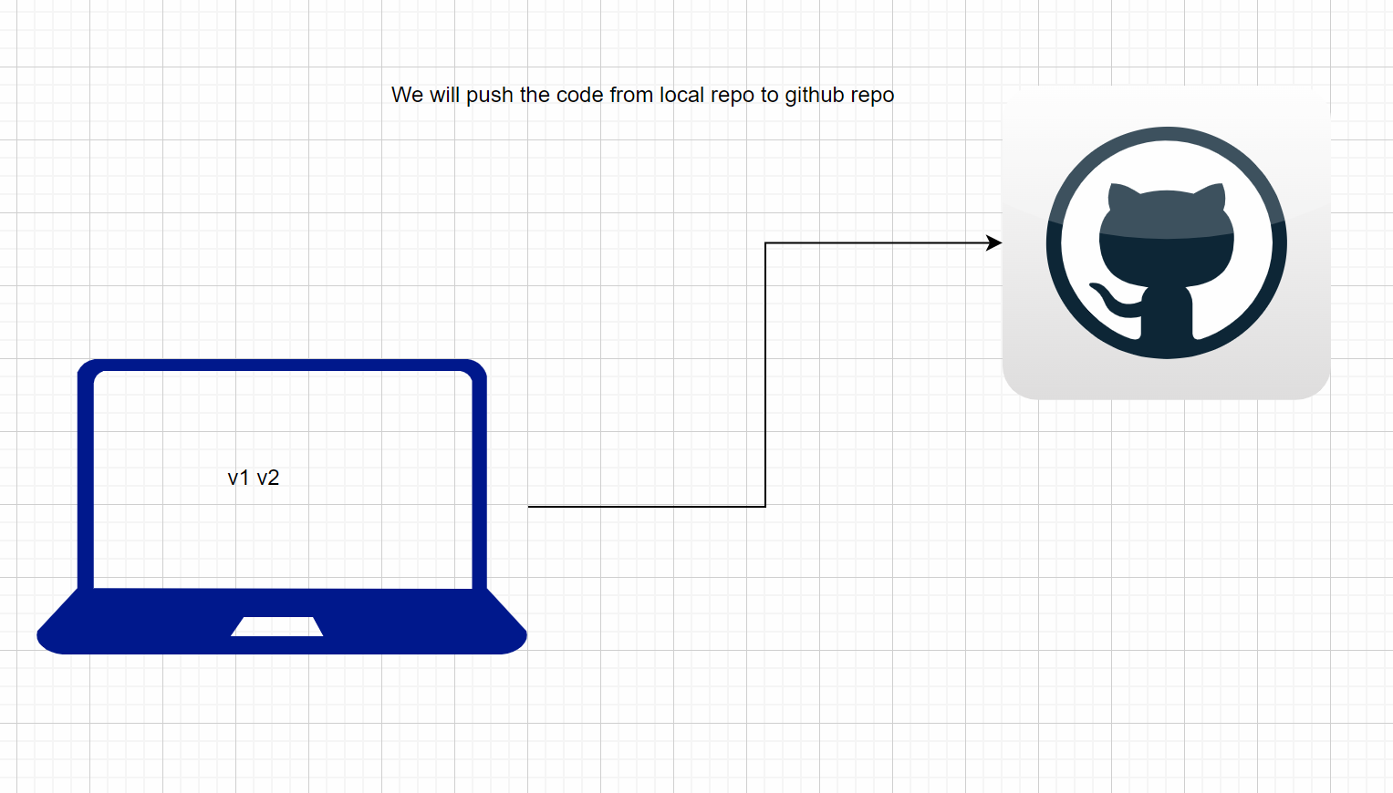

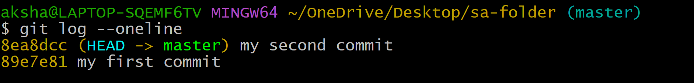

We will first create an account on github

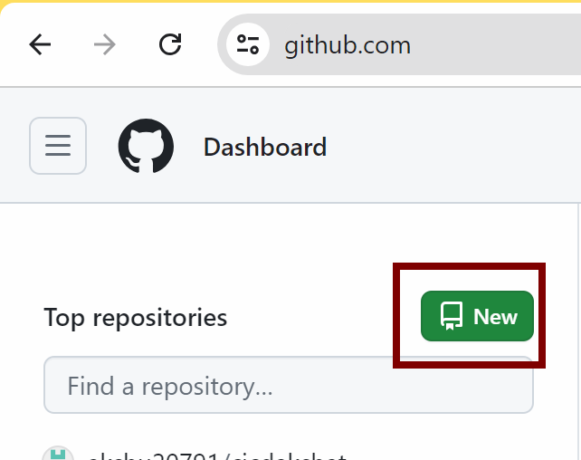

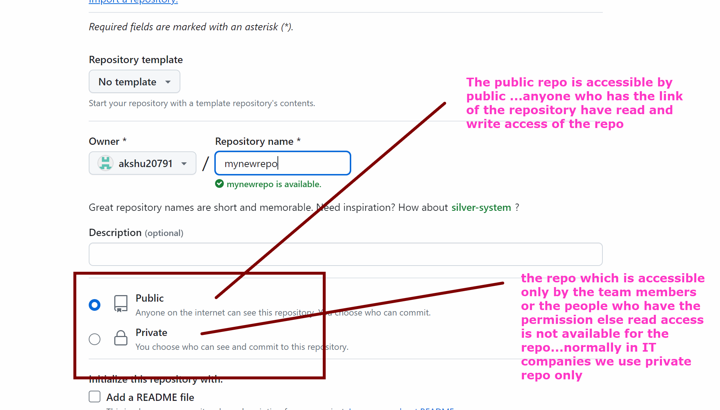

Create repo

### We have competitor of github which is code commit but it is discontinued from 25th july 2024

PROOF:
https://aws.amazon.com/blogs/devops/how-to-migrate-your-aws-codecommit-repository-to-another-git-provider/

Since the code commit is discontinued which is the centralised repo we have to use other famous central repo like github which is taught in the devops batches

Even we can see how code commit looks like 👍

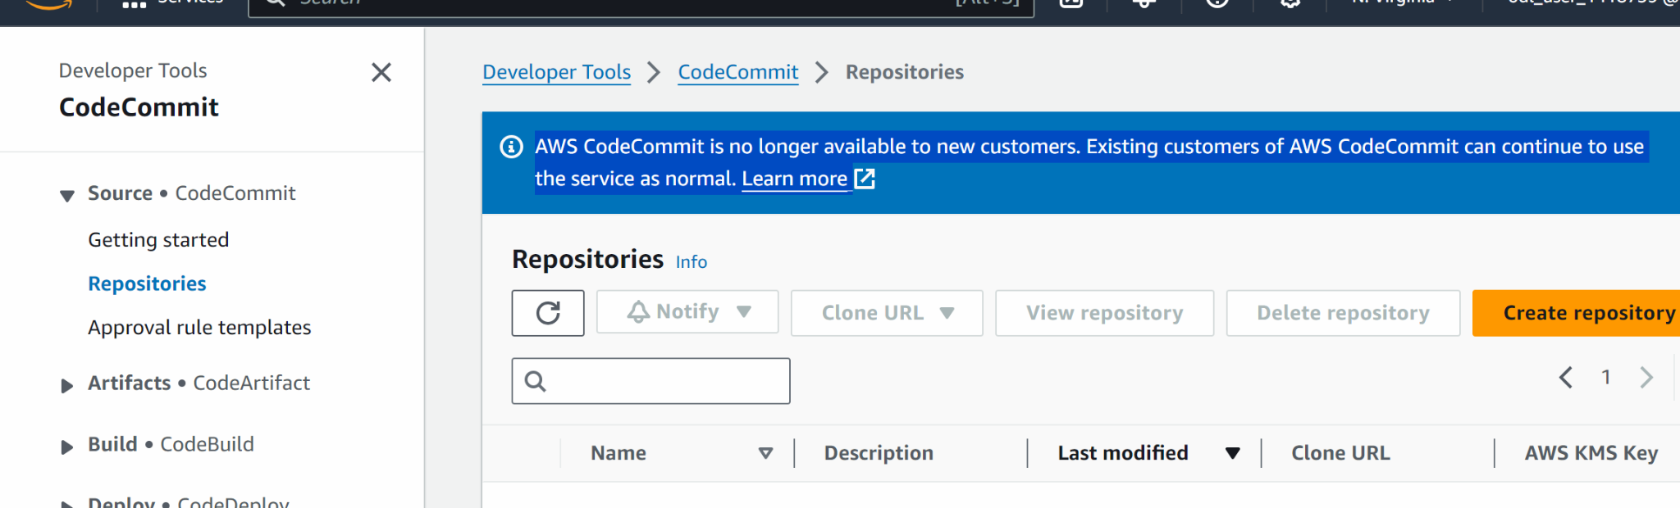

#########################

Now we need to push the code from git (local repo) to github.com (central repo)

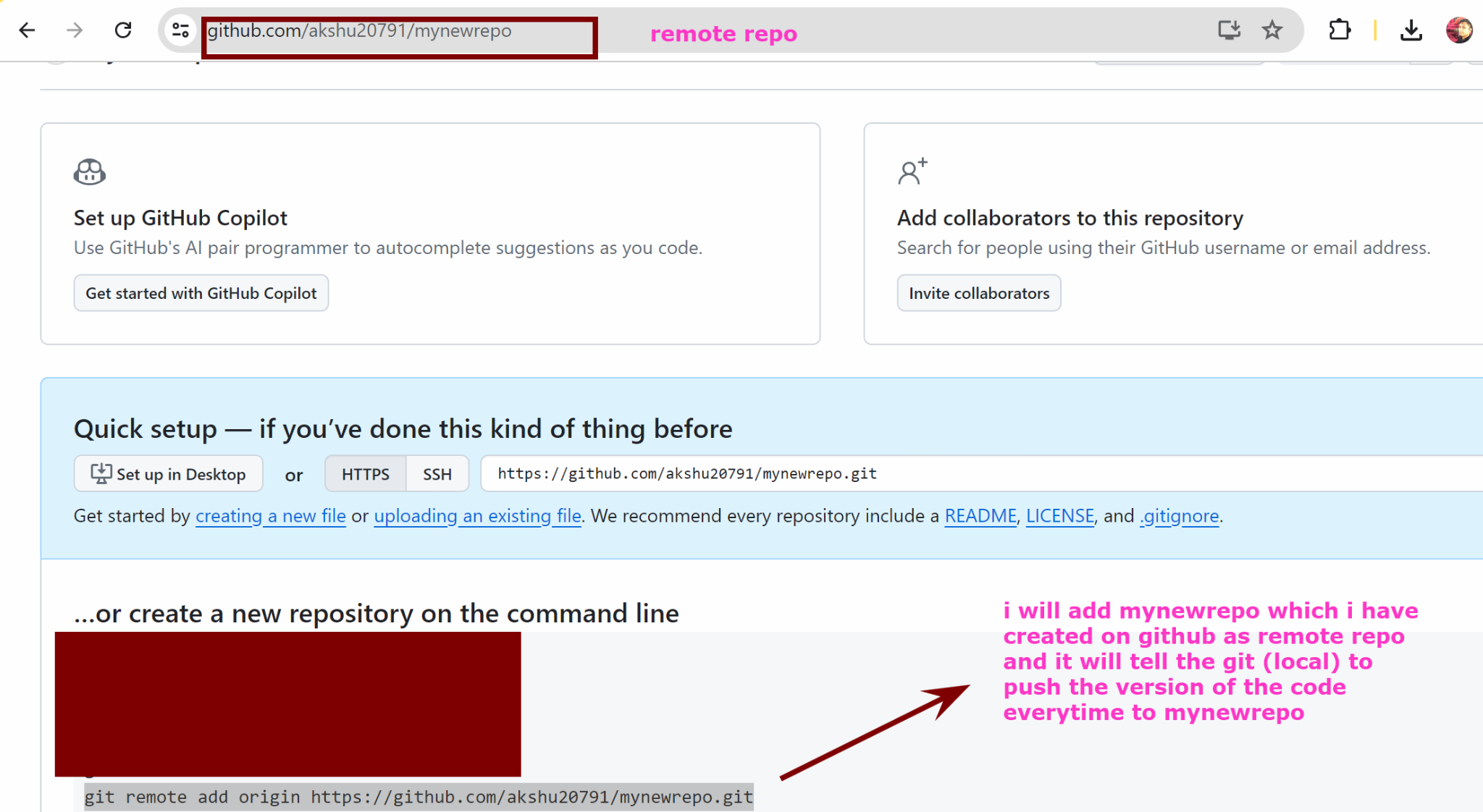

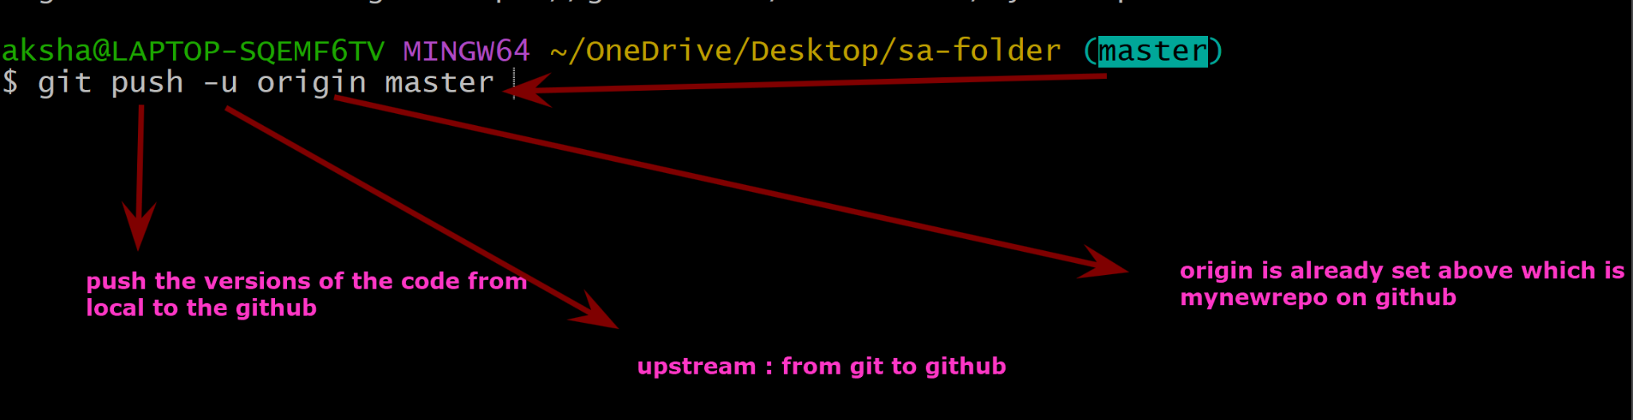

git remote add origin https://github.com/akshu20791/mynewrepo

git push -u origin master

In the button on the task bar you will see a pop up apprearing

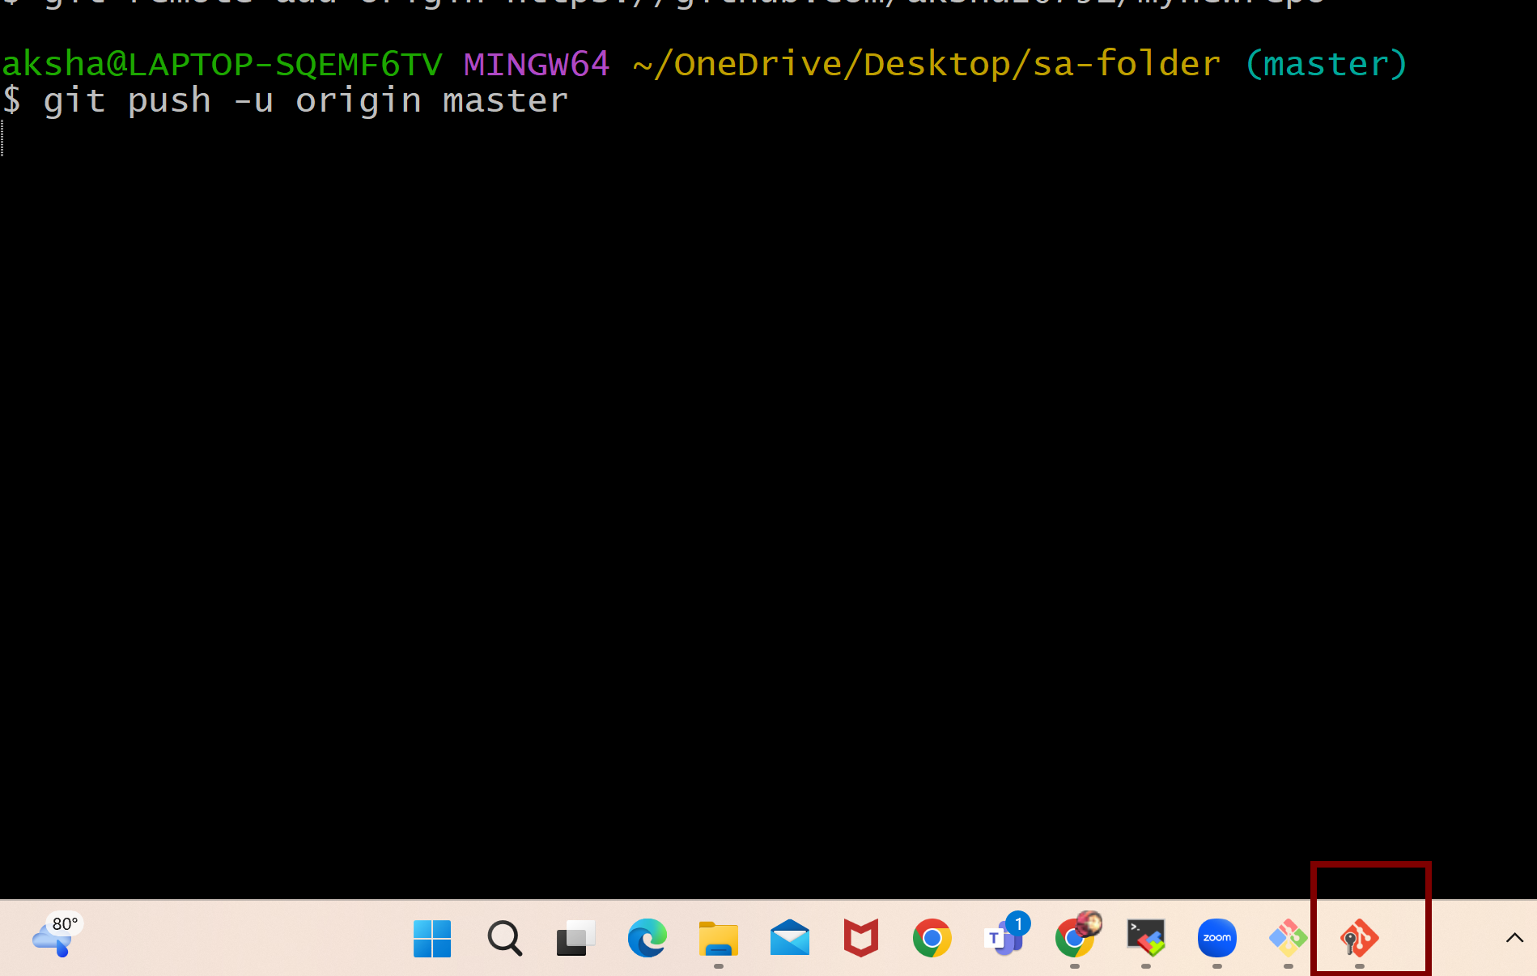

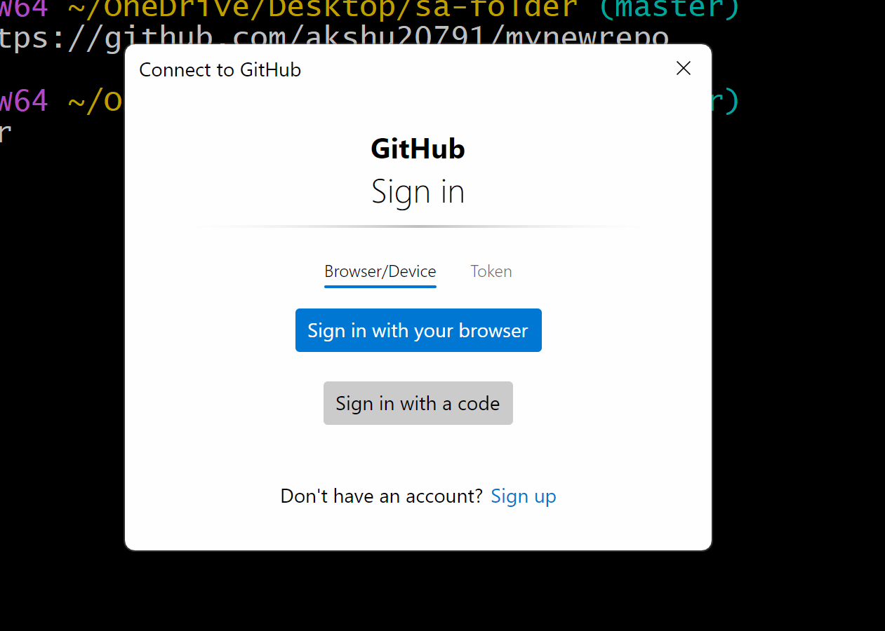

########################
Do it till page 16
#####
PAT : personal access token ….we will generate the personal access token and it will be shared with the developers of the company so that they can push and pull the code easily

To generate pat -> go to github.com
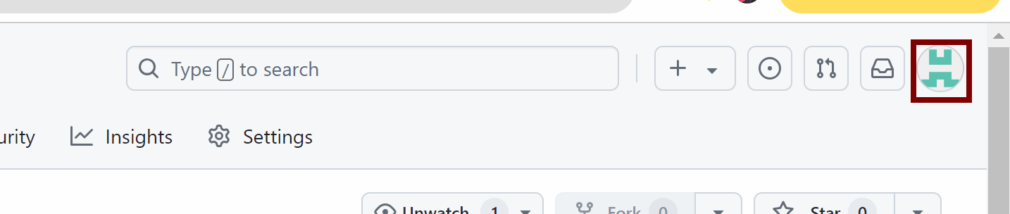

Click on settings

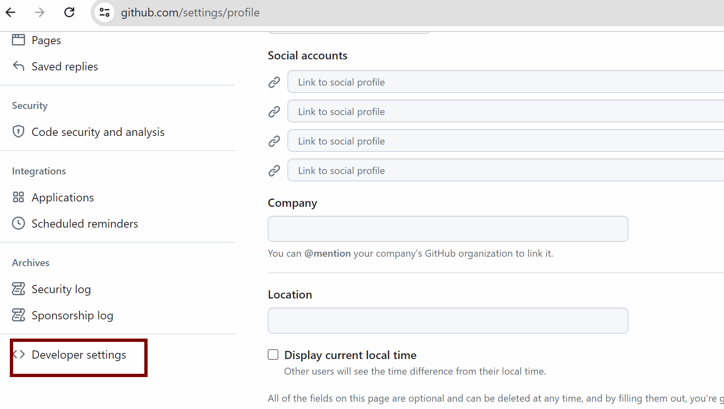

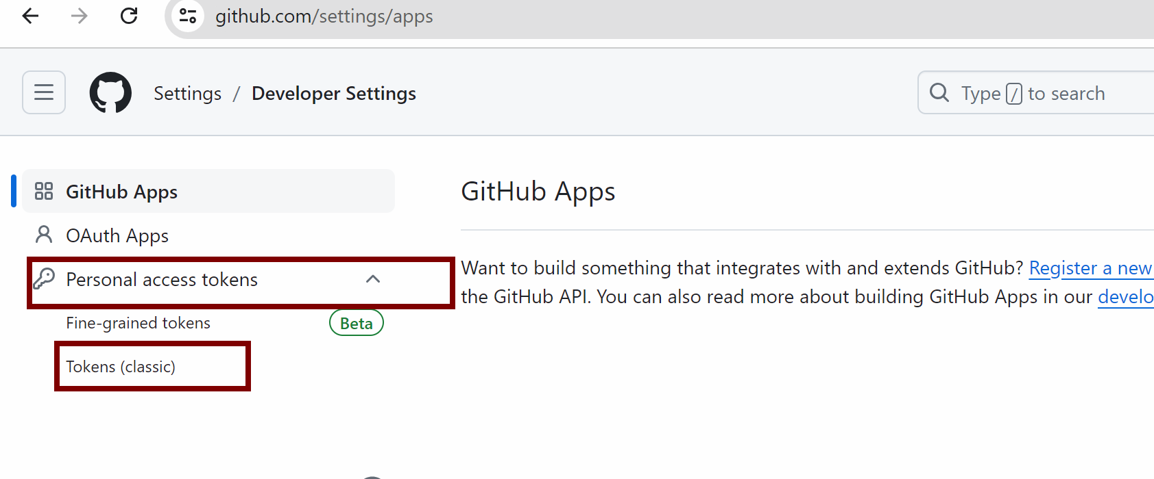

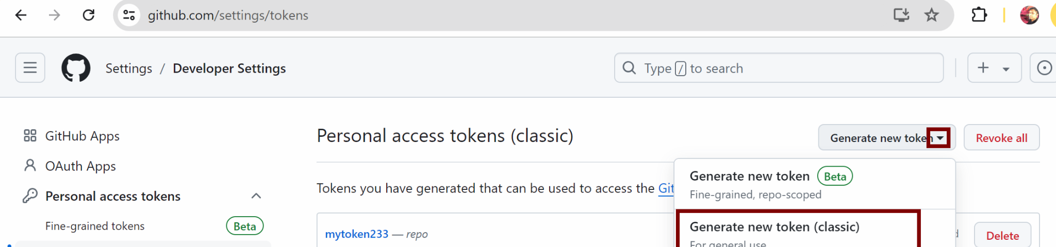

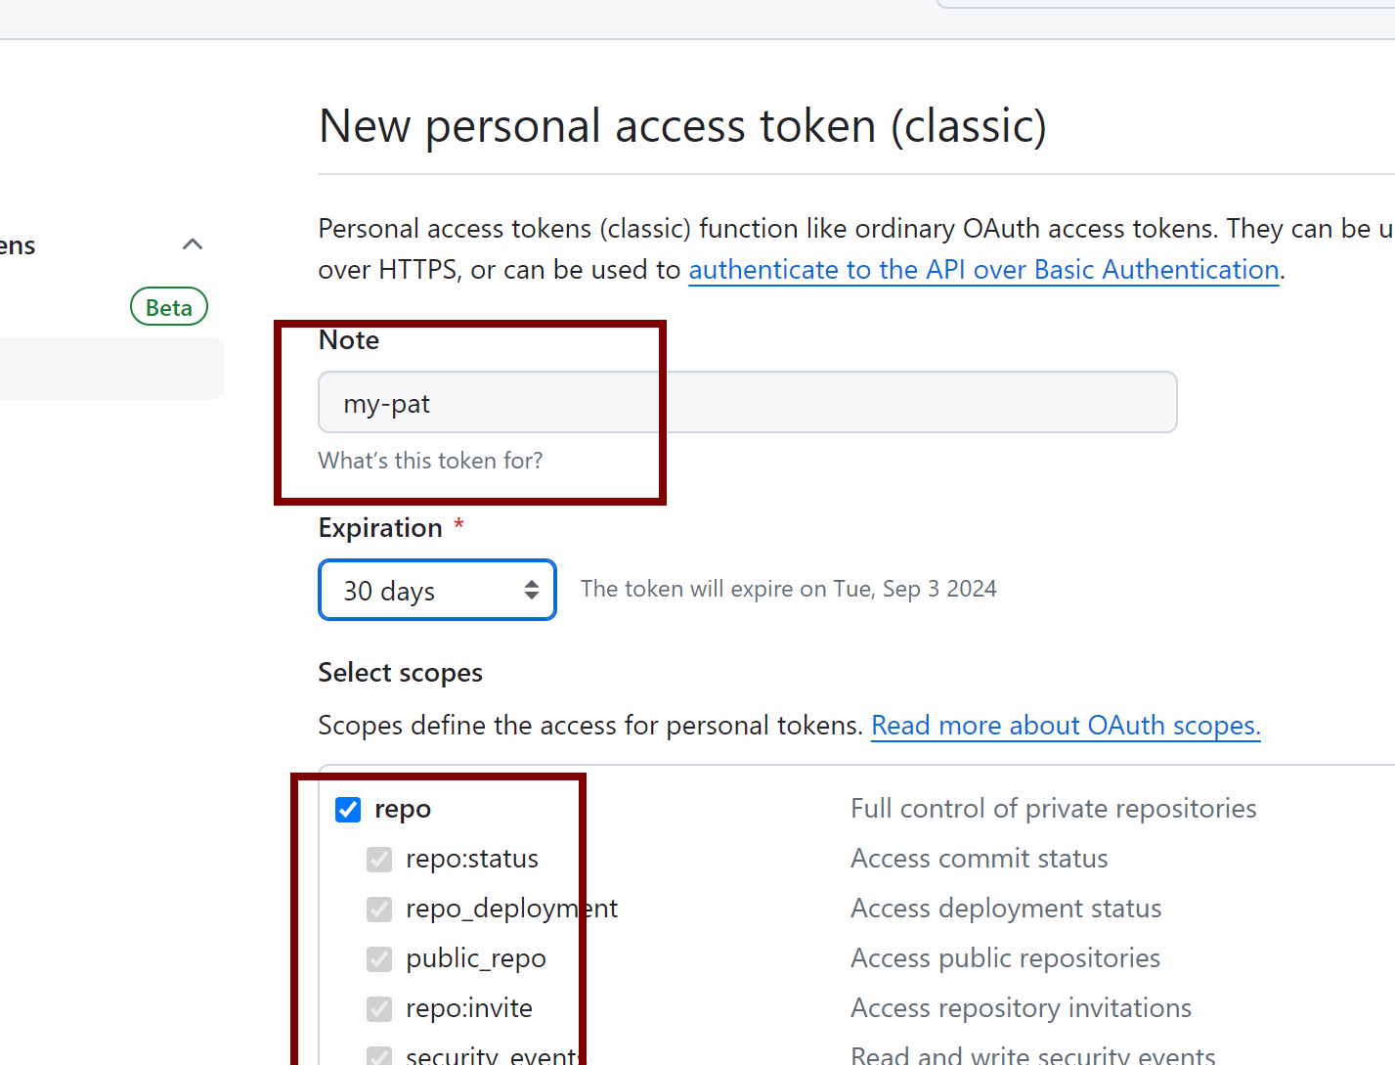

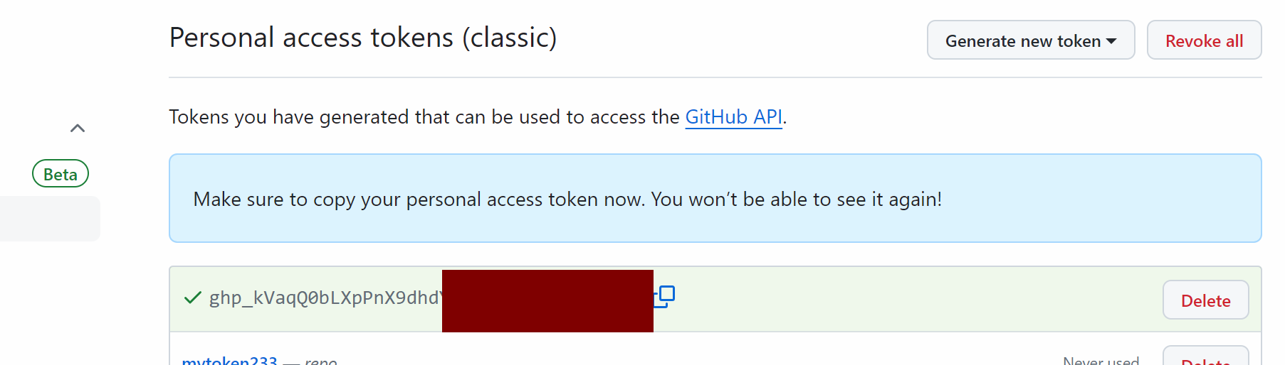

You can paste the token in some notepad ….

Now go the pop up which was appeared

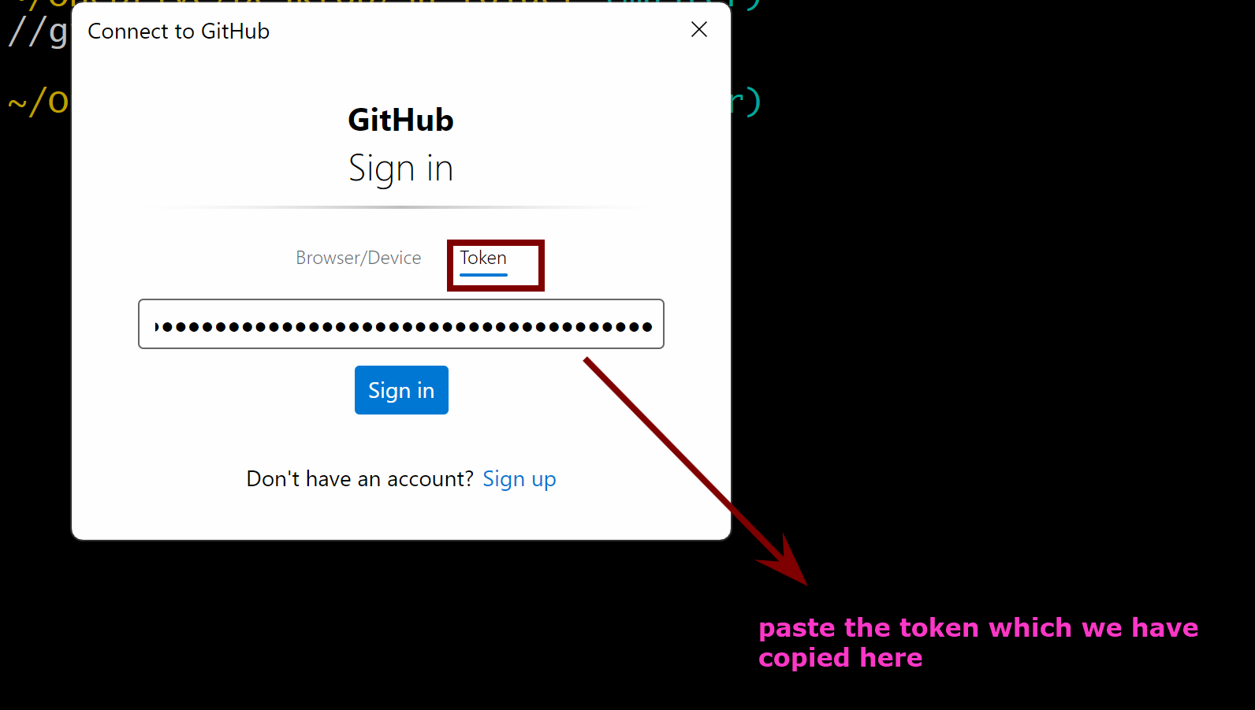

Sign in

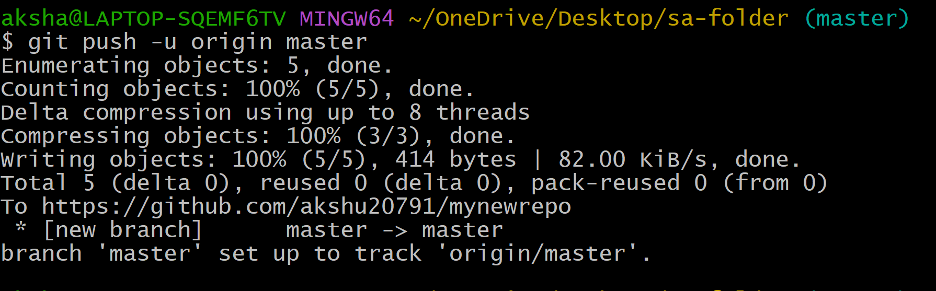

You will see that your code is now pushed to the github repo

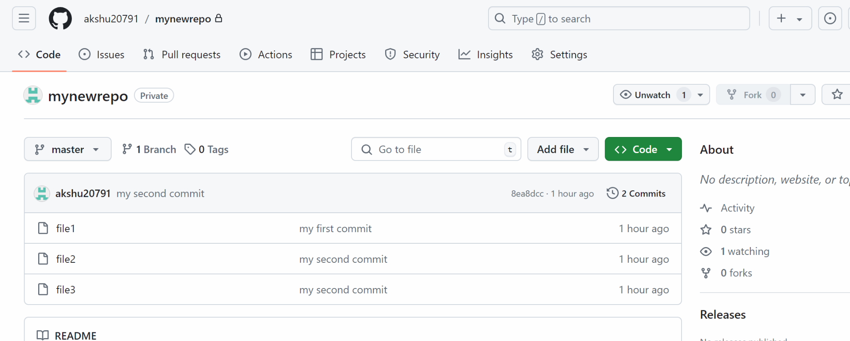

### the files are present on github

####################################################################

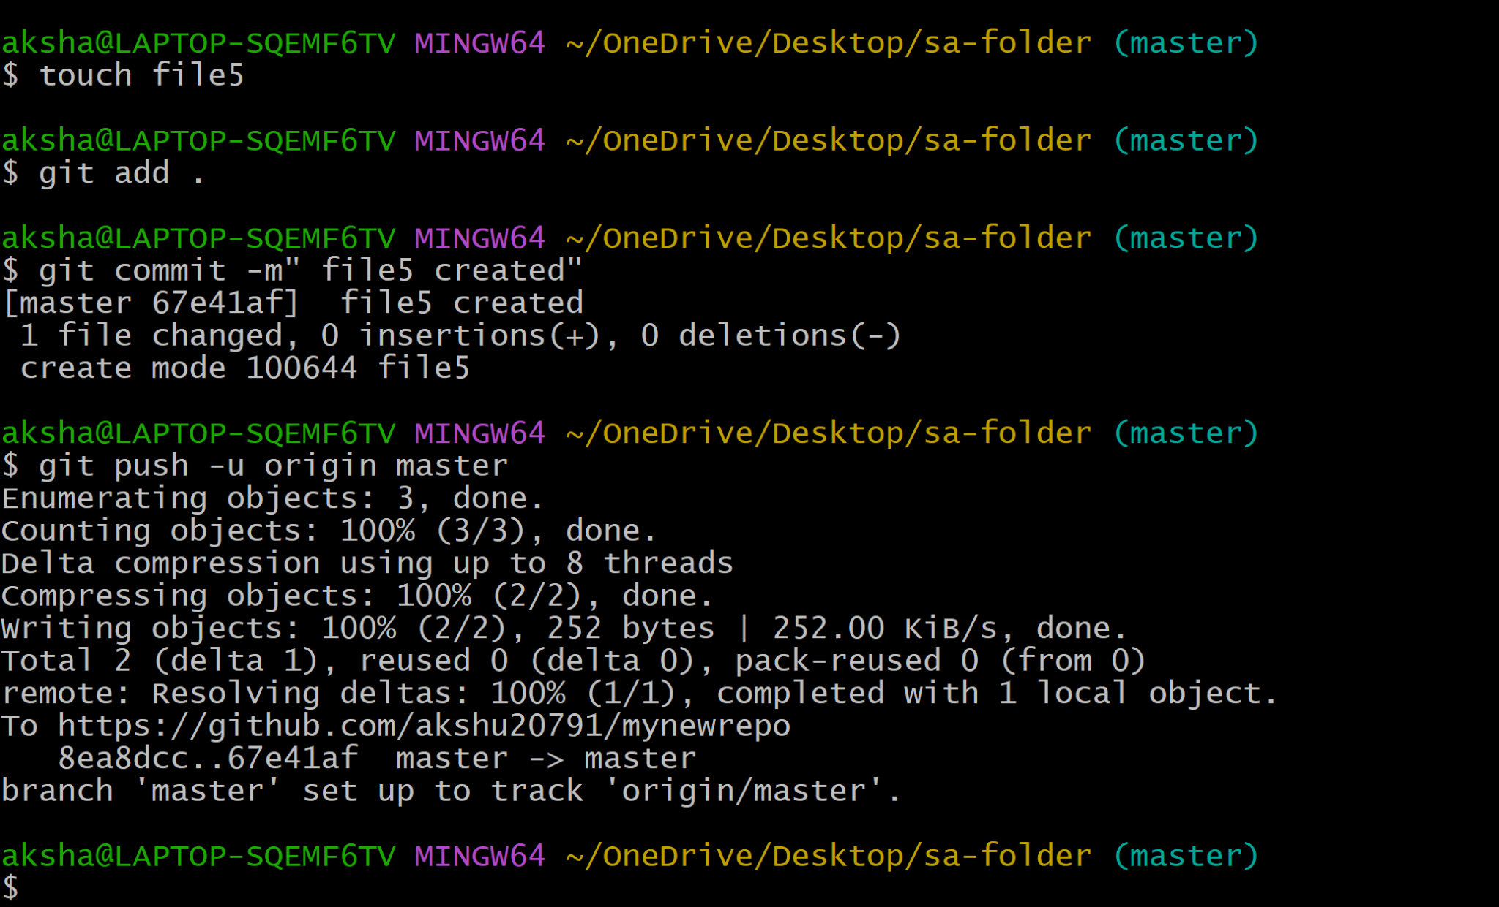

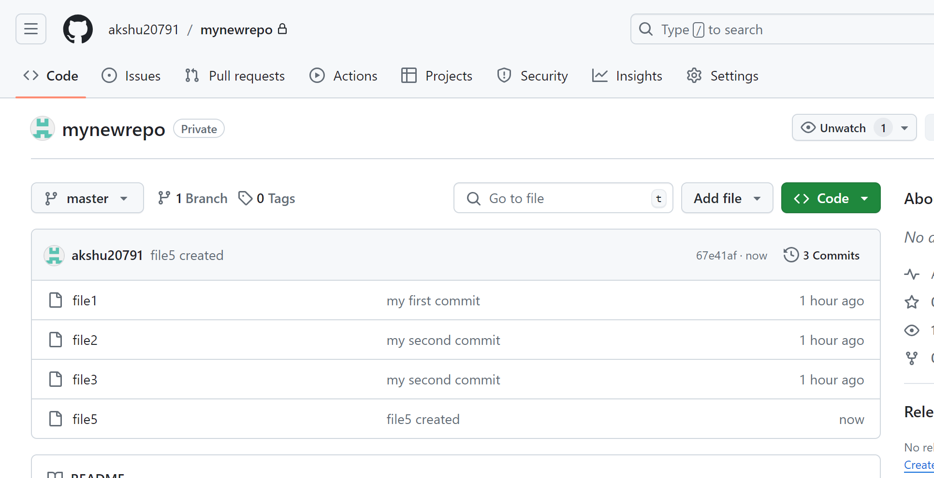

## HOW THE GIT PULL WORKS….

Lets suppose there are 2 developers working in a project …now if lets say developer 1 push the code to github and after some time developer 2 also wants to push the code?
Developer 2 will not be able to push because his local repo is not updated…in this case developer2 should use git pull to update the local repo

Since we dont have developer2 we will make some changes to the github directly and then we will try to push from our local repo

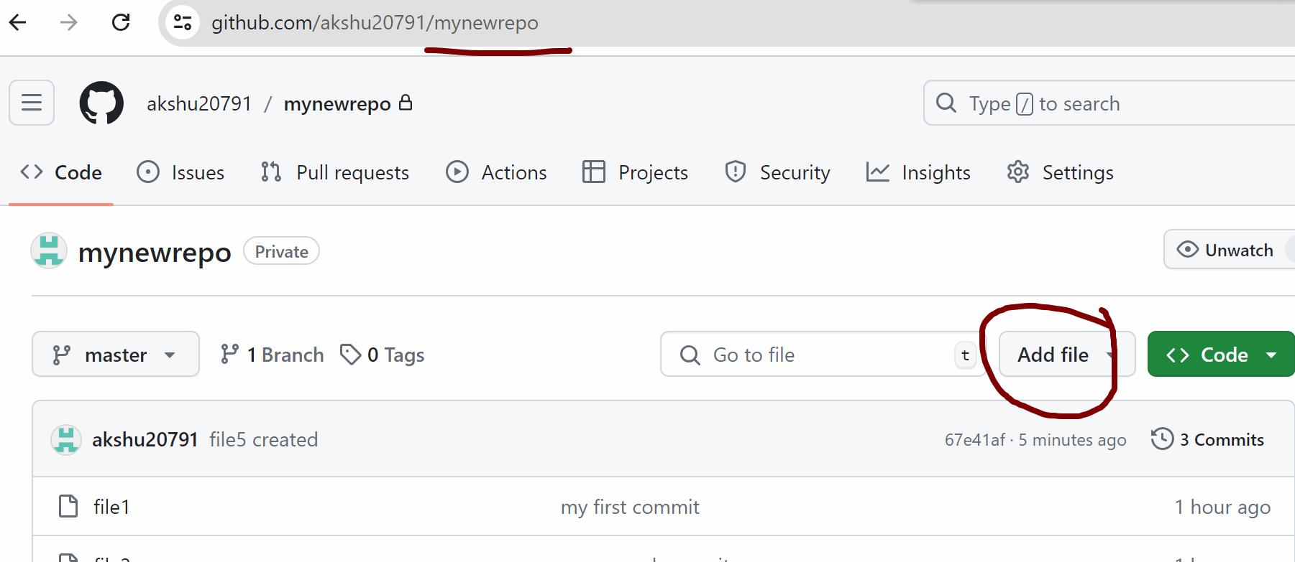

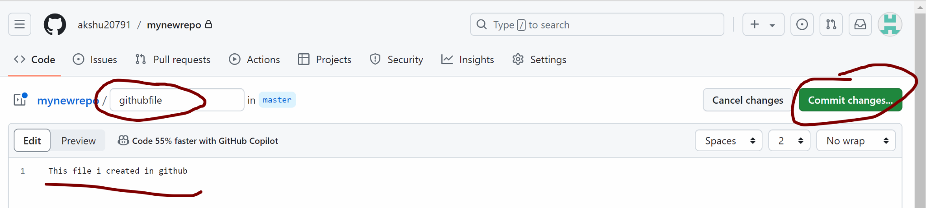

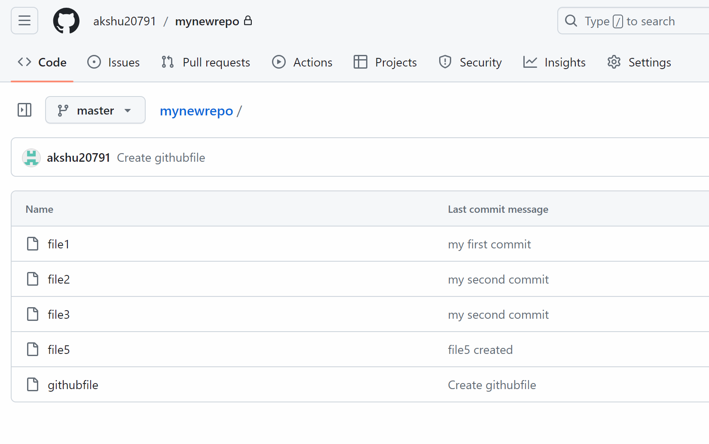

In github we have a file with name githubfile which is not present in our local repo as we created the same from github

Now lets suppose are unaware of this file:
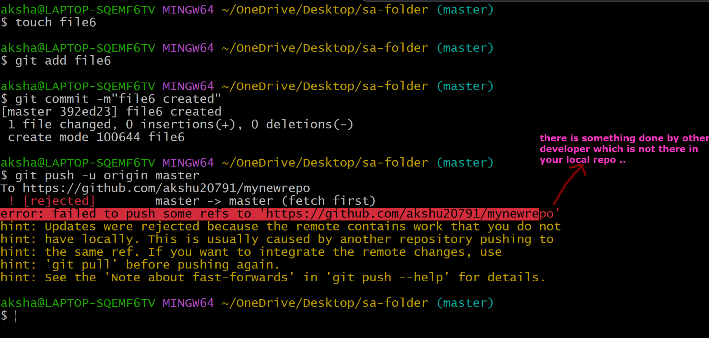

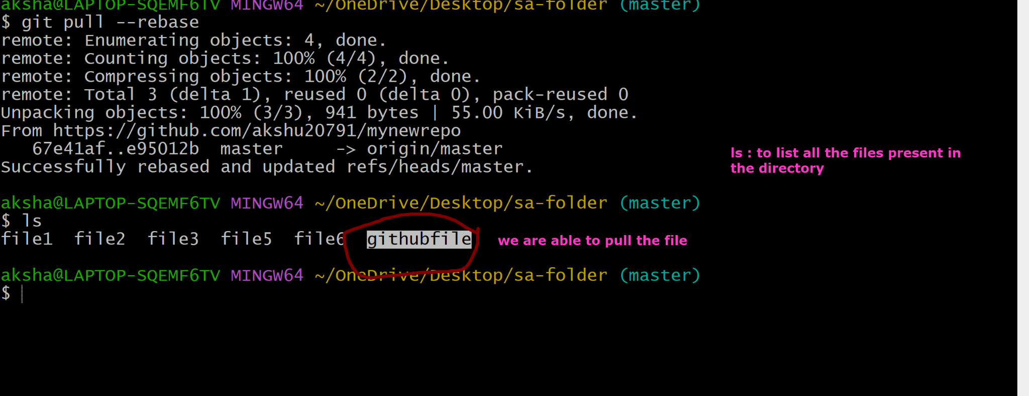

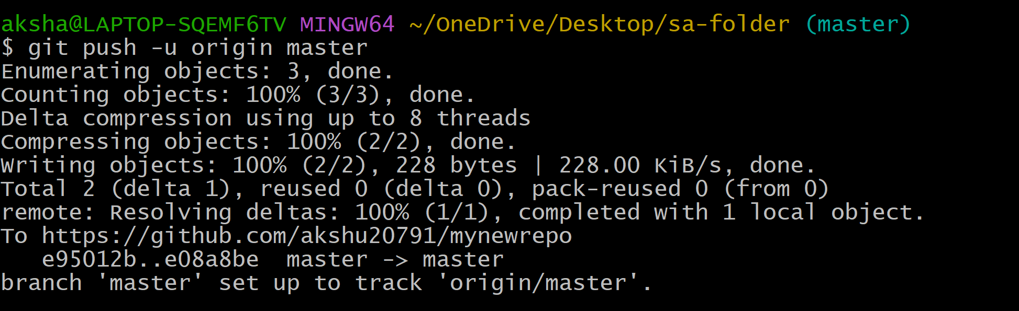

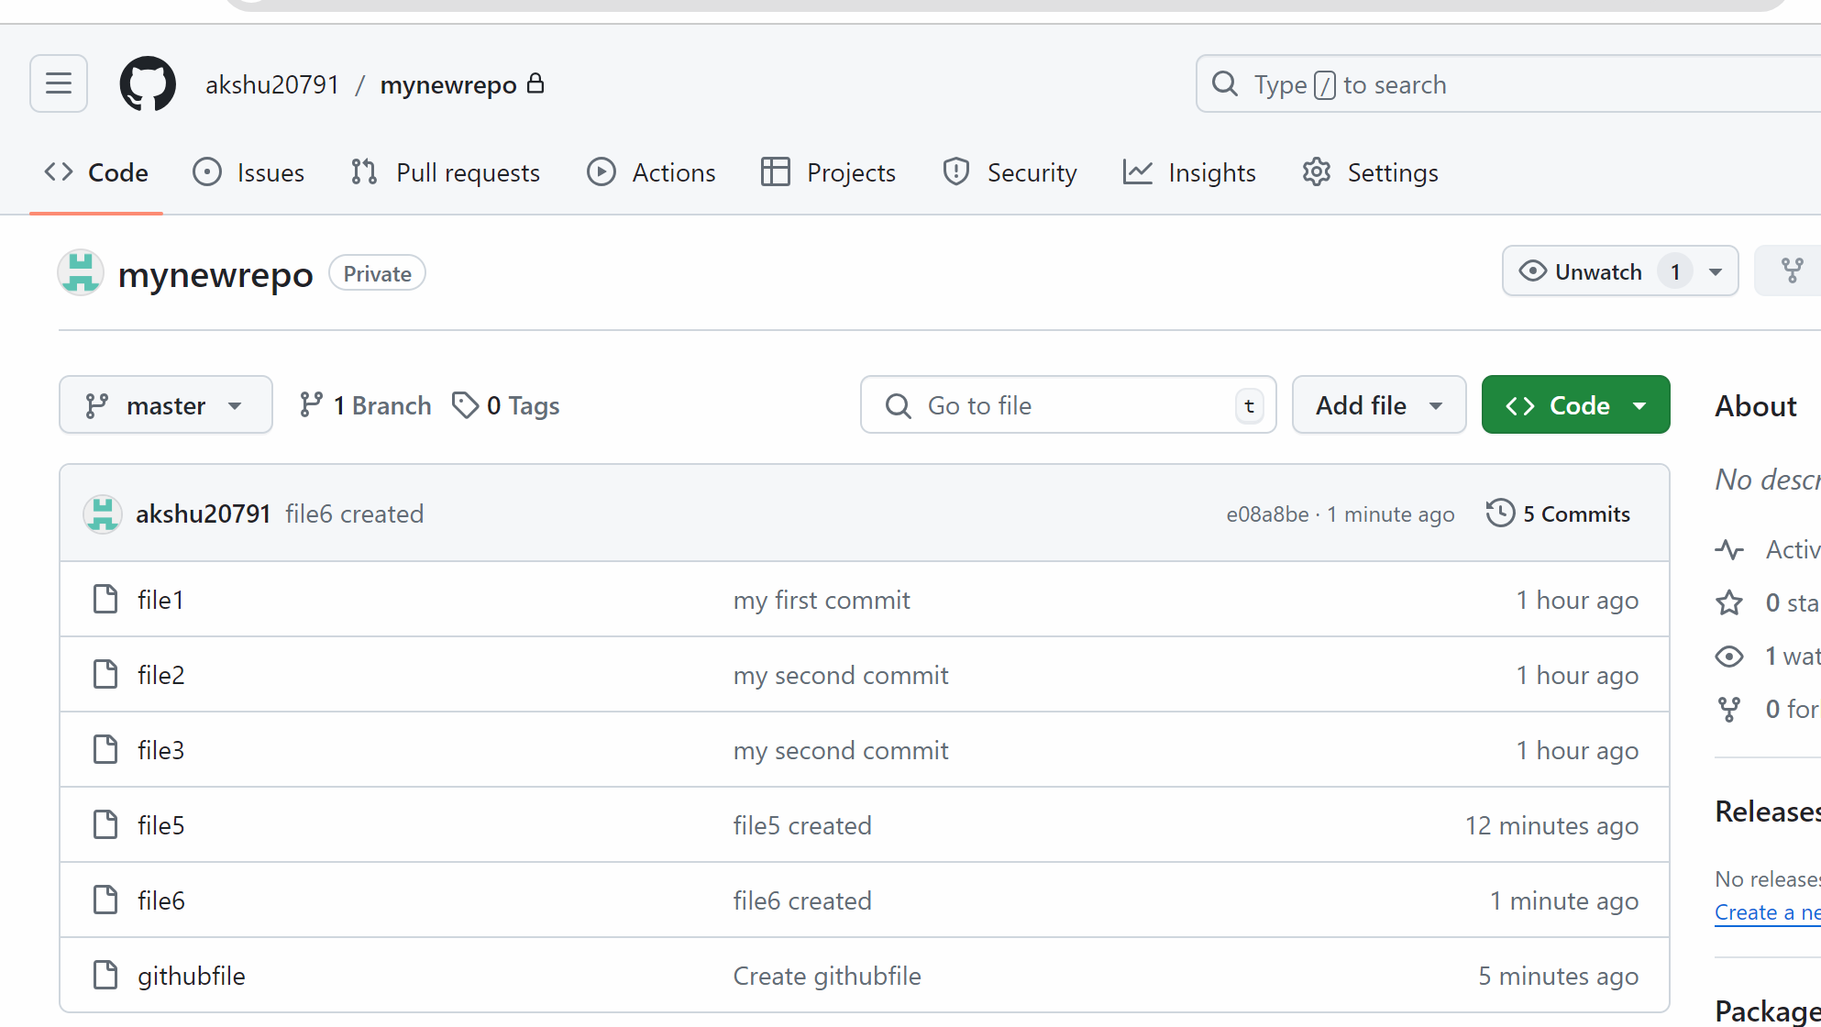

################

### BRANCHING CONCEPT 👍

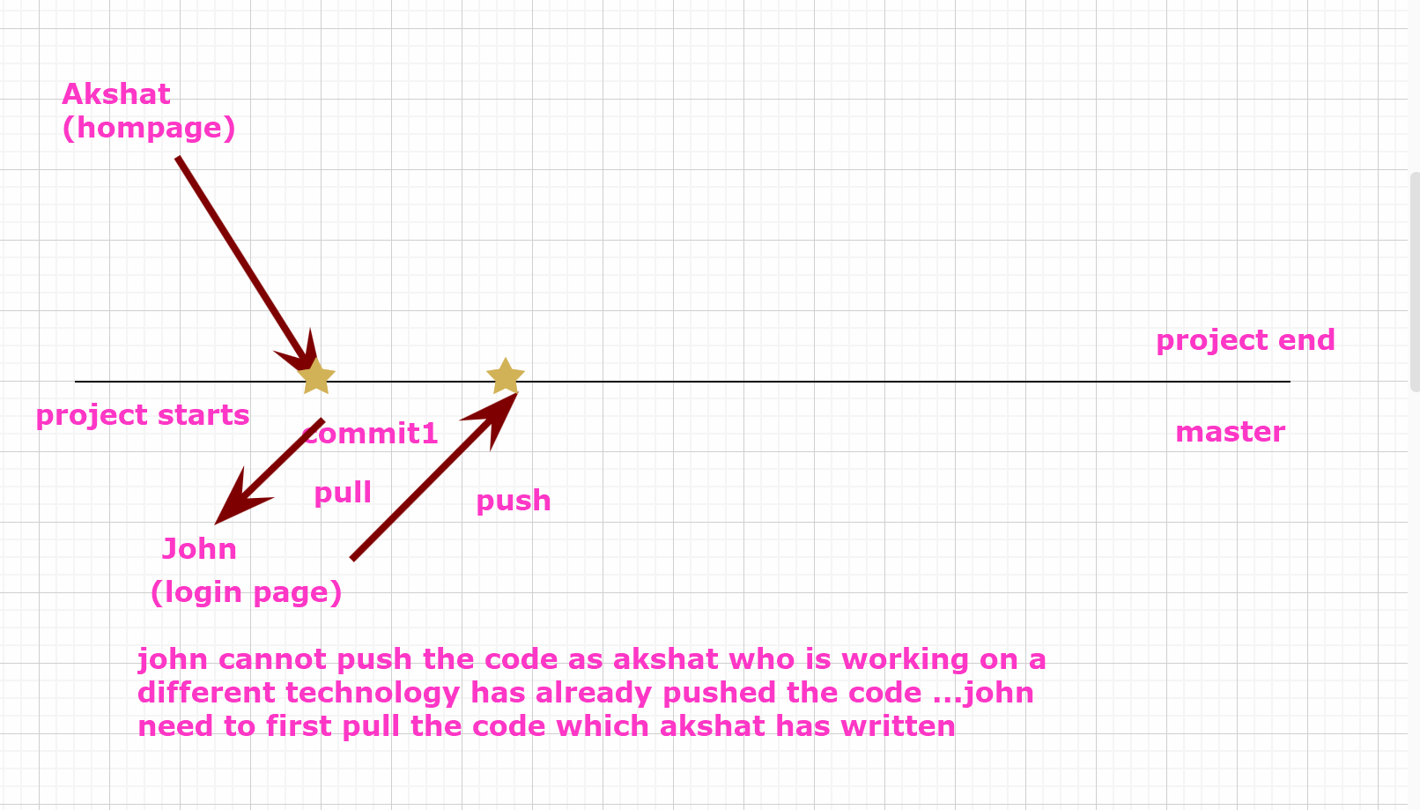
A branch in git is like a separate path or version of your project …
Think of it as a parallel universe where you can make the changes , add features, or fix the bugs without affecting the main project ….

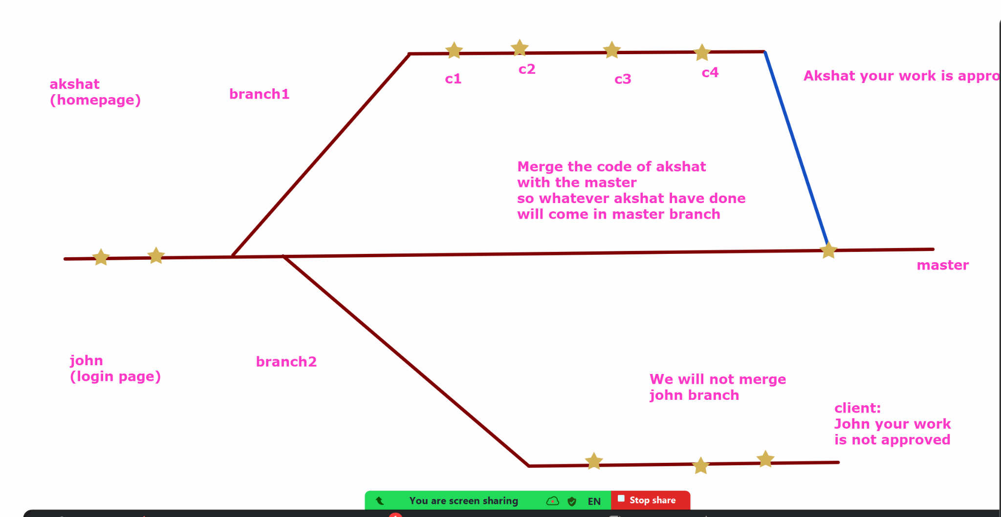

We can also switch between the branches to work on different parts of our project.
If the client approves the changes we can merge the changes to the master branch …which is the final branch where the final deliverables would be taken care of

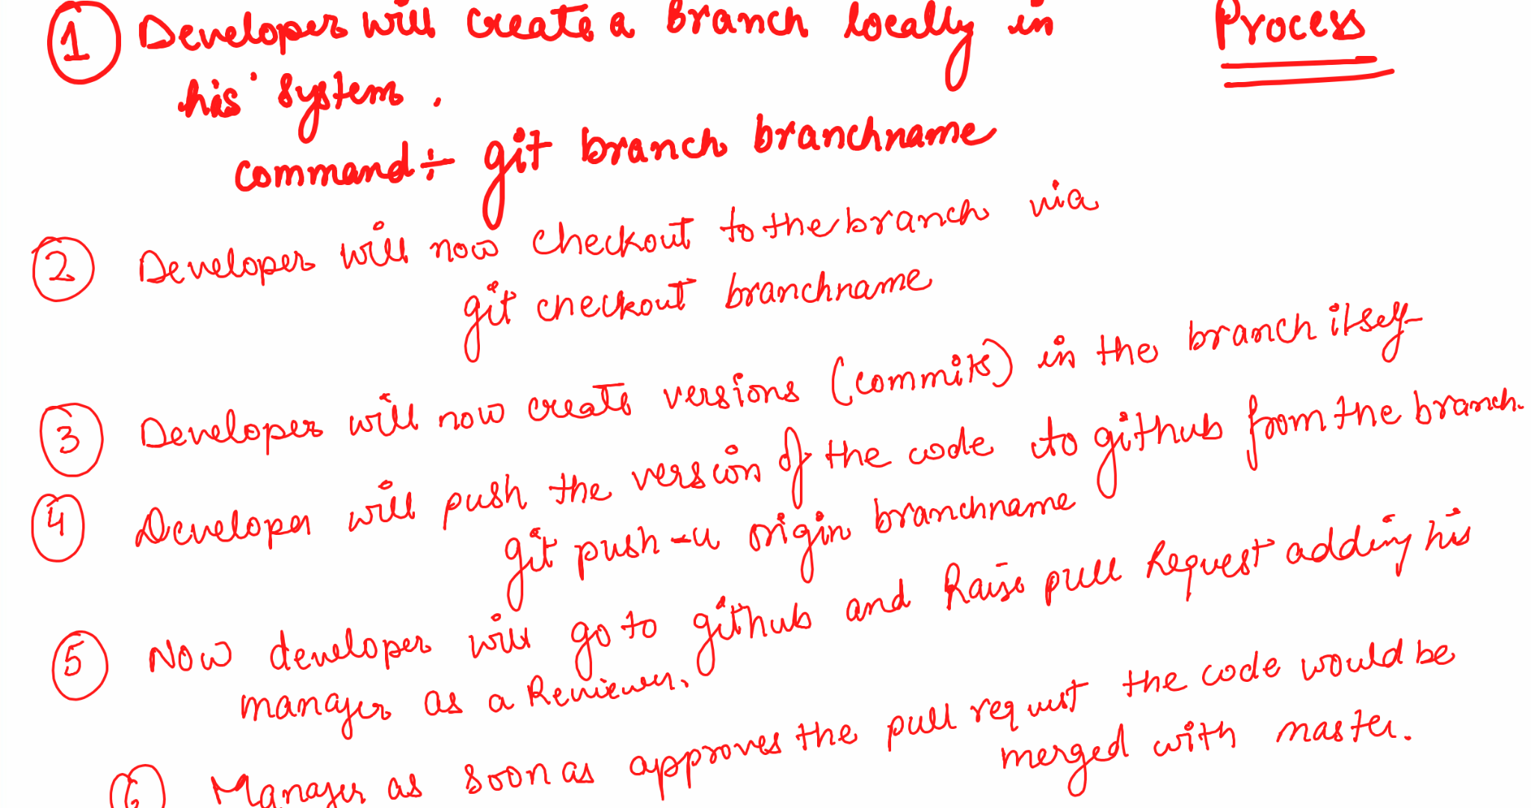

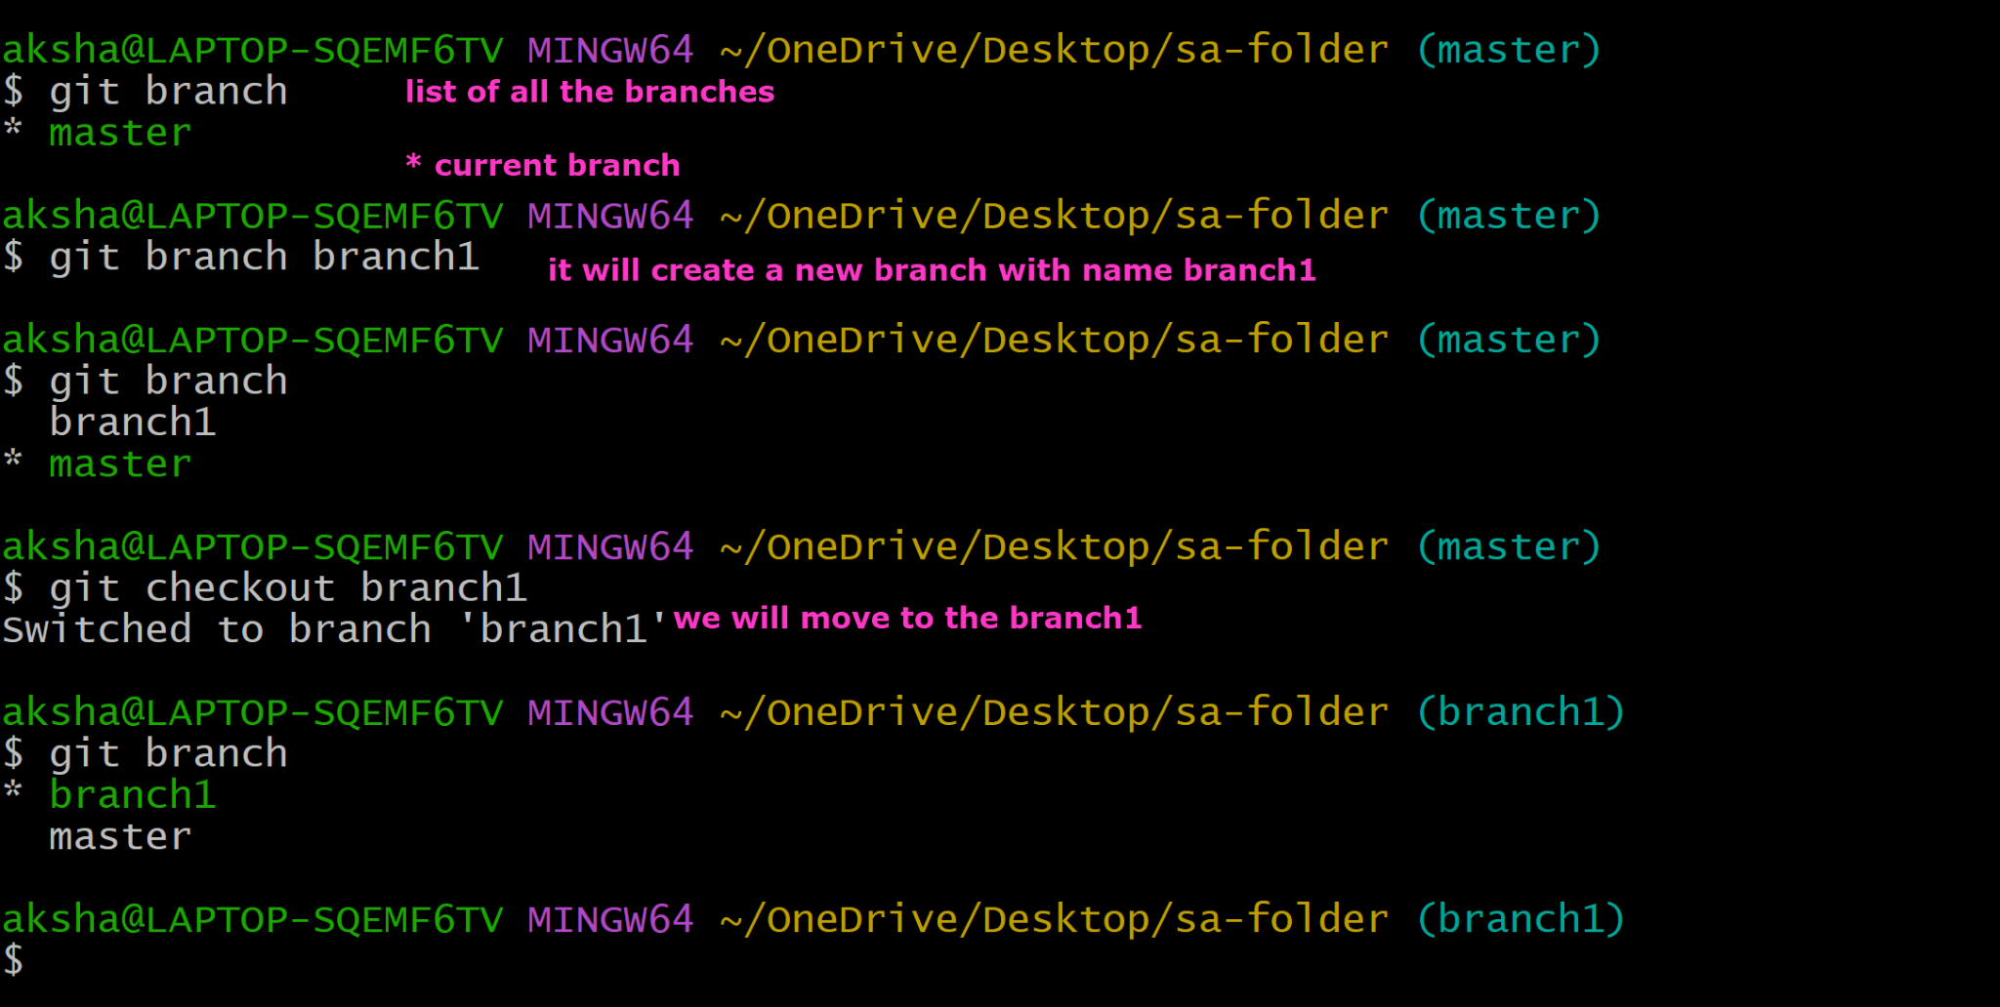
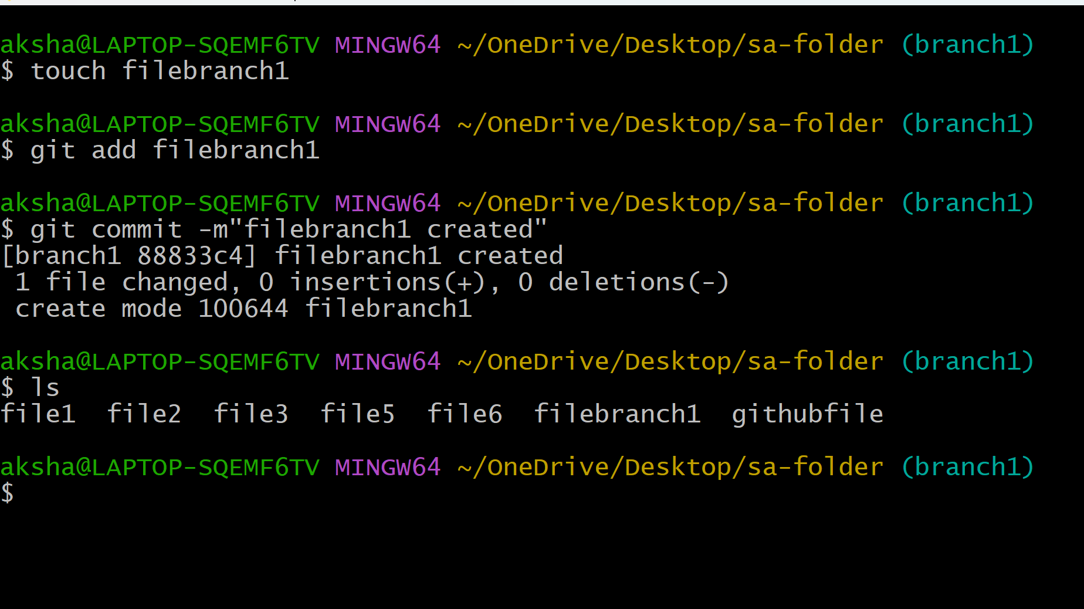

Now if we checkout to the master will the filebranch1 would be there or not?

No it will not be

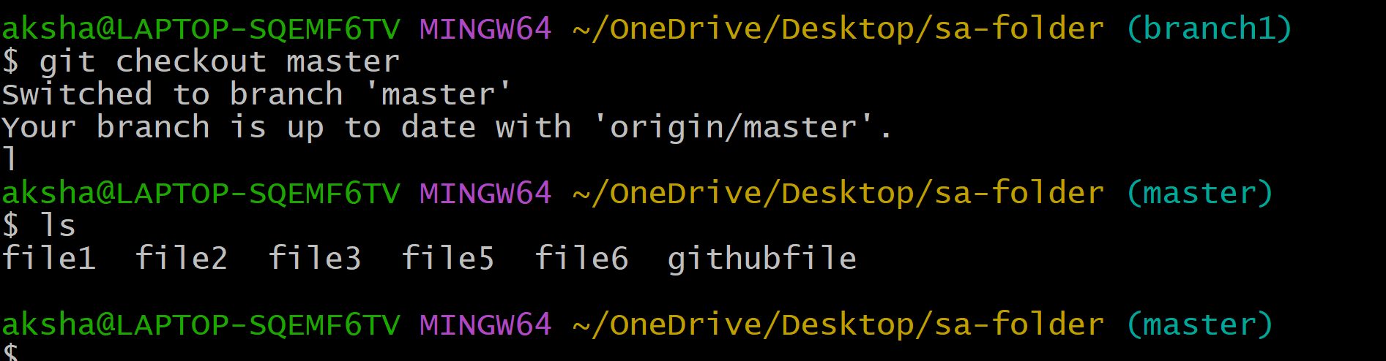

Since the branches are isolated with each other you will not see the filebranch1 created here

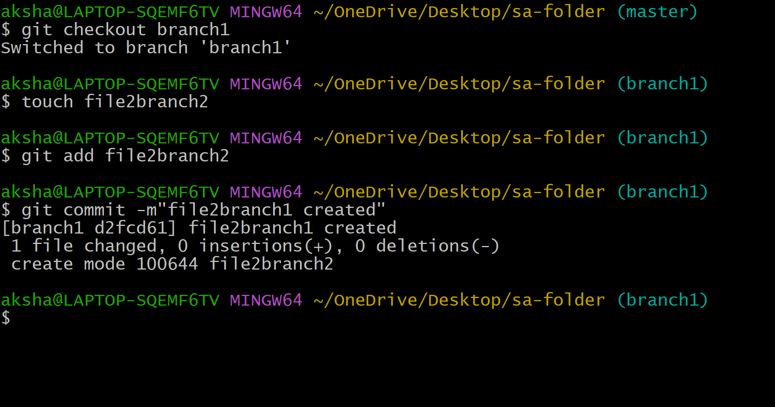

I want to push the code from branch

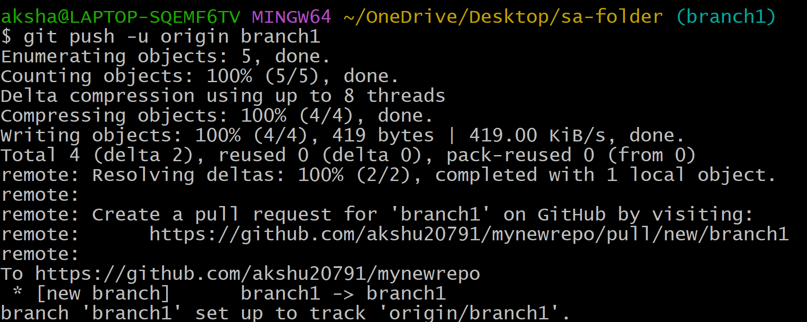

This branch will automatically be created on my github

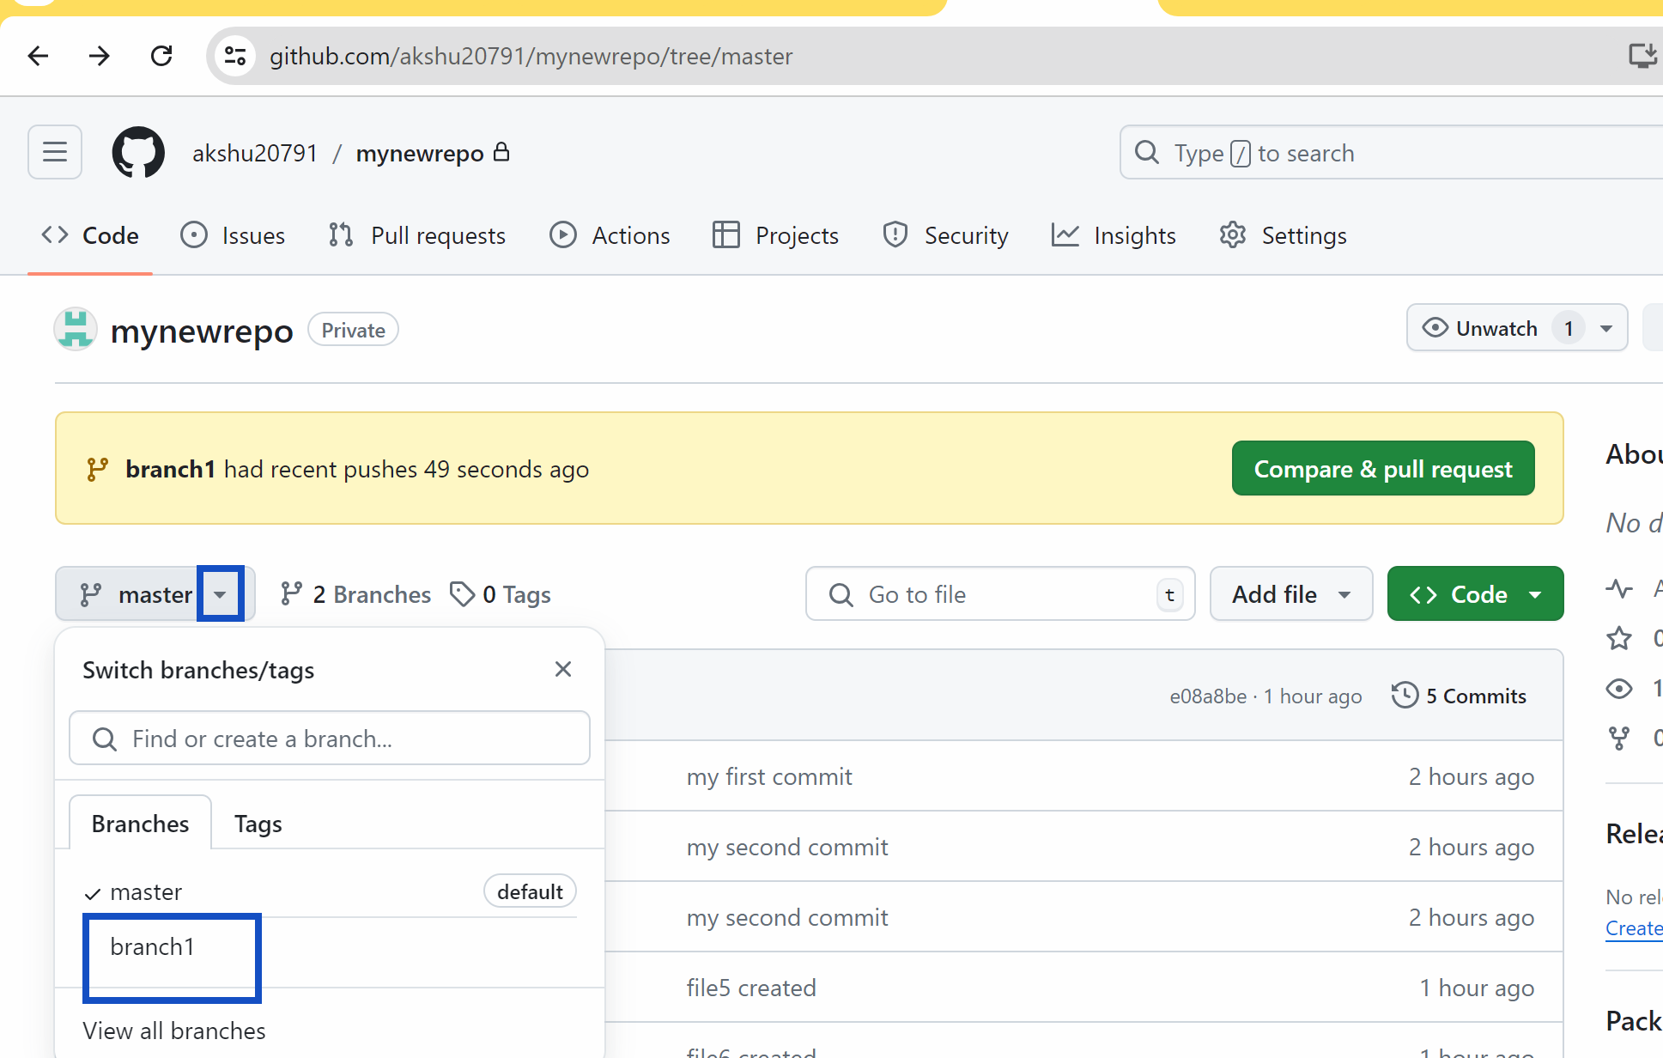

### Now consider you are developer and you pushed the code to github in your branch….now after the approval from the client and manager on your code you need to raise a pull request

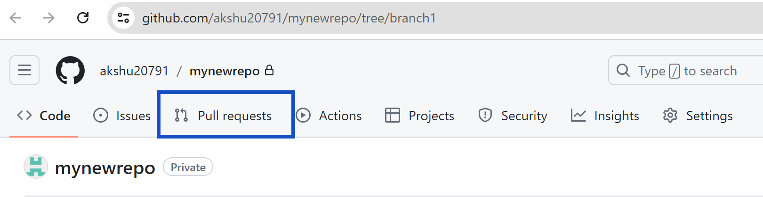

New pull request

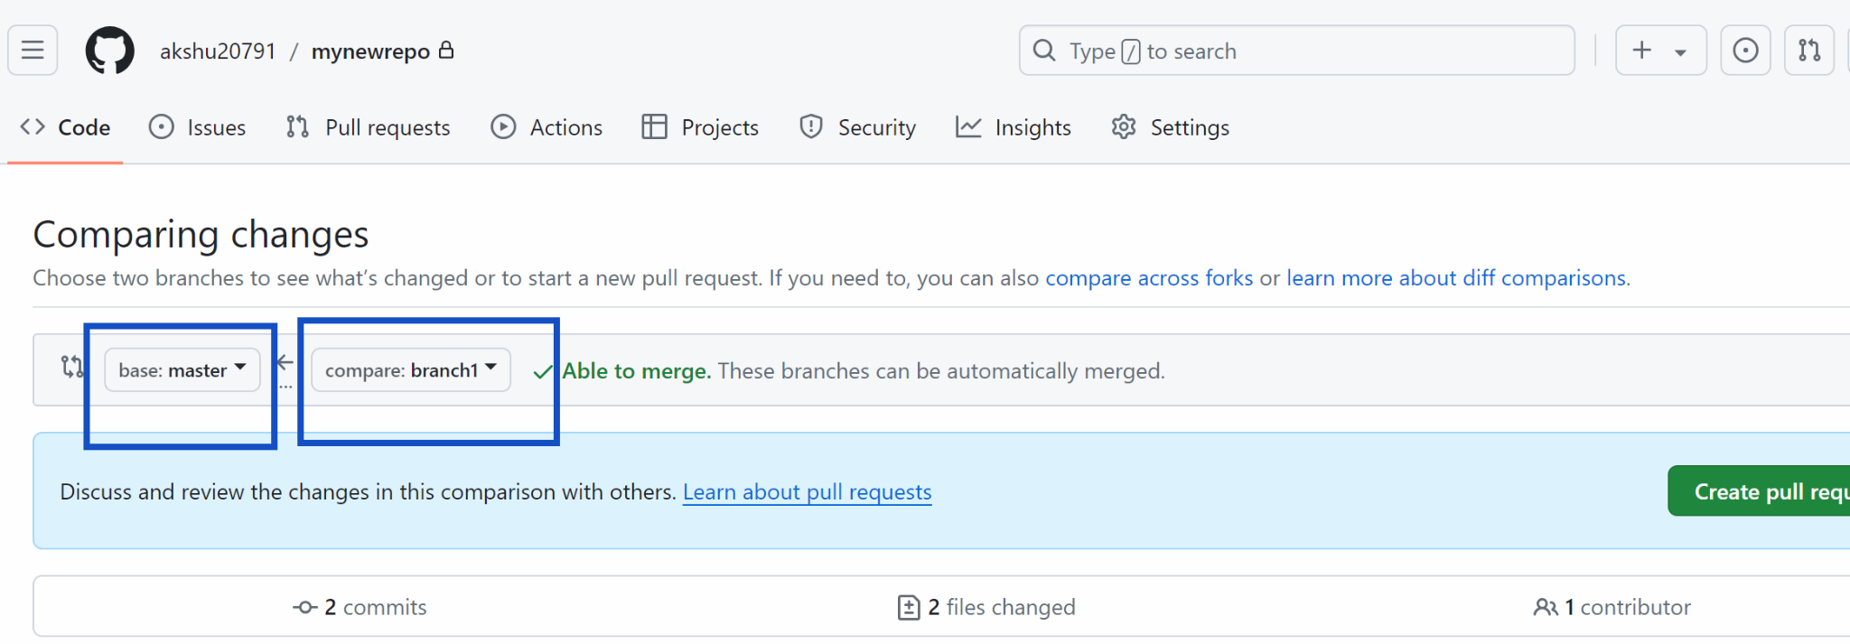

Create pull request

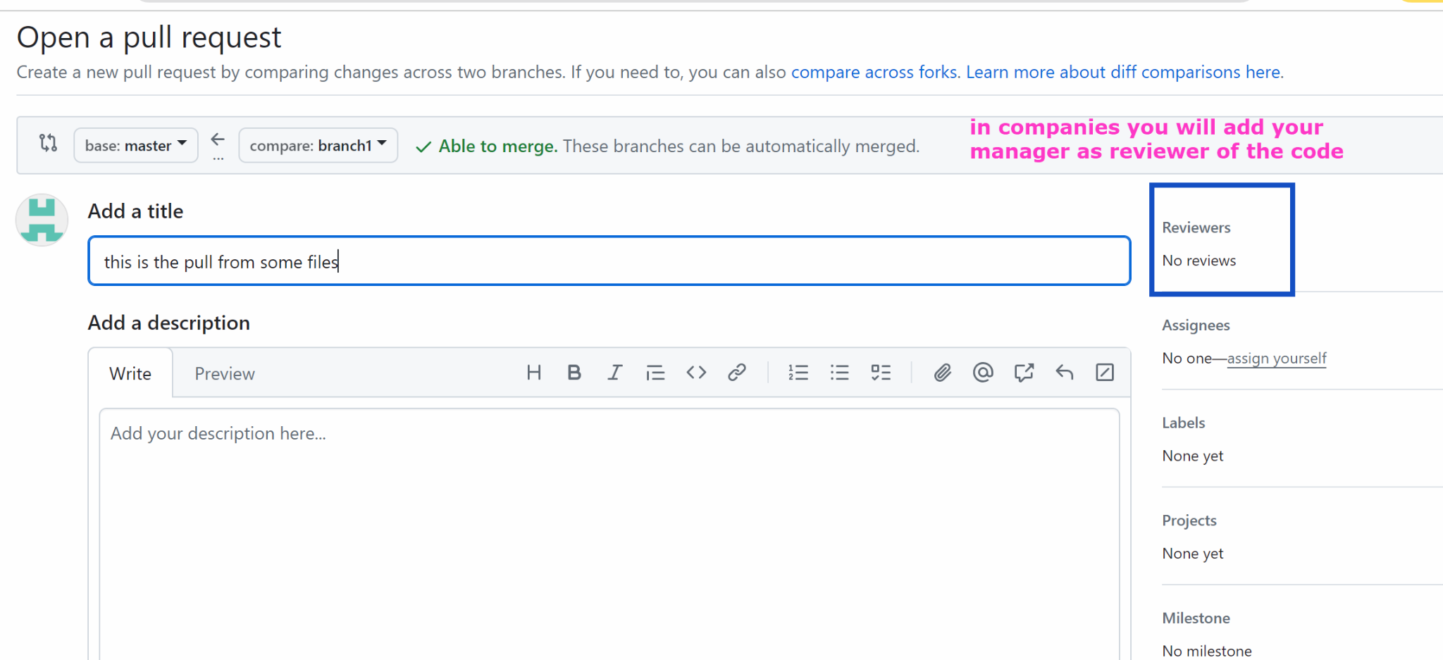

Create pull request

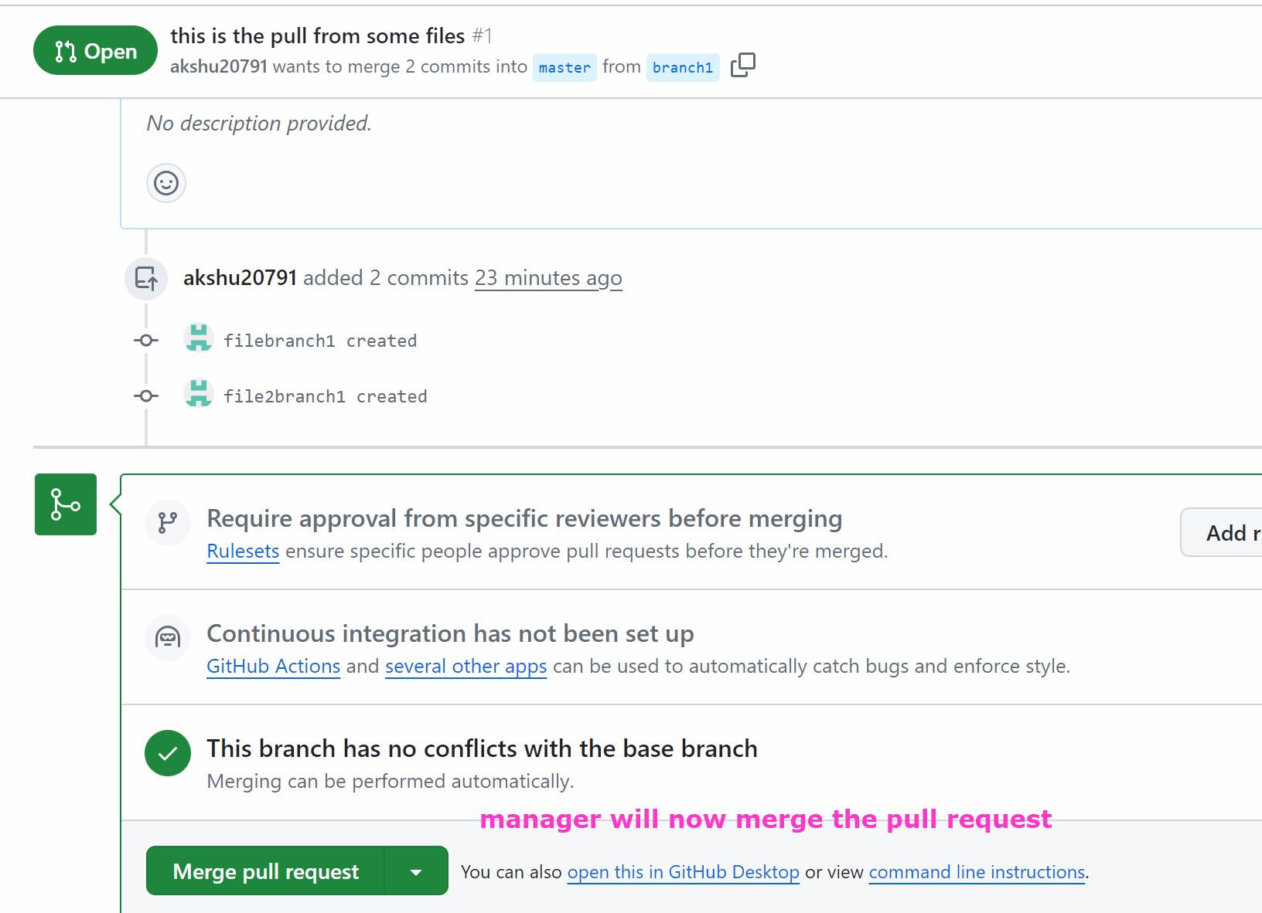

Click on merge pull request

Confirm merge

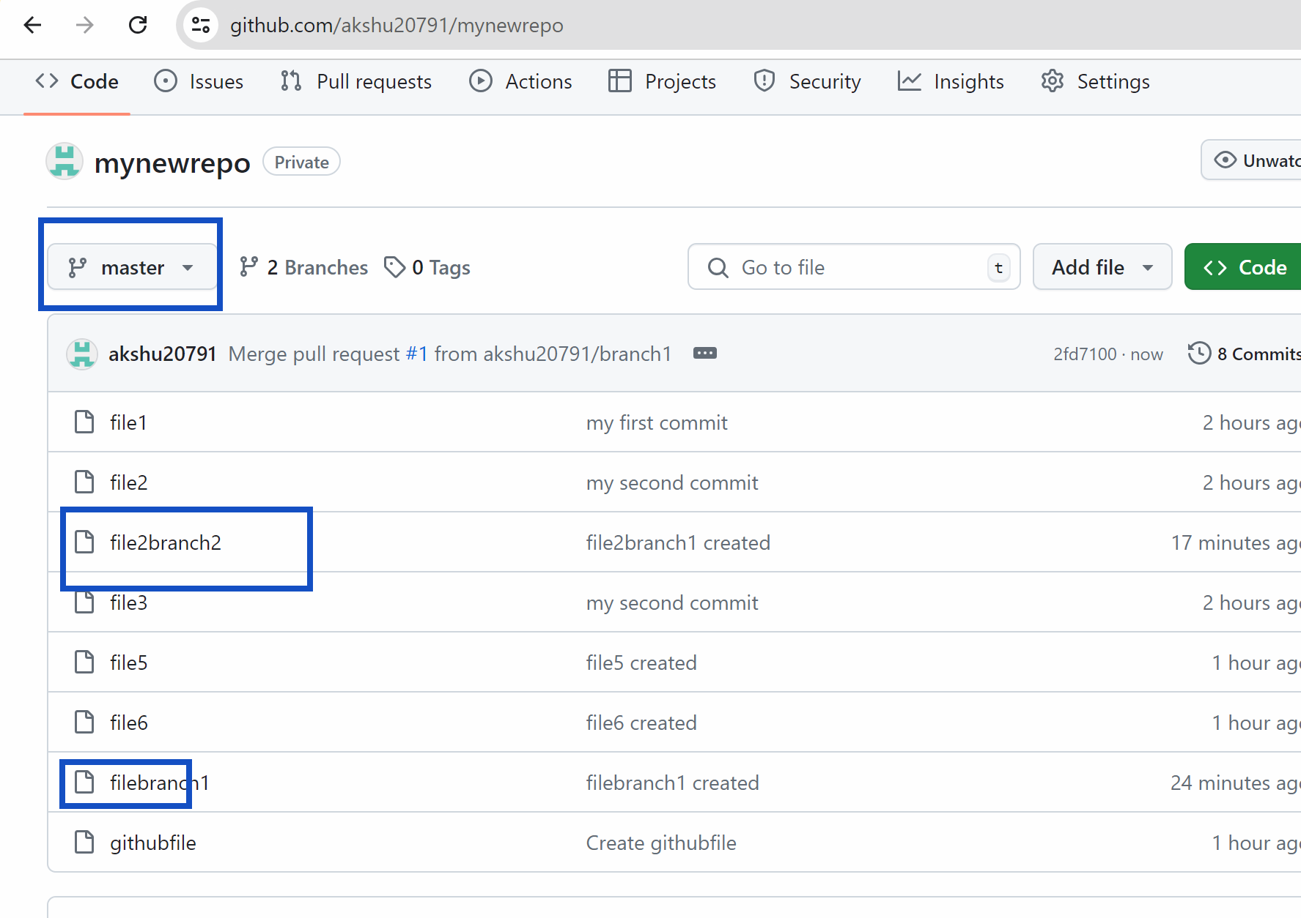

The files are now present in master branch

#######

- Create a ubuntu machine…install git ….create some commits …..create a private github repo…and push those commits in github repo …in master branch only

Perform this question

##############################

Code pipeline : It is the step by step by process via which we can automate the project deployment

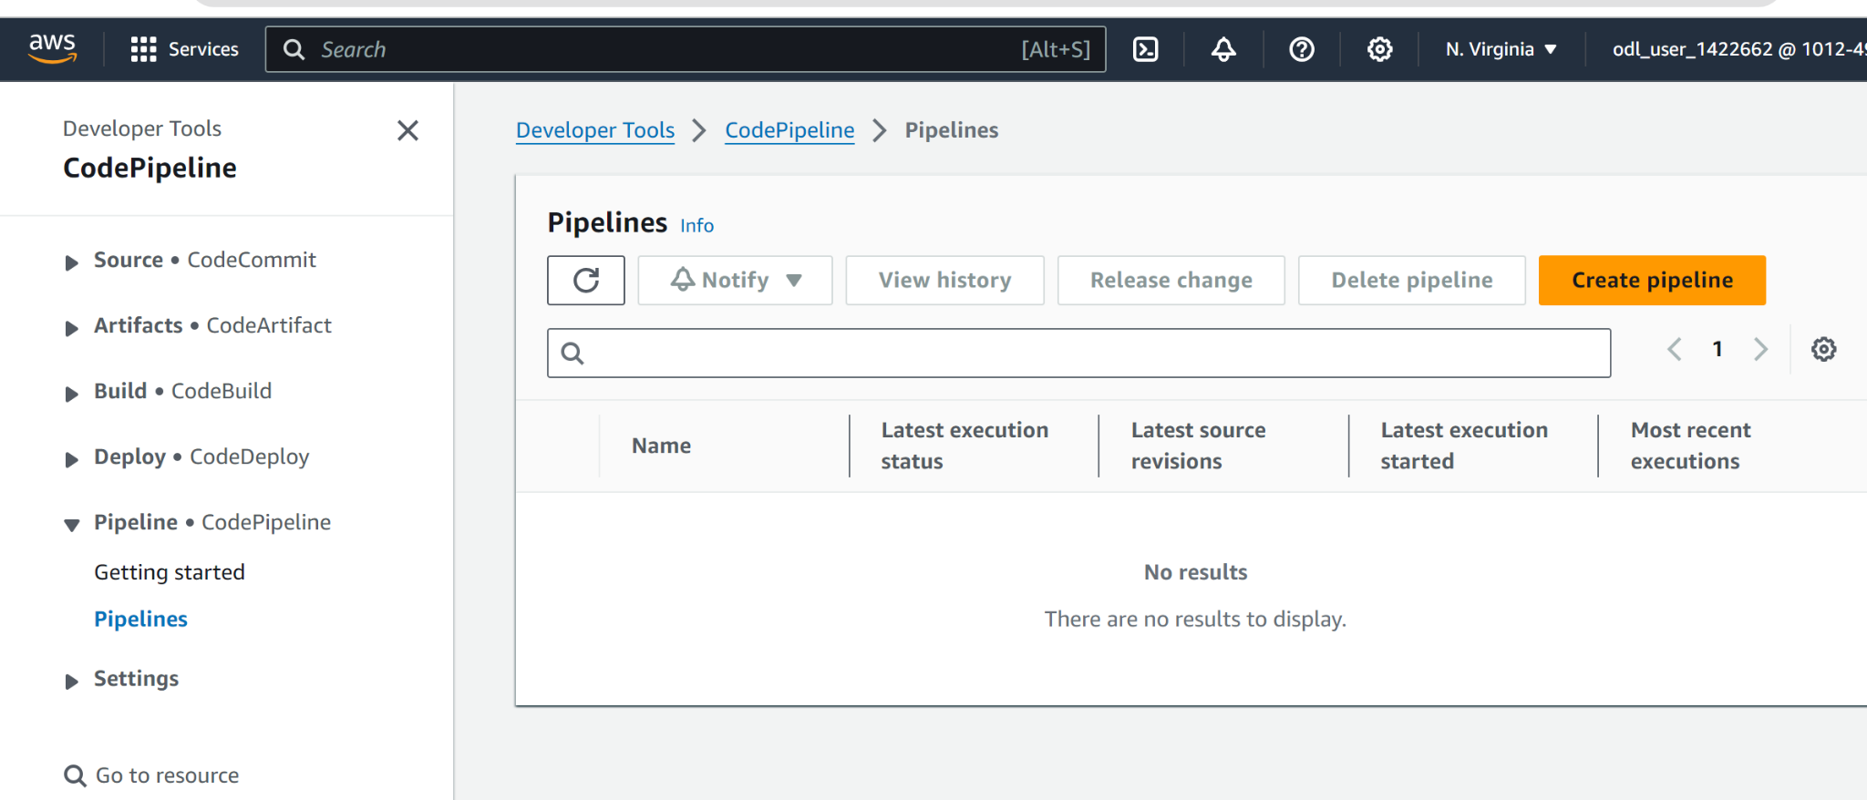

Click on create pipeline

Select custom pipeline
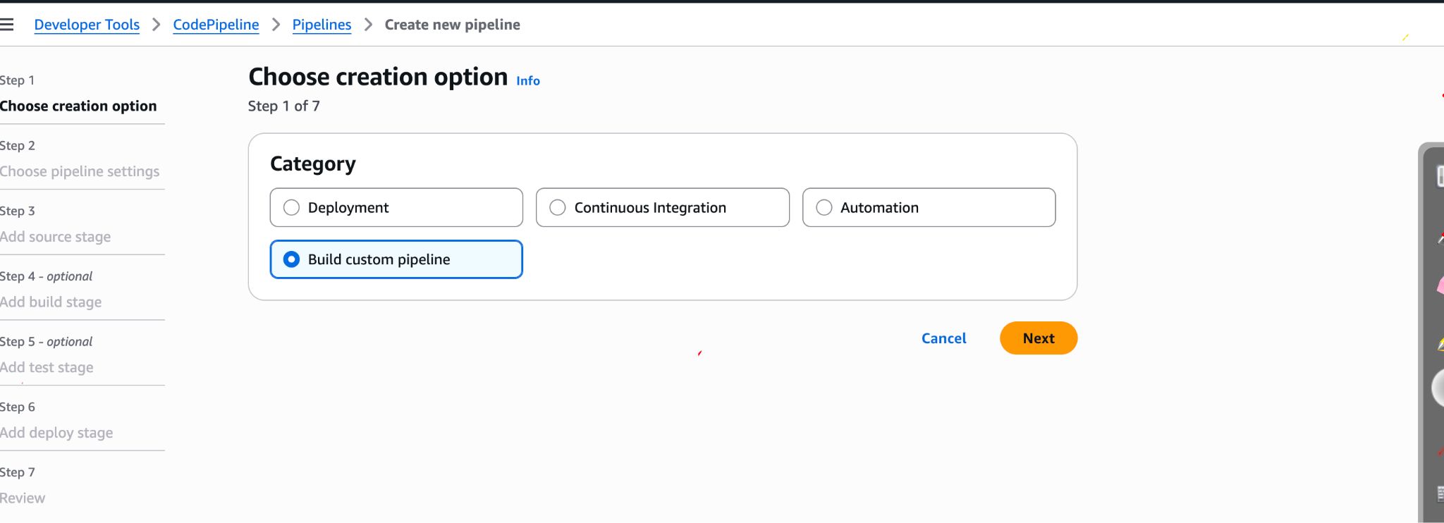

next
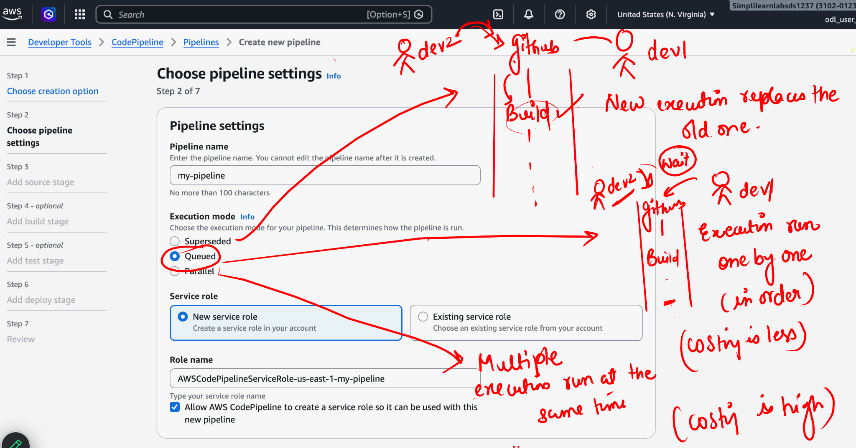

Name your role name

Next

Open https://github.com/akshu20791/apachewebsite

Click on fork button

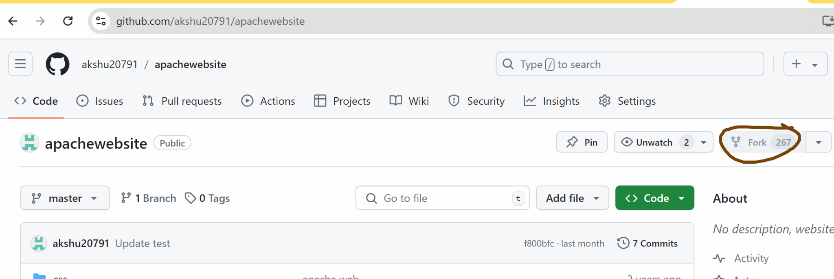

Go back to your code pipeline

Select the source as github Oauth app
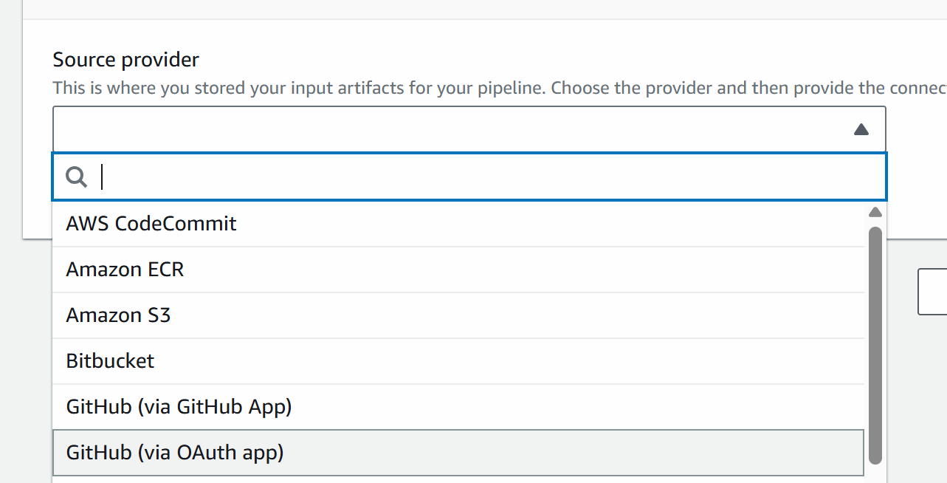

Click on connect
There connect your github account with the aws code pipeline

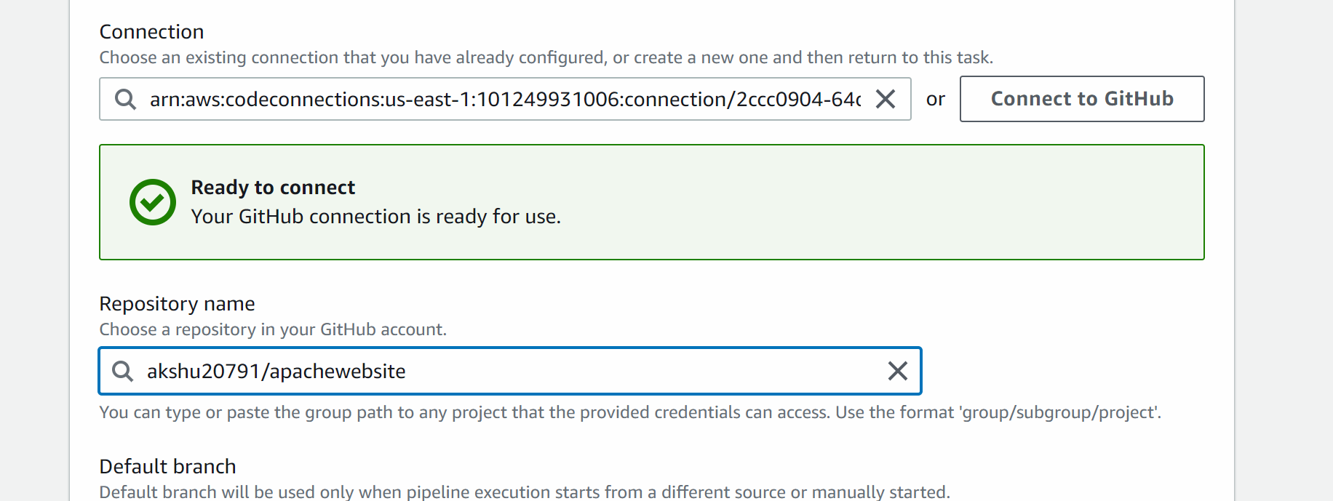

Next

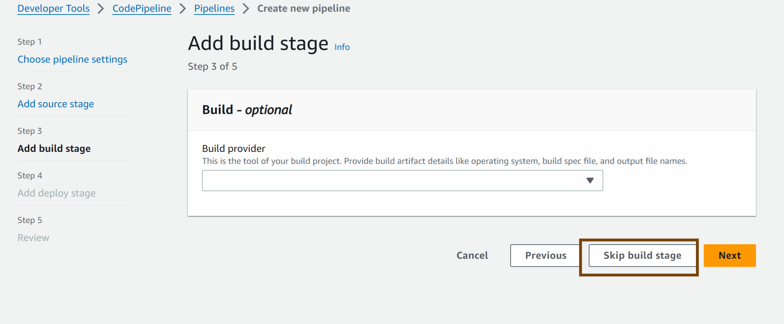

Skip test stage

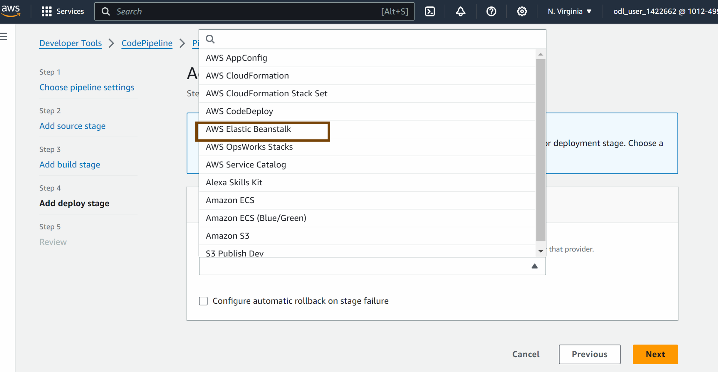

### now we need to first deploy the sample app on elastic beanstalk which can be connected with my pipeline

ELASTIC BEANSTALK

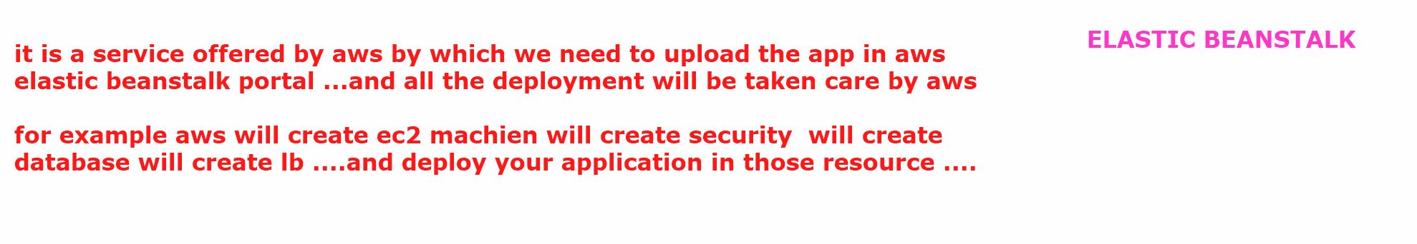

Lets deploy the sample php application on elastic beanstalk

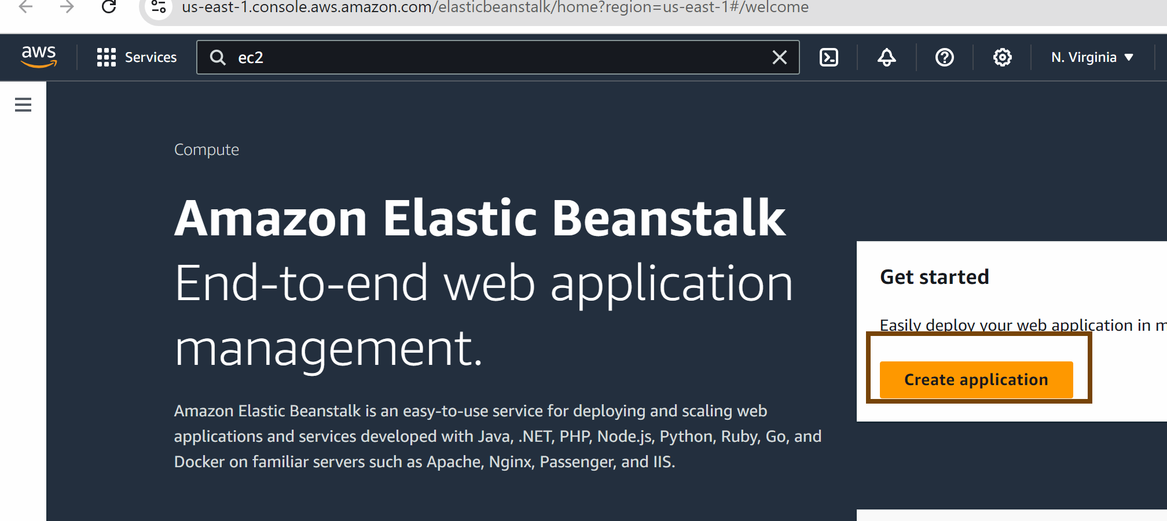

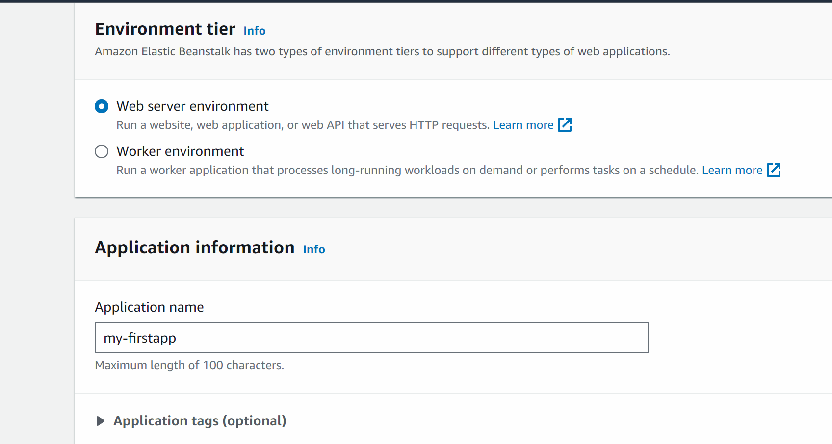

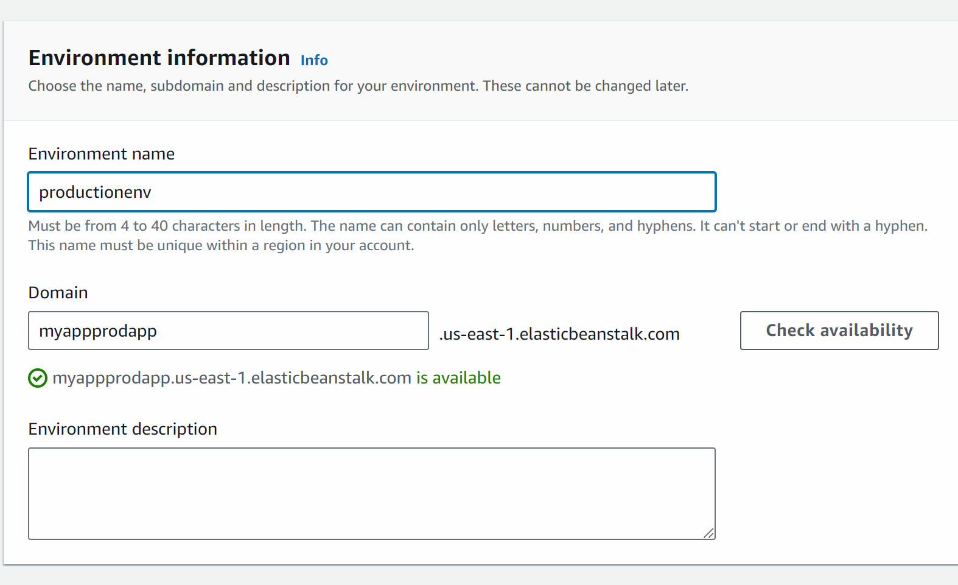

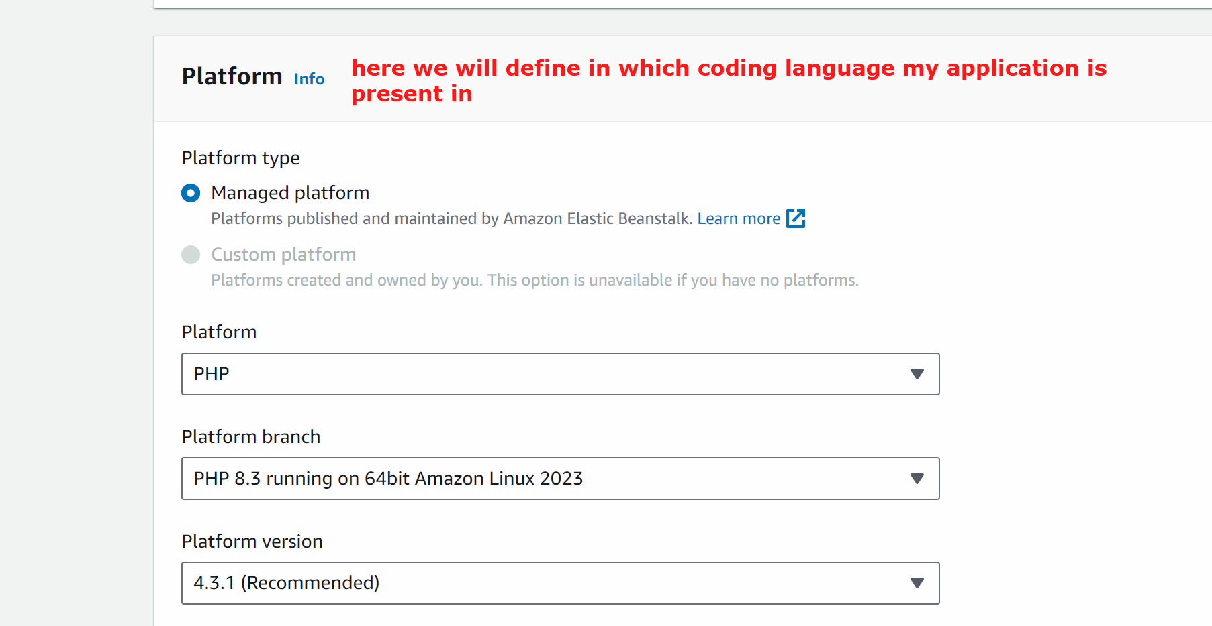

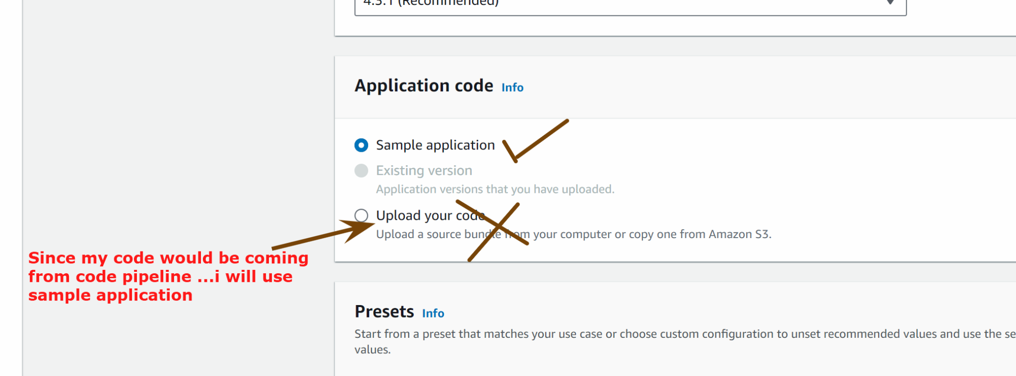

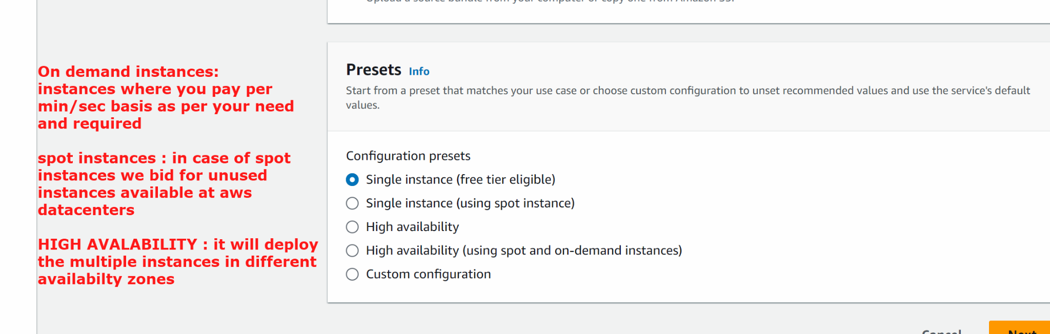

Next

In front of service role -> create role
Next -> next -> create role

Go back to elastic beanstalk -> check the role
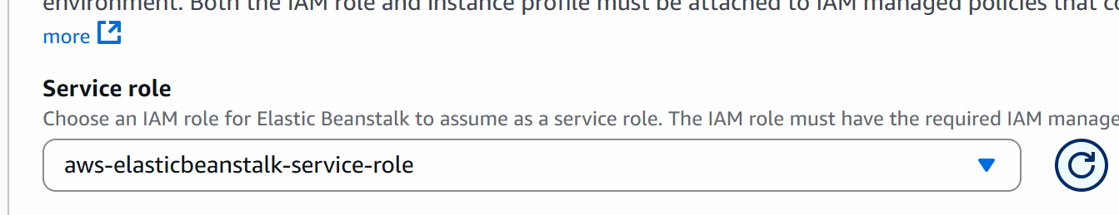

Similarly create role for ec2 instance
Create role -> next -> next -> next
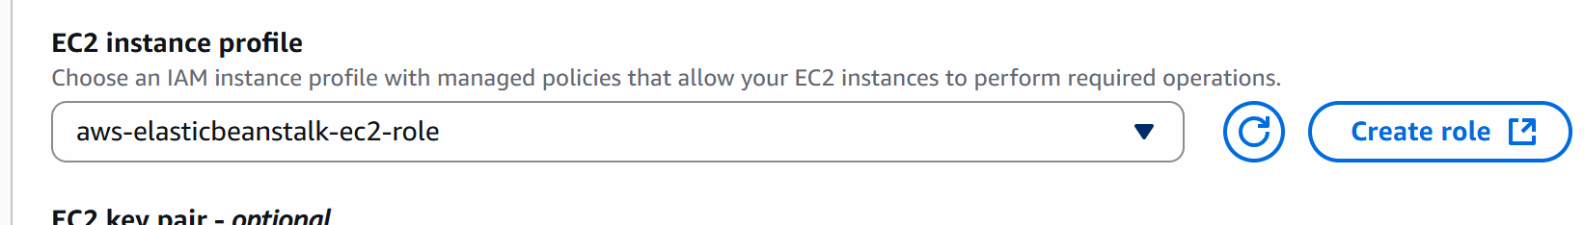

To generate the key pair -> go to ec2 -> create a new keypair
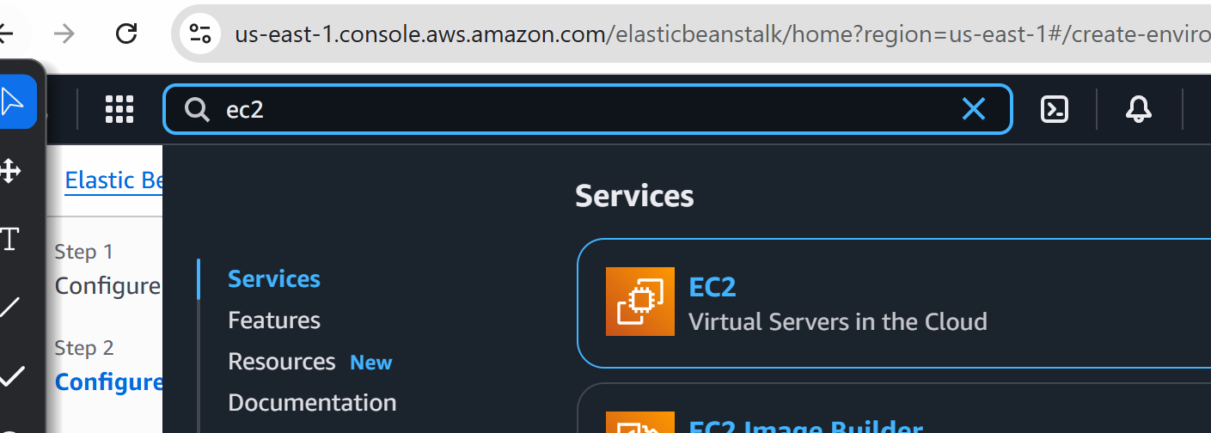

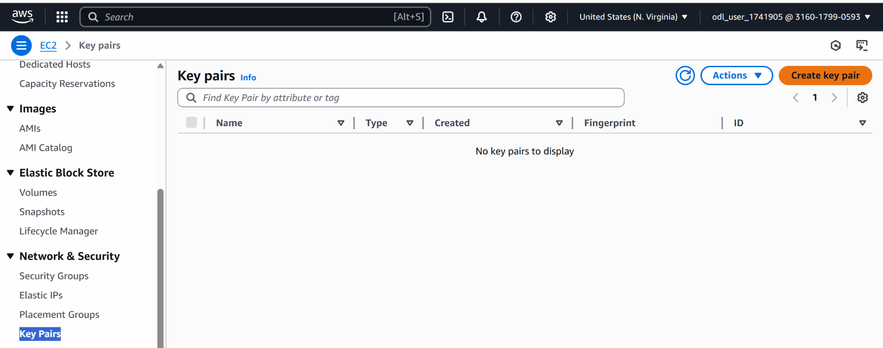

Name the key and create the key pair

Elastic beanstalk:
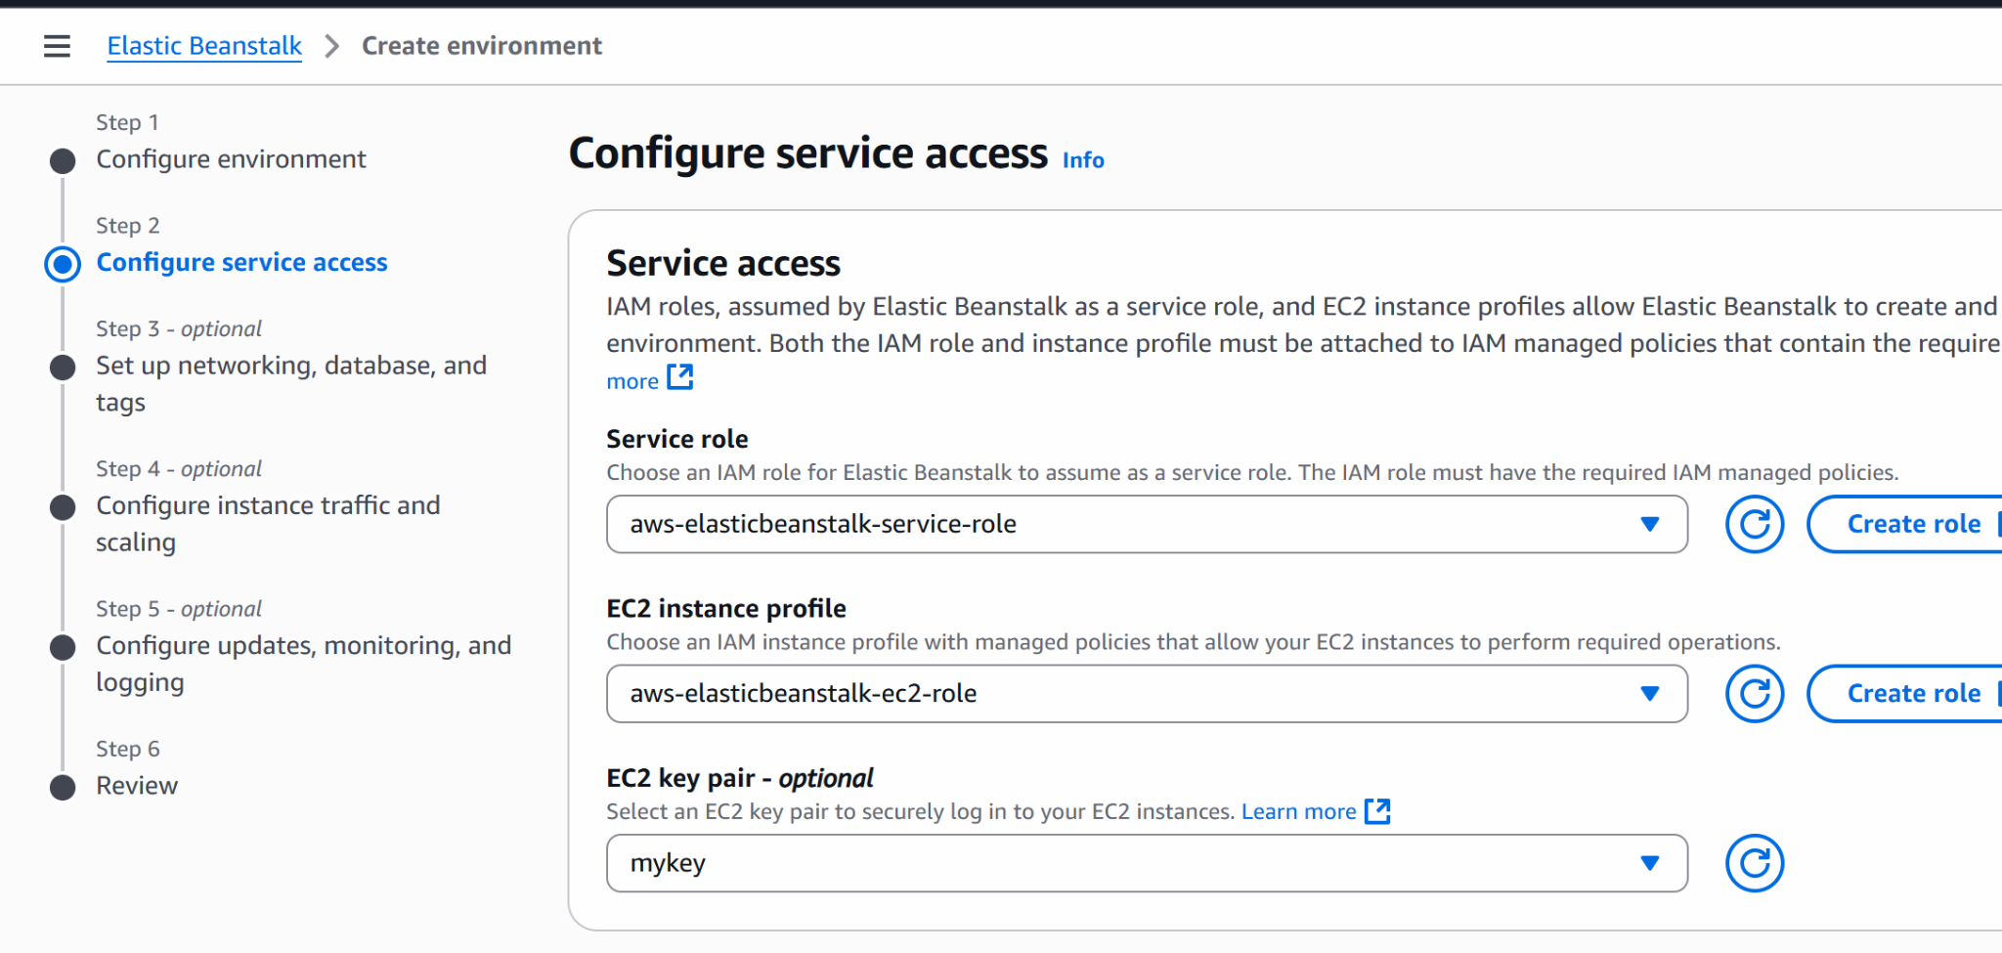

Next

Select vpc from drop down
Tick the public key
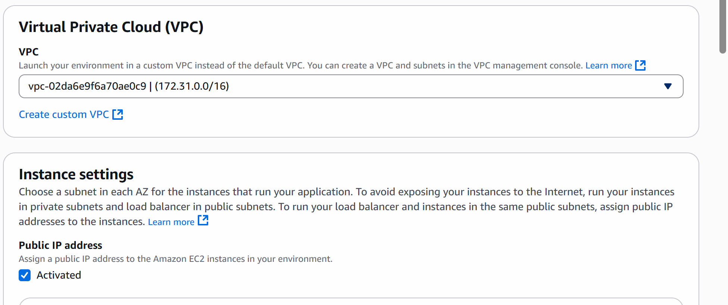

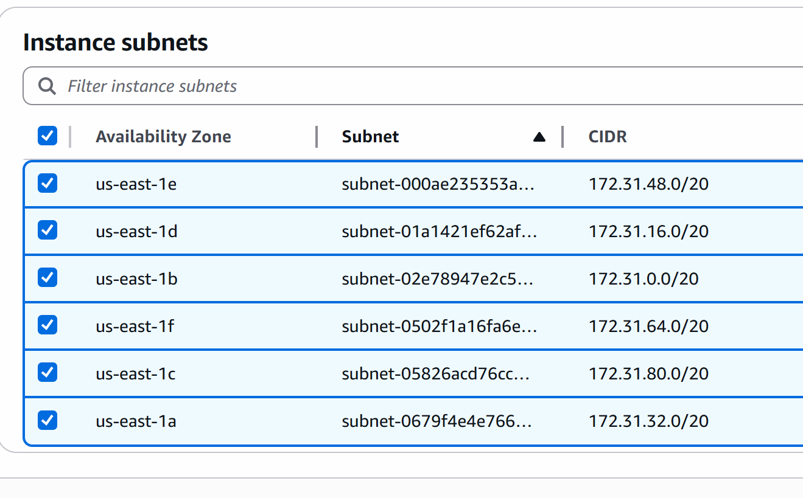

Next

In Root volume type: general purpose 3 (ssd)

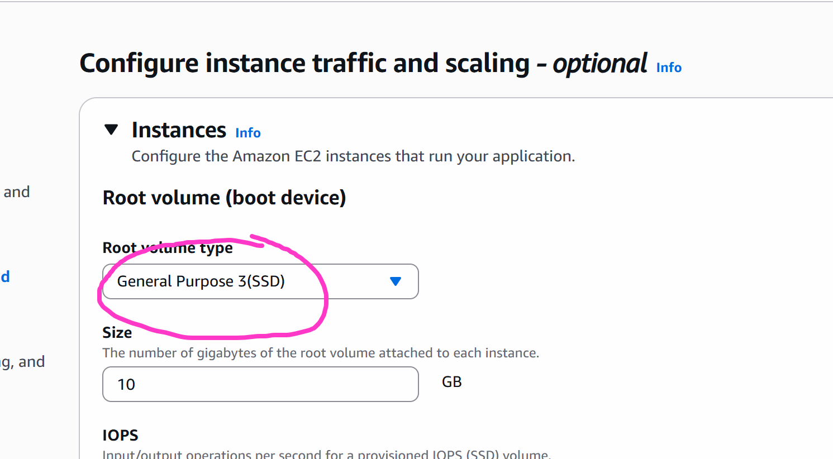

Next
No changes
Next

Create

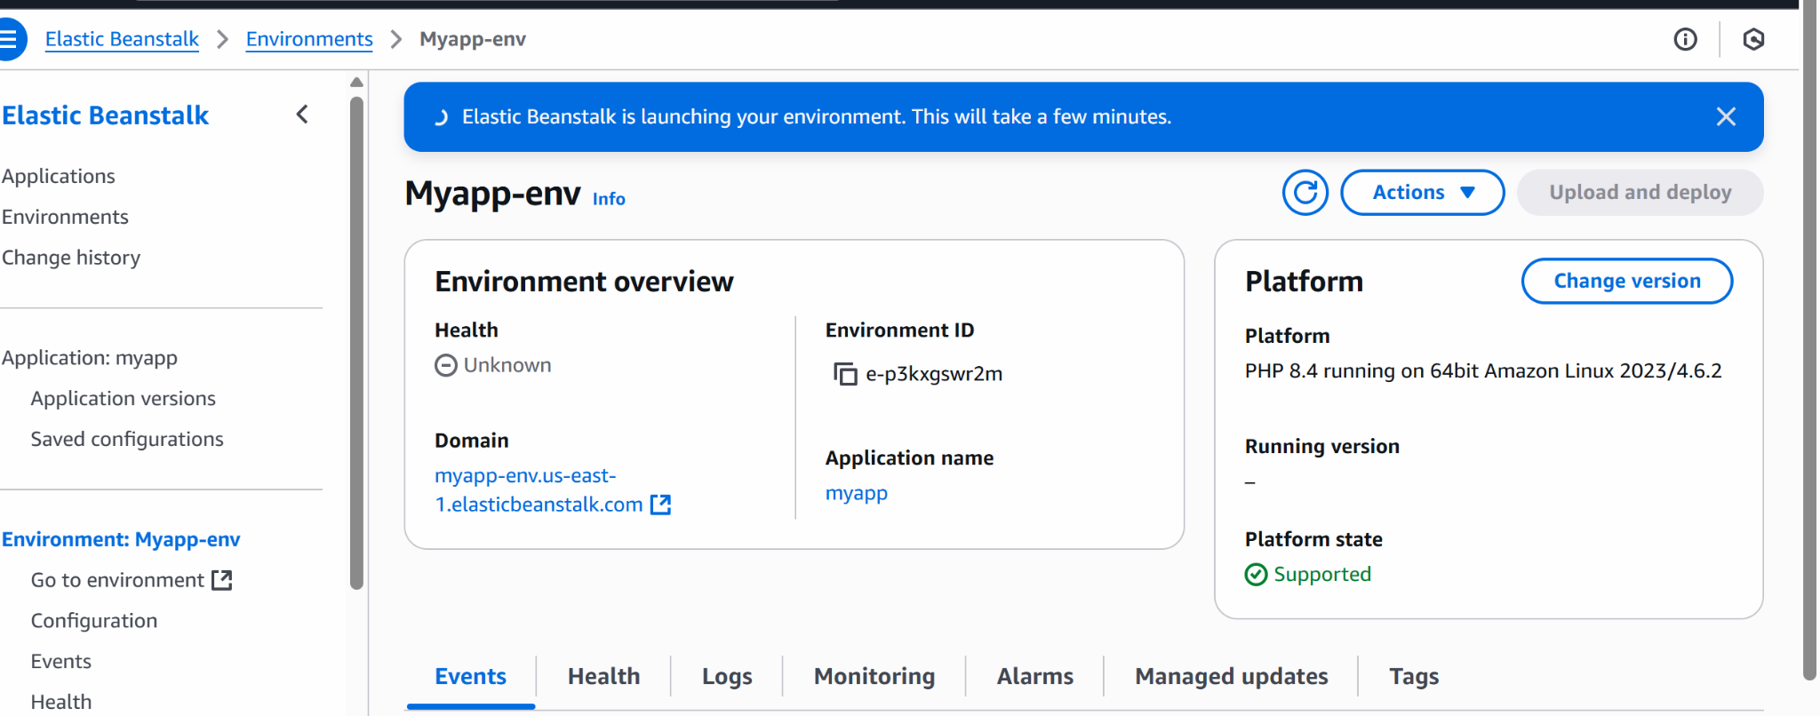

Wait for 5-10 mins

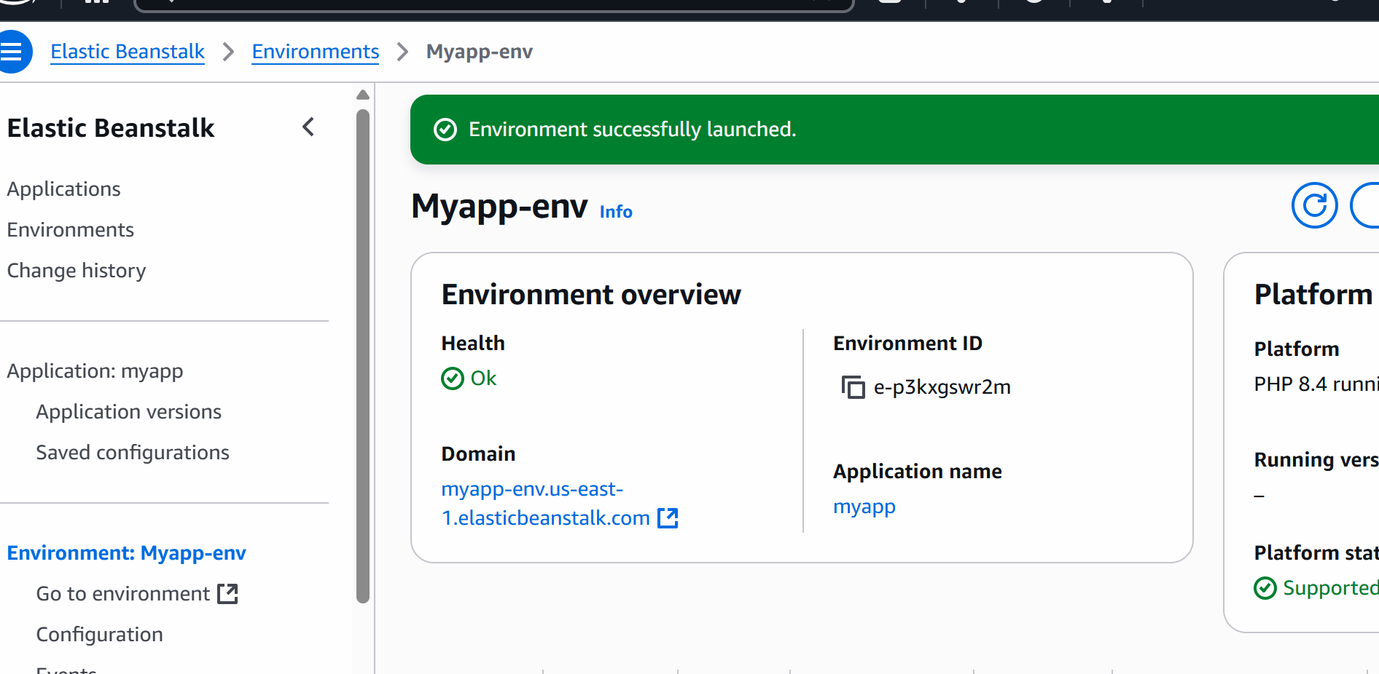

If health is not ok then we need to find the problem

#######

Now lets move back to code pipeline and we will deploy the code to the elastic beanstalk

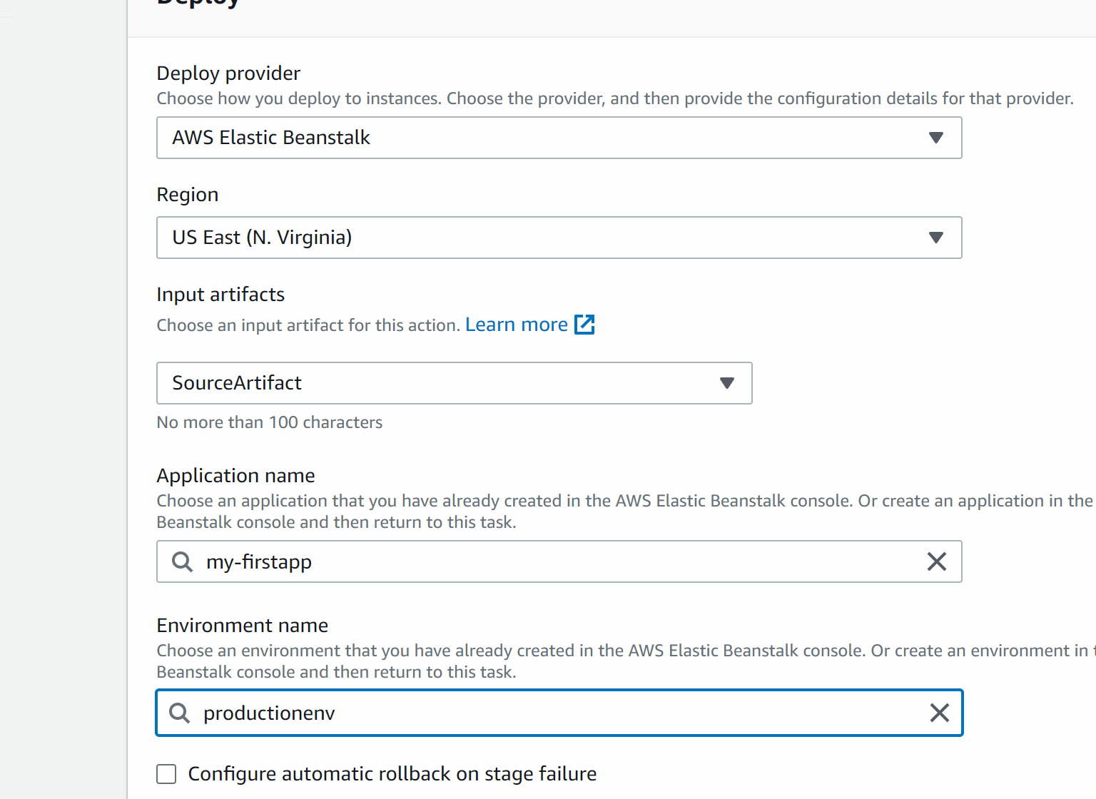

Create pipeline

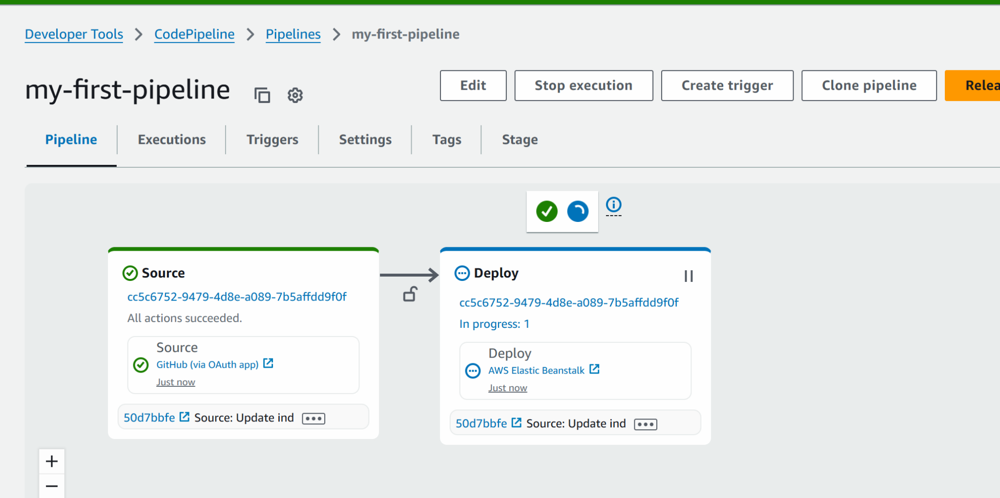
Deployment WILL FAIL
Lets solve the issue:

If the Deployment fails this is because the IAM role does not have elastic beanstalk full permission. Select code pipeline and check the role attached to it…and now go to iam and search for the role and attach that specific role

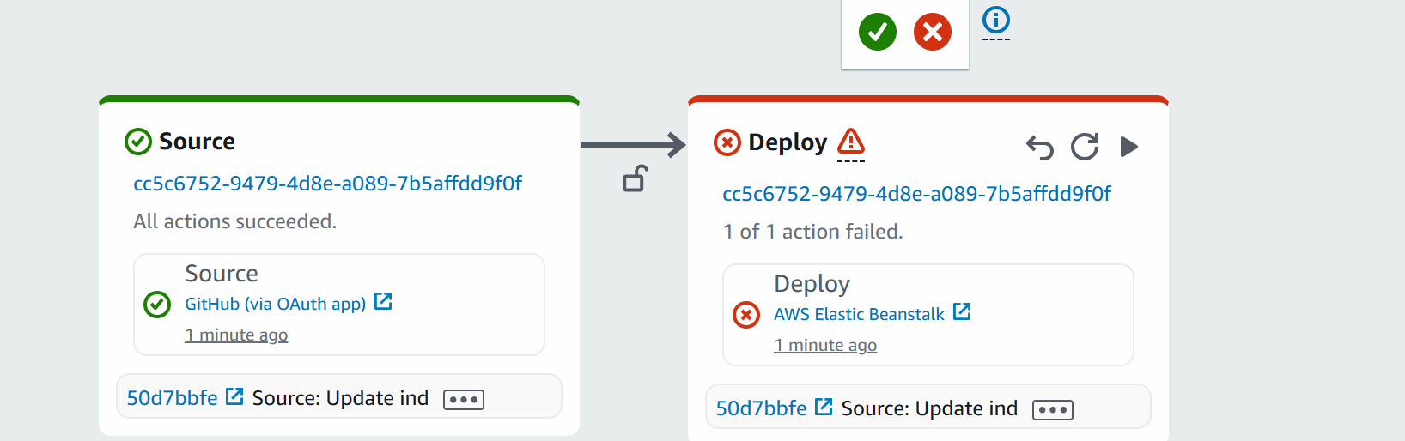

Click on deploy box on deploy button

Settings -> click on service role ARN
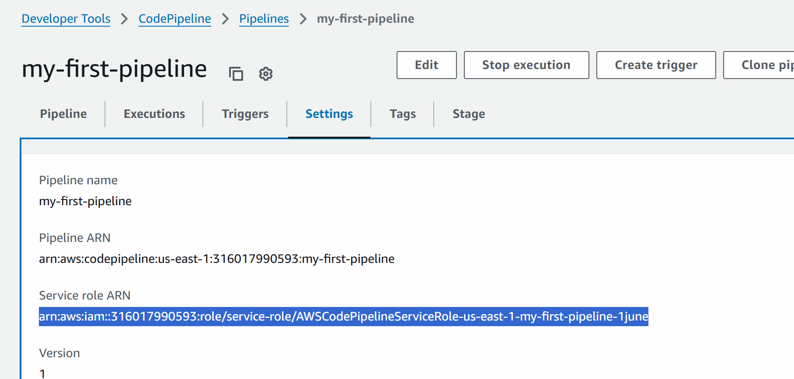

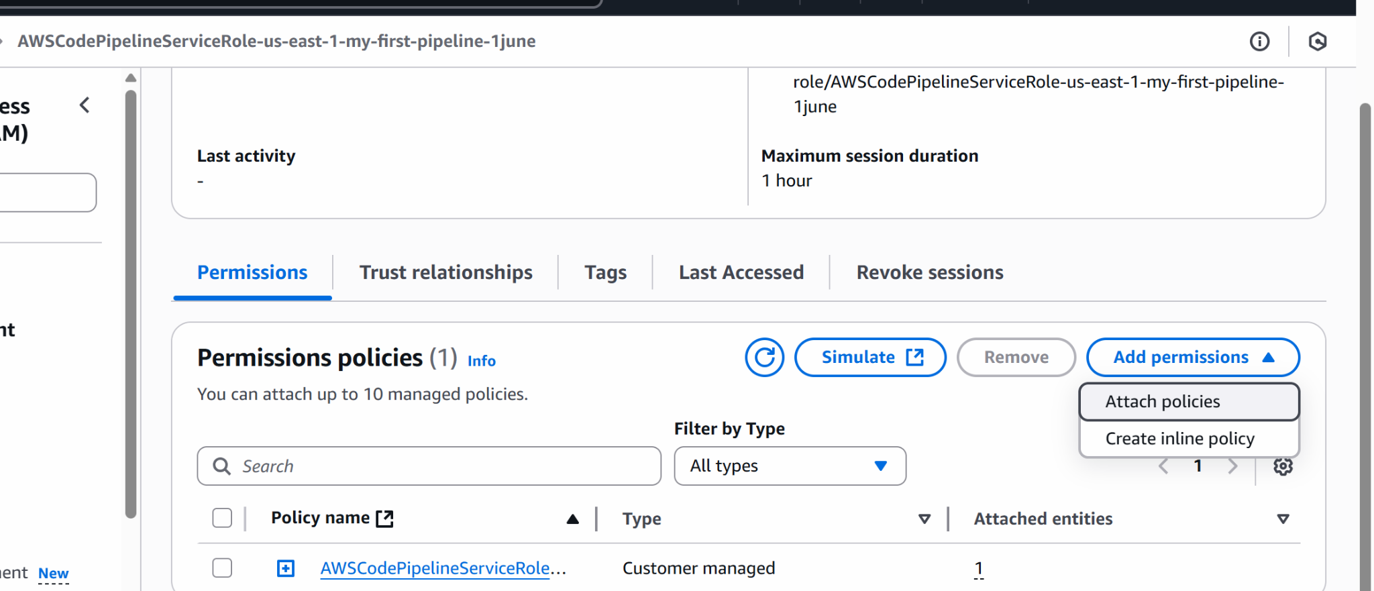

Add policies
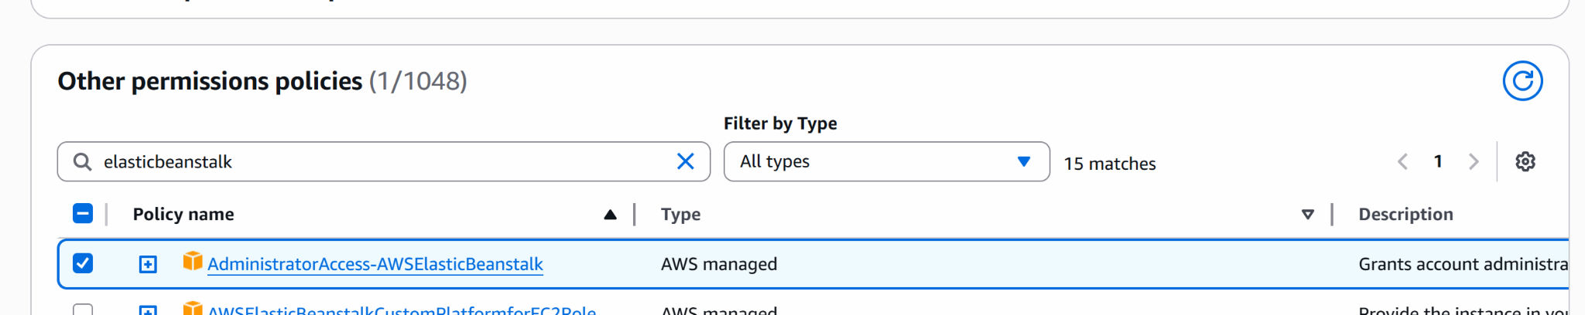

Add permissiomns

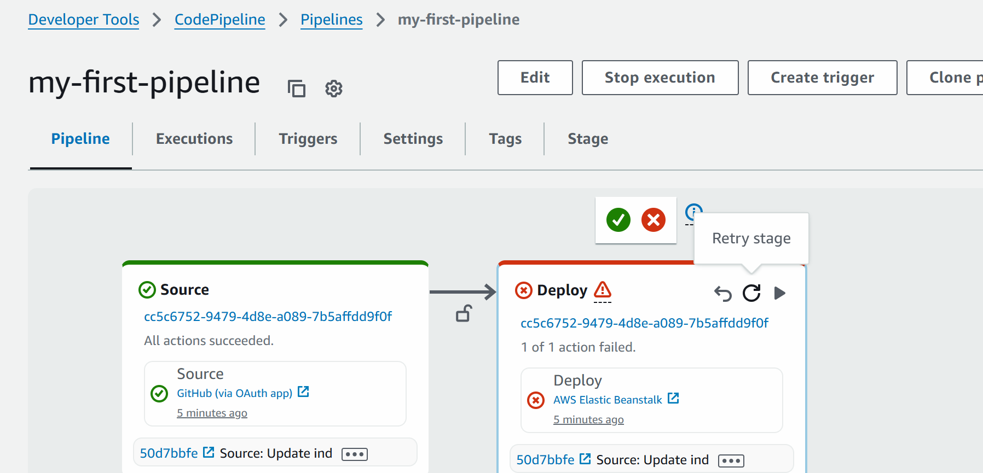

Retry the stage

Now lets go and check the environment endpoint url for beanstalk

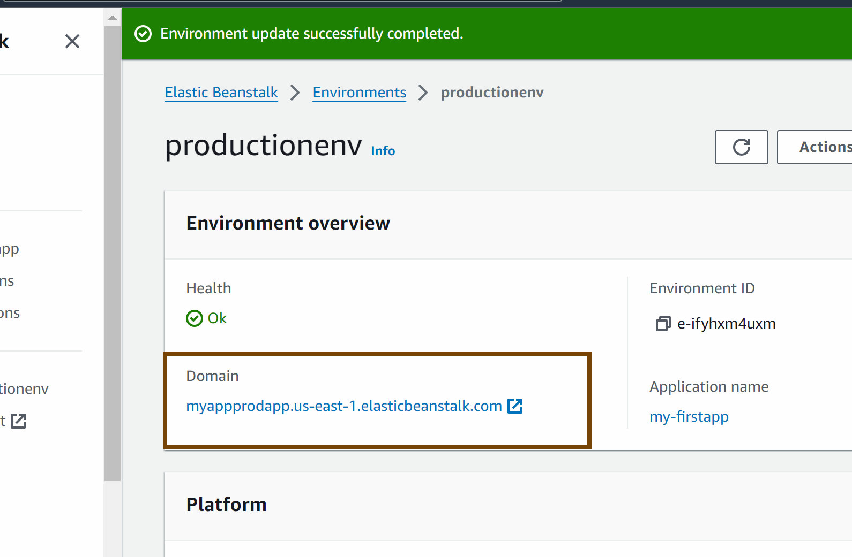



#################

## if we update anything in the github repo automatically my pipeline should trigger

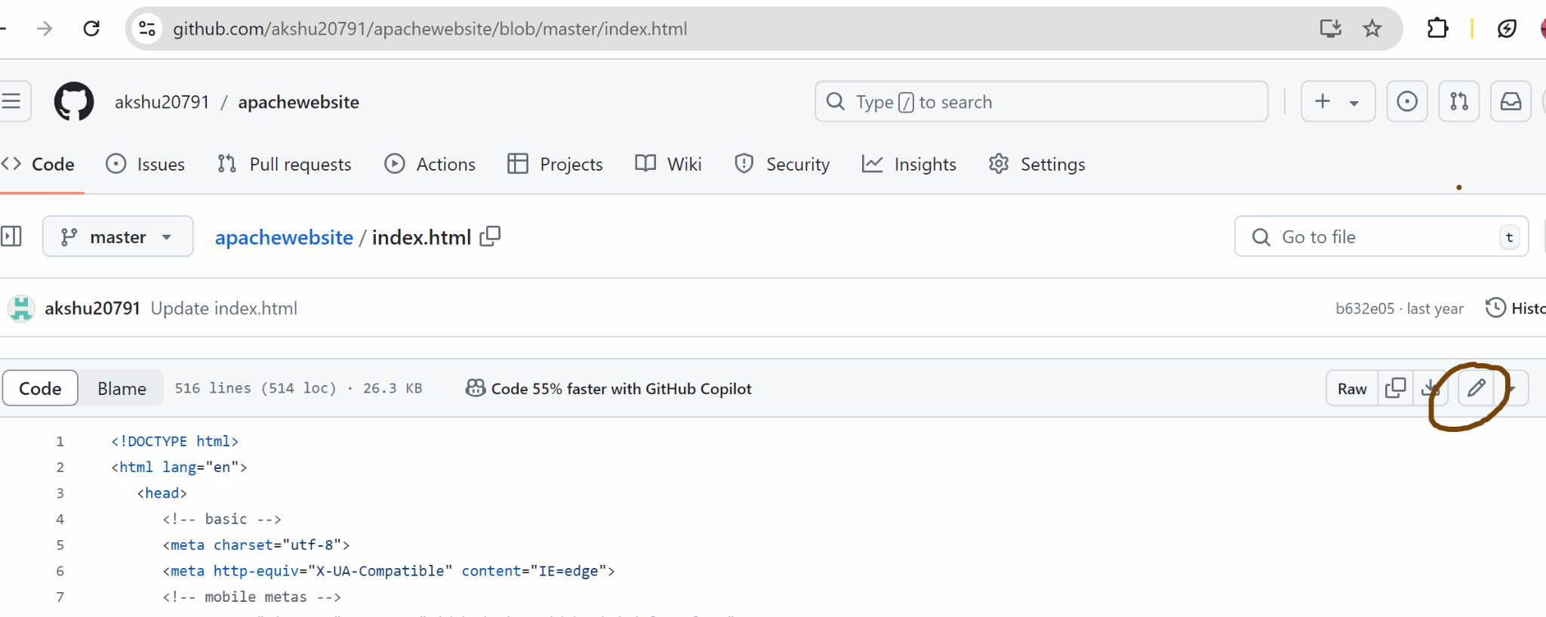

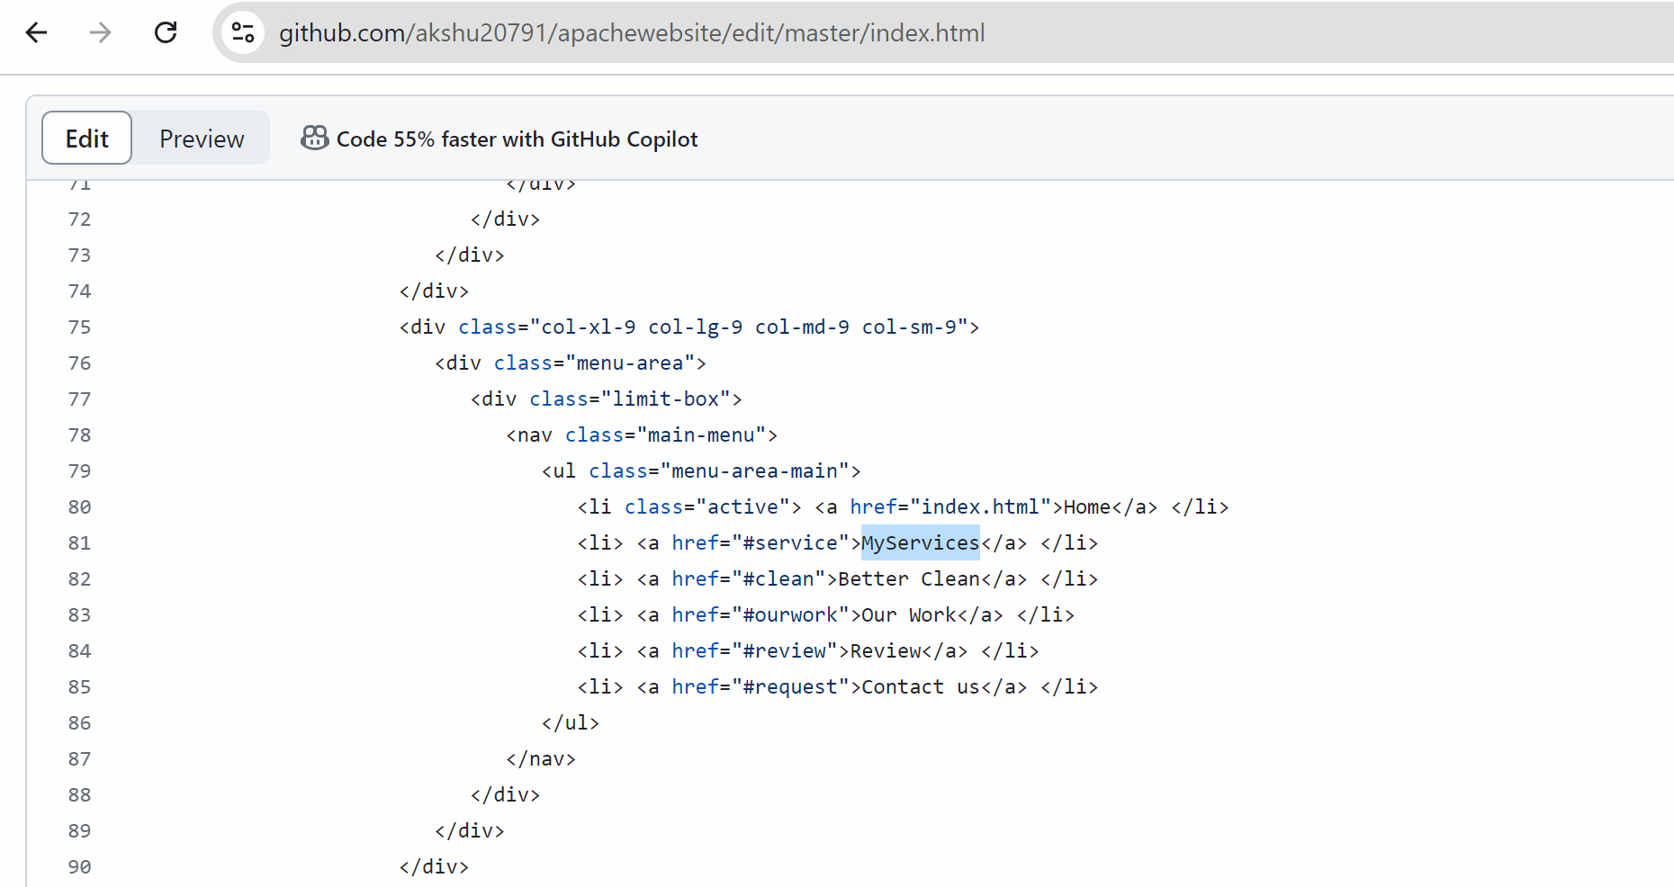

Save

Automatically the pipeline would be trigger and the project would be deployed



We can add stages in the pipeline as well….like we can add build step where in we can provide a build spec file which defines in what requirement is there to build this project

####################################
CODE BUILD 👍

Go IAM -> select roles -> create a new role for code build with administrator access

GO TO CODE BUILD :

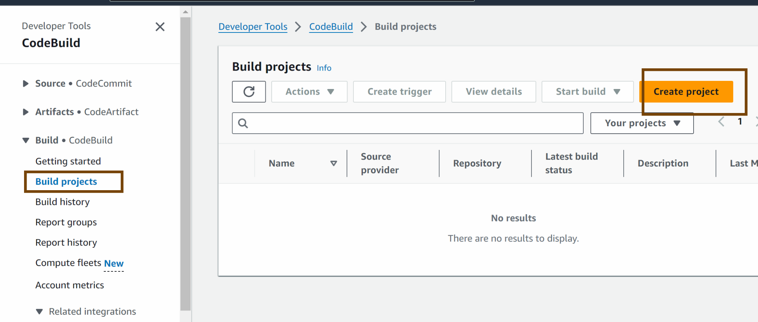
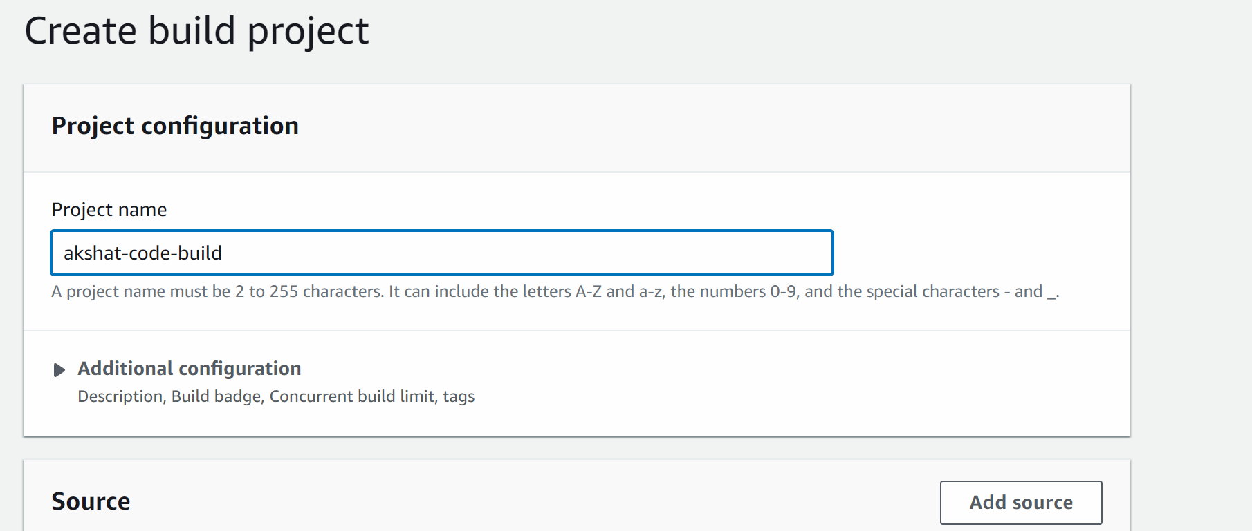

In source select no source

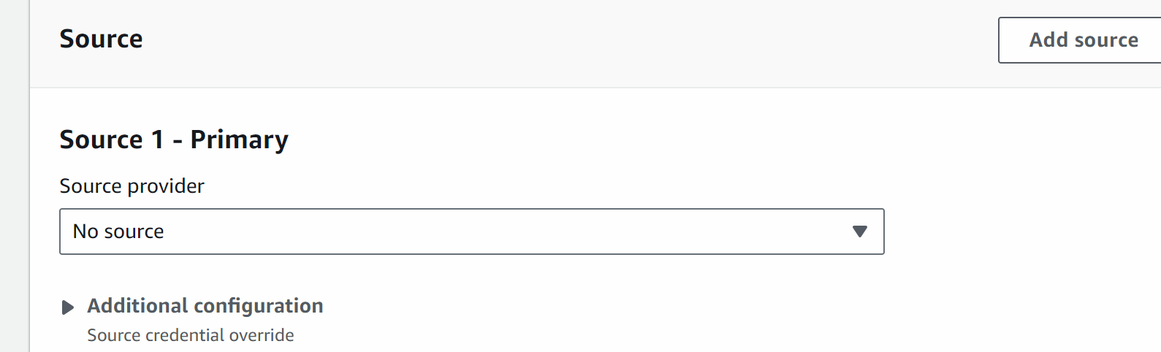

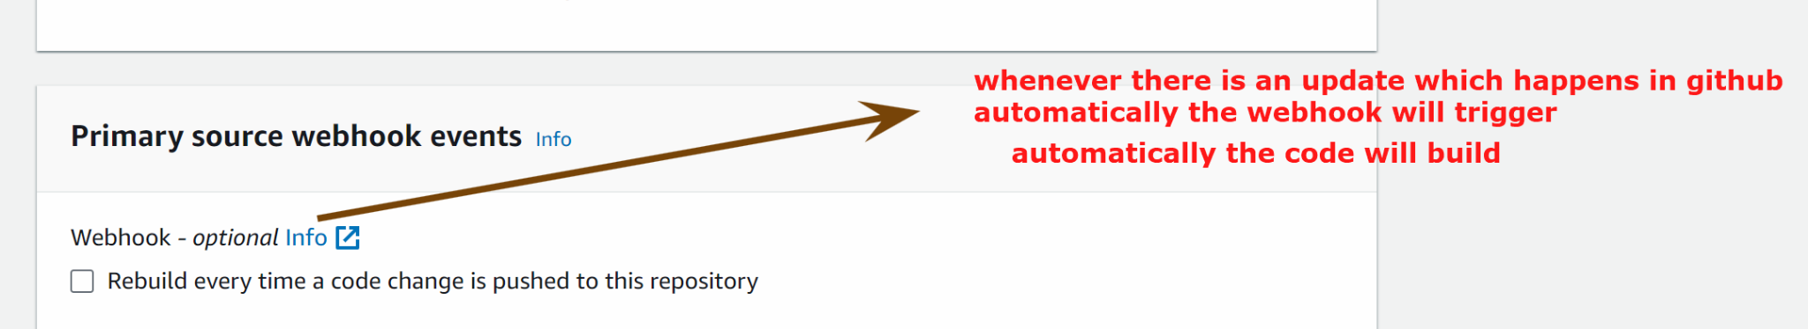

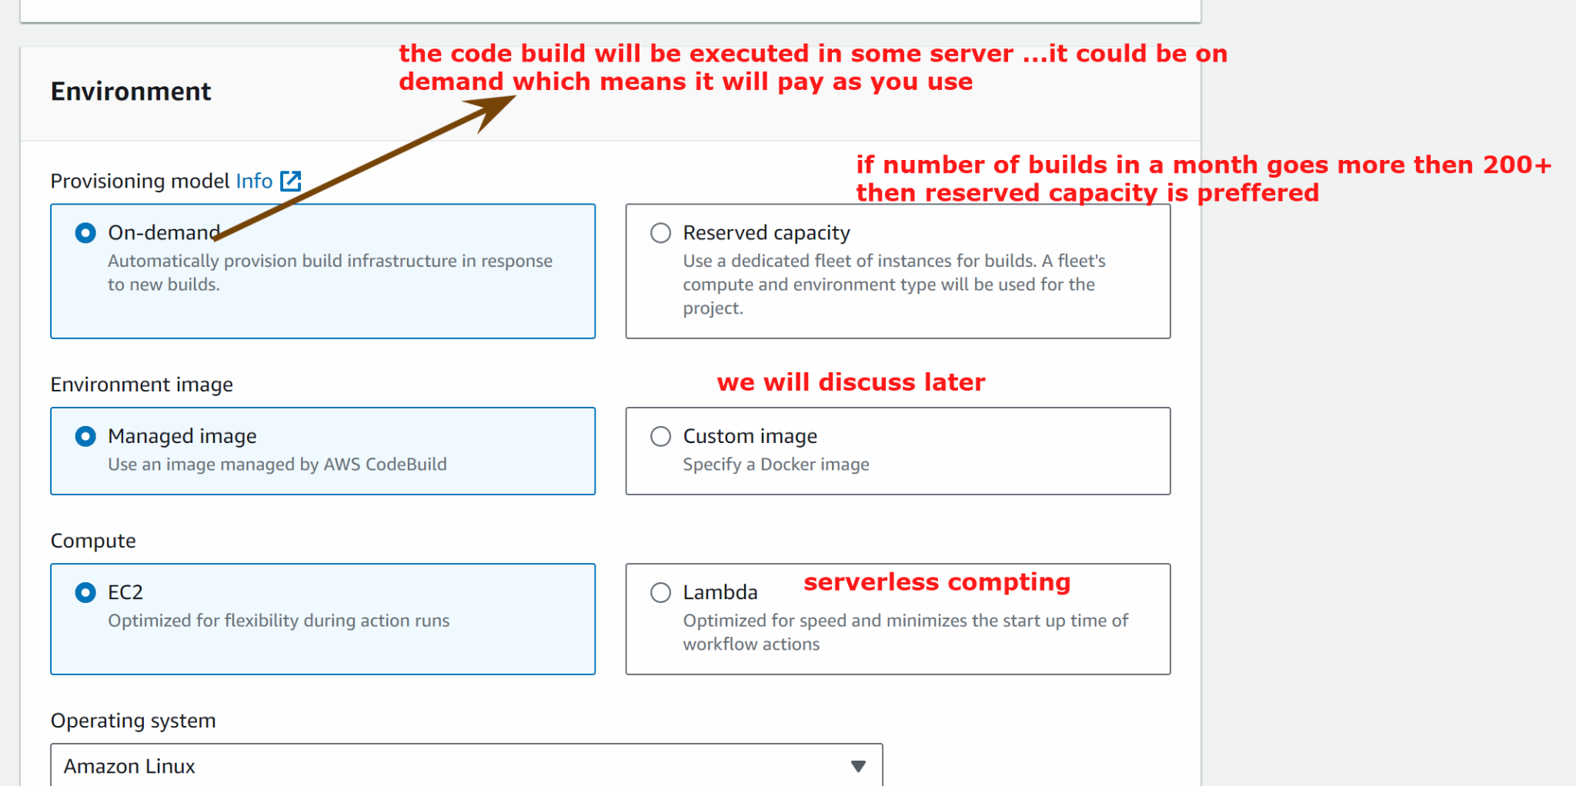

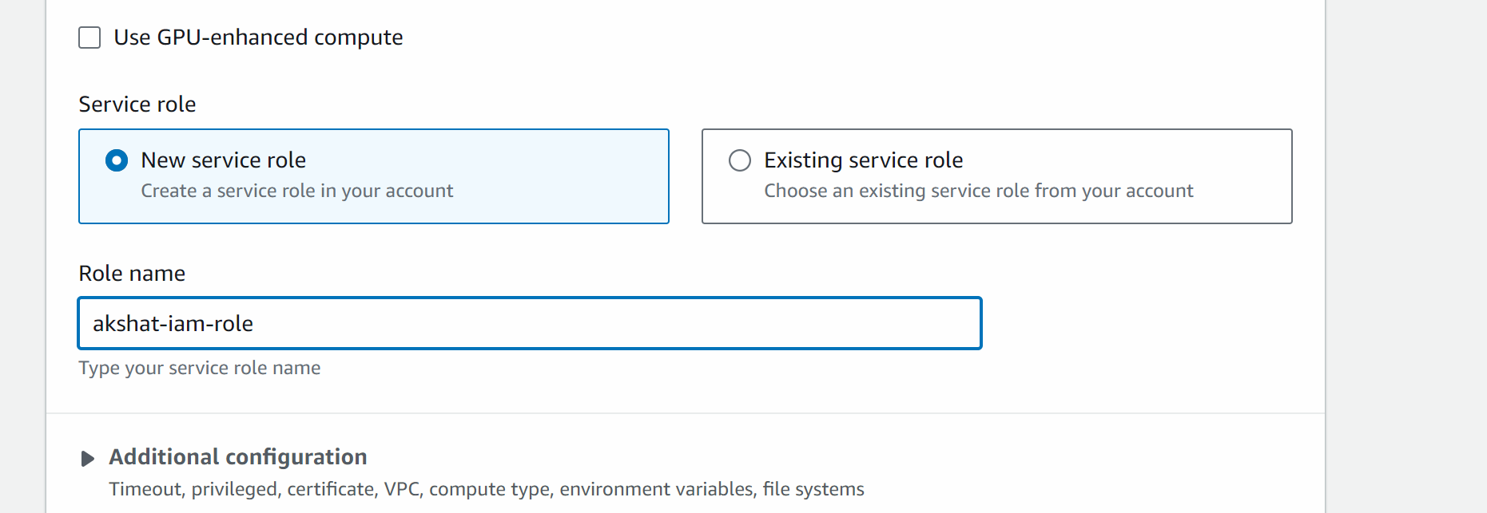
IN ABOVE PICTURE -> CLICK ON EXISTING SERVICE ROLE AND SELECT THE ROLE WHICH WE CREATED ABOVE (when we started creating code build on page 54 marked in yellow color ) otherwise u will get authentication error in lab.
Or else use git token to connect to account

Click on below link

https://github.com/akshu20791/apachewebsite/blob/master/buildspec.yml
And copy the content of this file

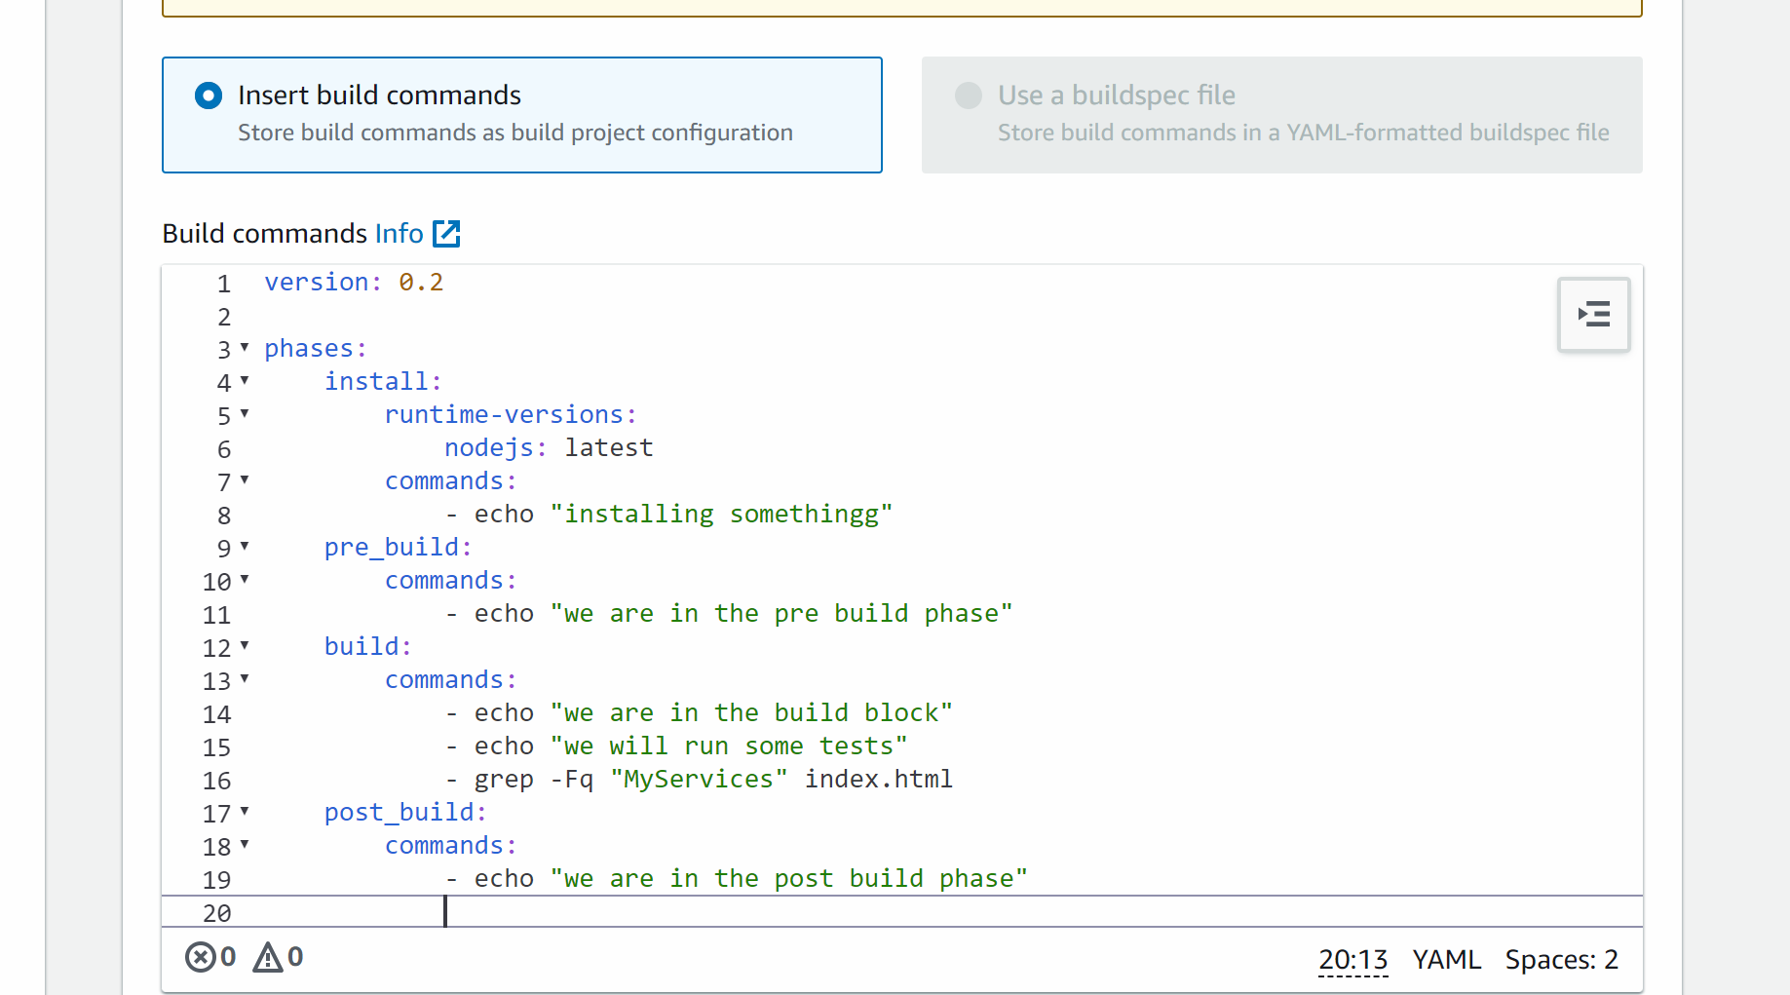

Create build project

## Now we will integrate the code build in the pipeline

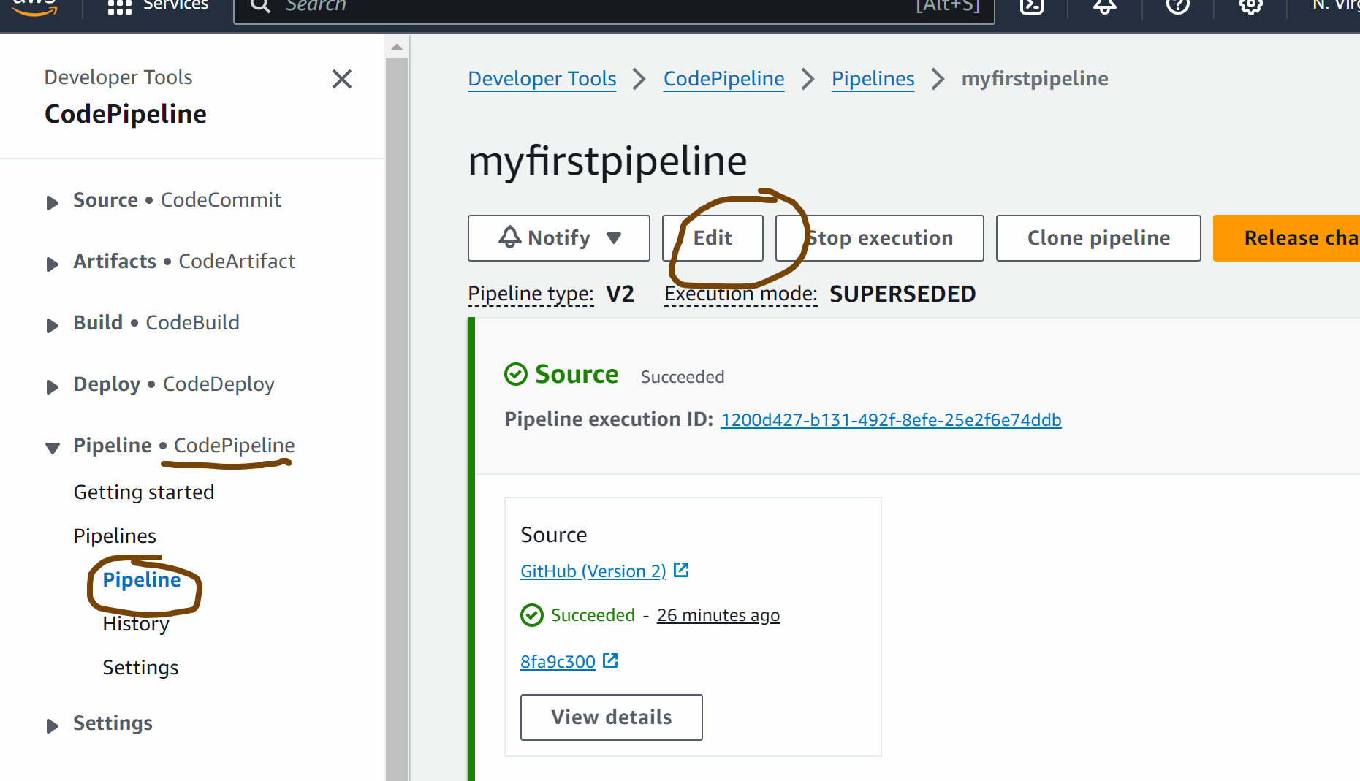
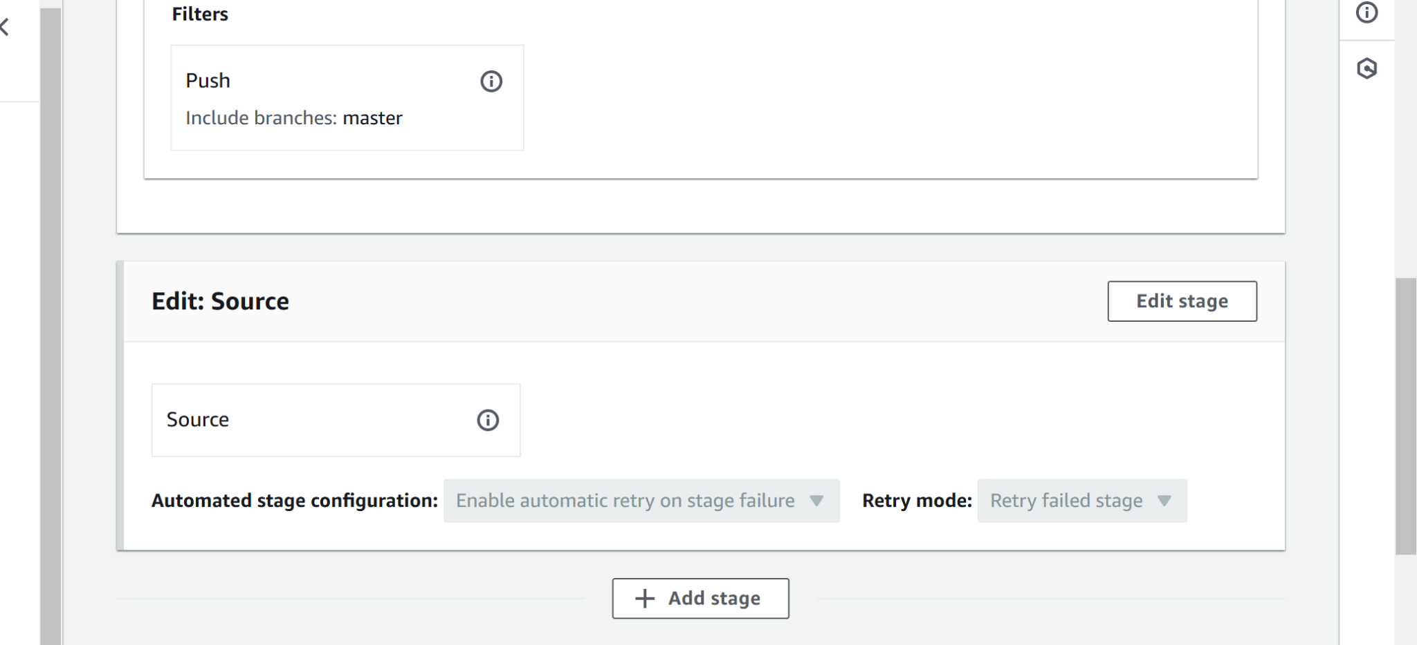

Add stage below source

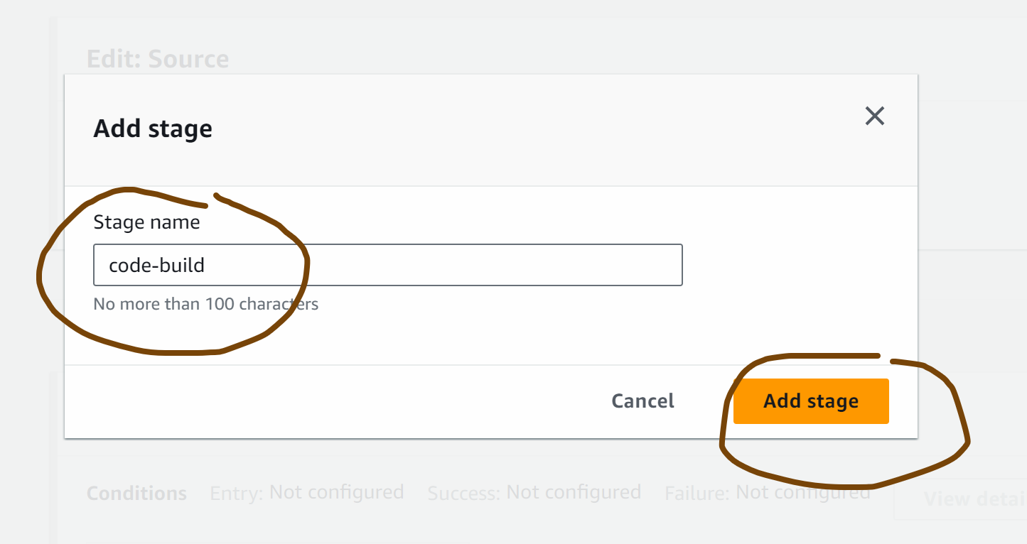

Add action group

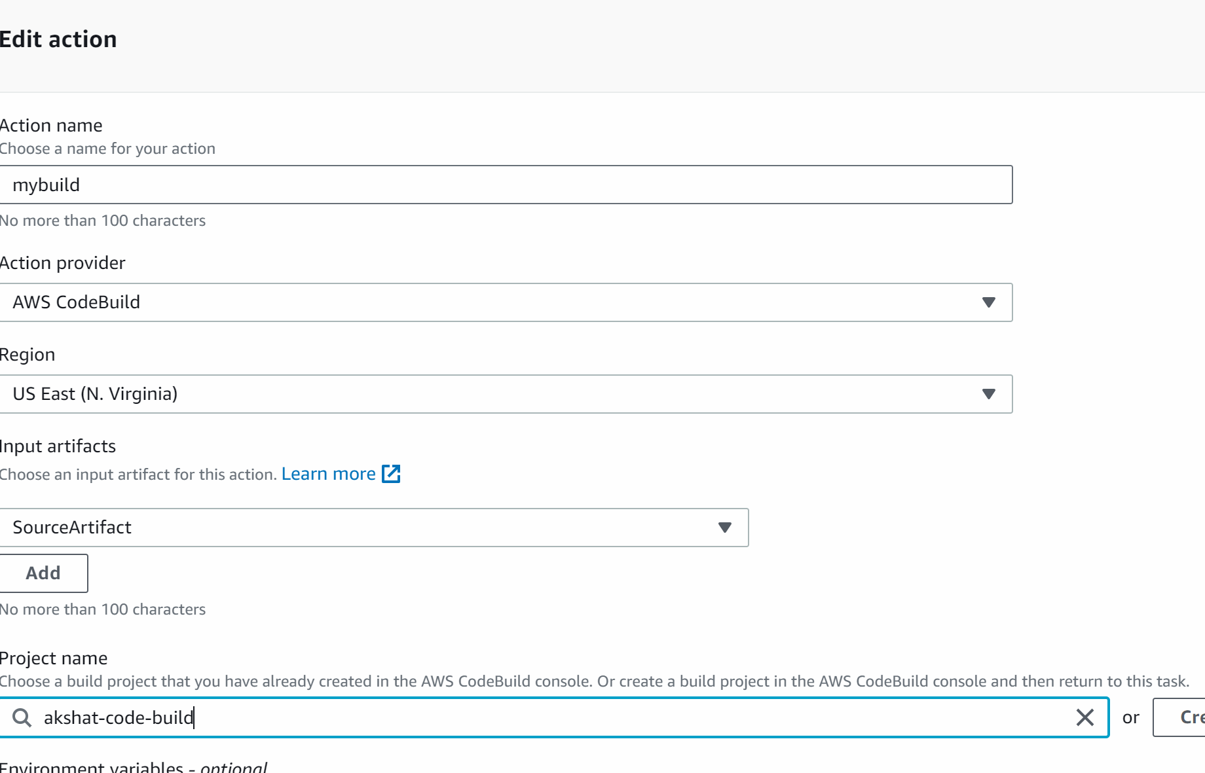

Output artifact ; myoutput
Done

Save the pipeline

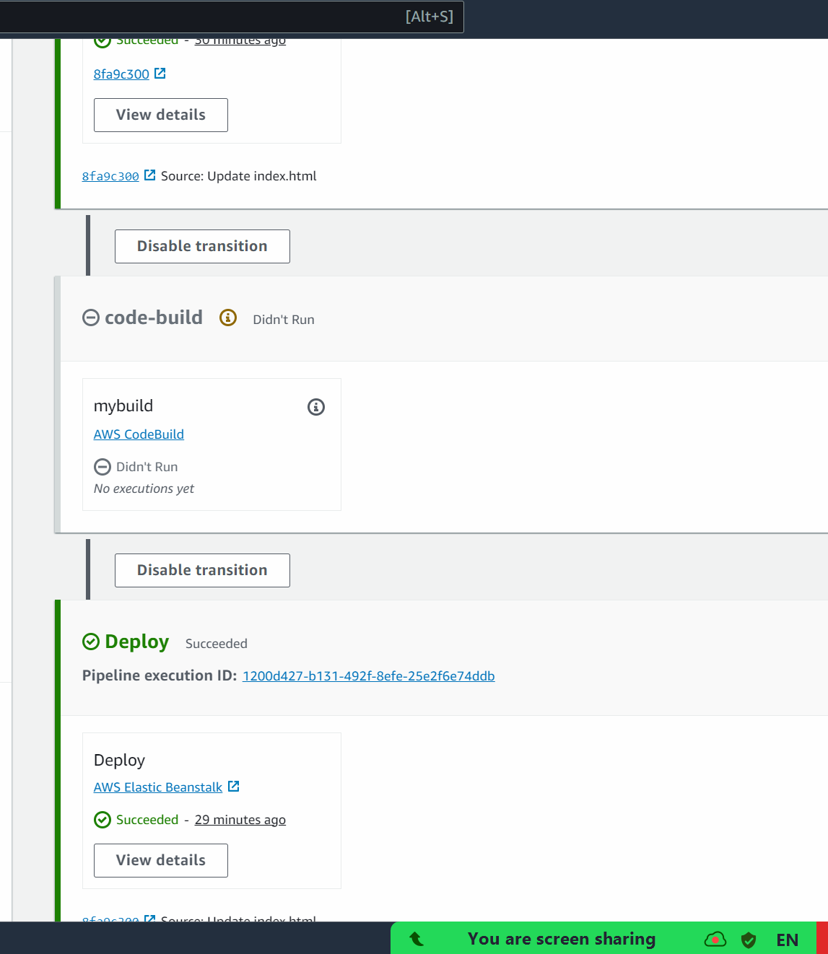

Now we update anything on github repo you will see the pipeline would be deployed

########################

Ansible : Next topic

